PrepUS History
Unit 8 - WWII
Firebombing Tokyo

In its attacks on Japan, the US abandoned the precision bombing it used in Europe and adopted a policy of saturation bombing, using incendiaries, or bombs designed to start fires, to burn Japanese cities. These tactics were used to devastating effect with many urban areas burned out.

To increase damage, US bombers began to drop incendiary bombs to burn Japan's vulnerable wood-and-paper buildings. Tokyo was hit by incendiaries in February of 1945 when 174 B-29s flew a high altitude raid during daylight hours and destroyed around 643 acres (2.6 sq. km) of the snow-covered city, using 453.7 tons of mostly incendiary bombs. Then they began to attack at a relatively low altitude of 5,000 to 9,000 ft and at night, because Japan's anti-aircraft artillery defenses were weakest in this altitude range, and the fighter defenses were ineffective at night.

On the night of March 9th 334 B-29s took off to raid Tokyo in what was called Operation Meetinghouse. 279 of them dropped 1,665 tons of bombs which threw out a jet of flaming napalm globs. In the first two hours of the raid, 226 of the attacking aircraft unloaded their bombs to overwhelm the city's fire defenses. The first B-29s to arrive dropped bombs in a large X pattern centered in Tokyo's densely populated working class district near city wards on the water; later aircraft simply aimed near this flaming X. The individual fires caused by the bombs joined to create a general conflagration (large destructive fire).

The US assessed that the firebombing campaign had been highly successful, and noted that American losses during these attacks were much lower than those incurred during day precision raids. New plans were developed for a two-stage campaign against 22 other Japanese cities and important industrial facilities. While this campaign was intended to form part of preparations for the Allied invasion of Japan, some believed that it alone would be sufficient to force the country's surrender.

The Japanese government was concerned about the results of the March firebombing attacks as the raids had demonstrated that the Japanese military was unable to protect the nation's airspace. As well as the extensive physical damage in the targeted cities, the attacks also caused increased absenteeism as civilians were afraid to leave their homes to work in factories which might be bombed.

The US estimated that nearly 88,000 people died in this one raid, 41,000 were injured, and over a million residents lost their homes. The Tokyo Fire Department estimated a higher toll: 97,000 killed and 125,000 wounded. The Tokyo Metropolitan Police Department established a figure of 83,793 dead and 40,918 wounded and 286,358 buildings and homes destroyed. Richard Rhodes, historian, put deaths at over 100,000, injuries at a million and homeless residents at a million.

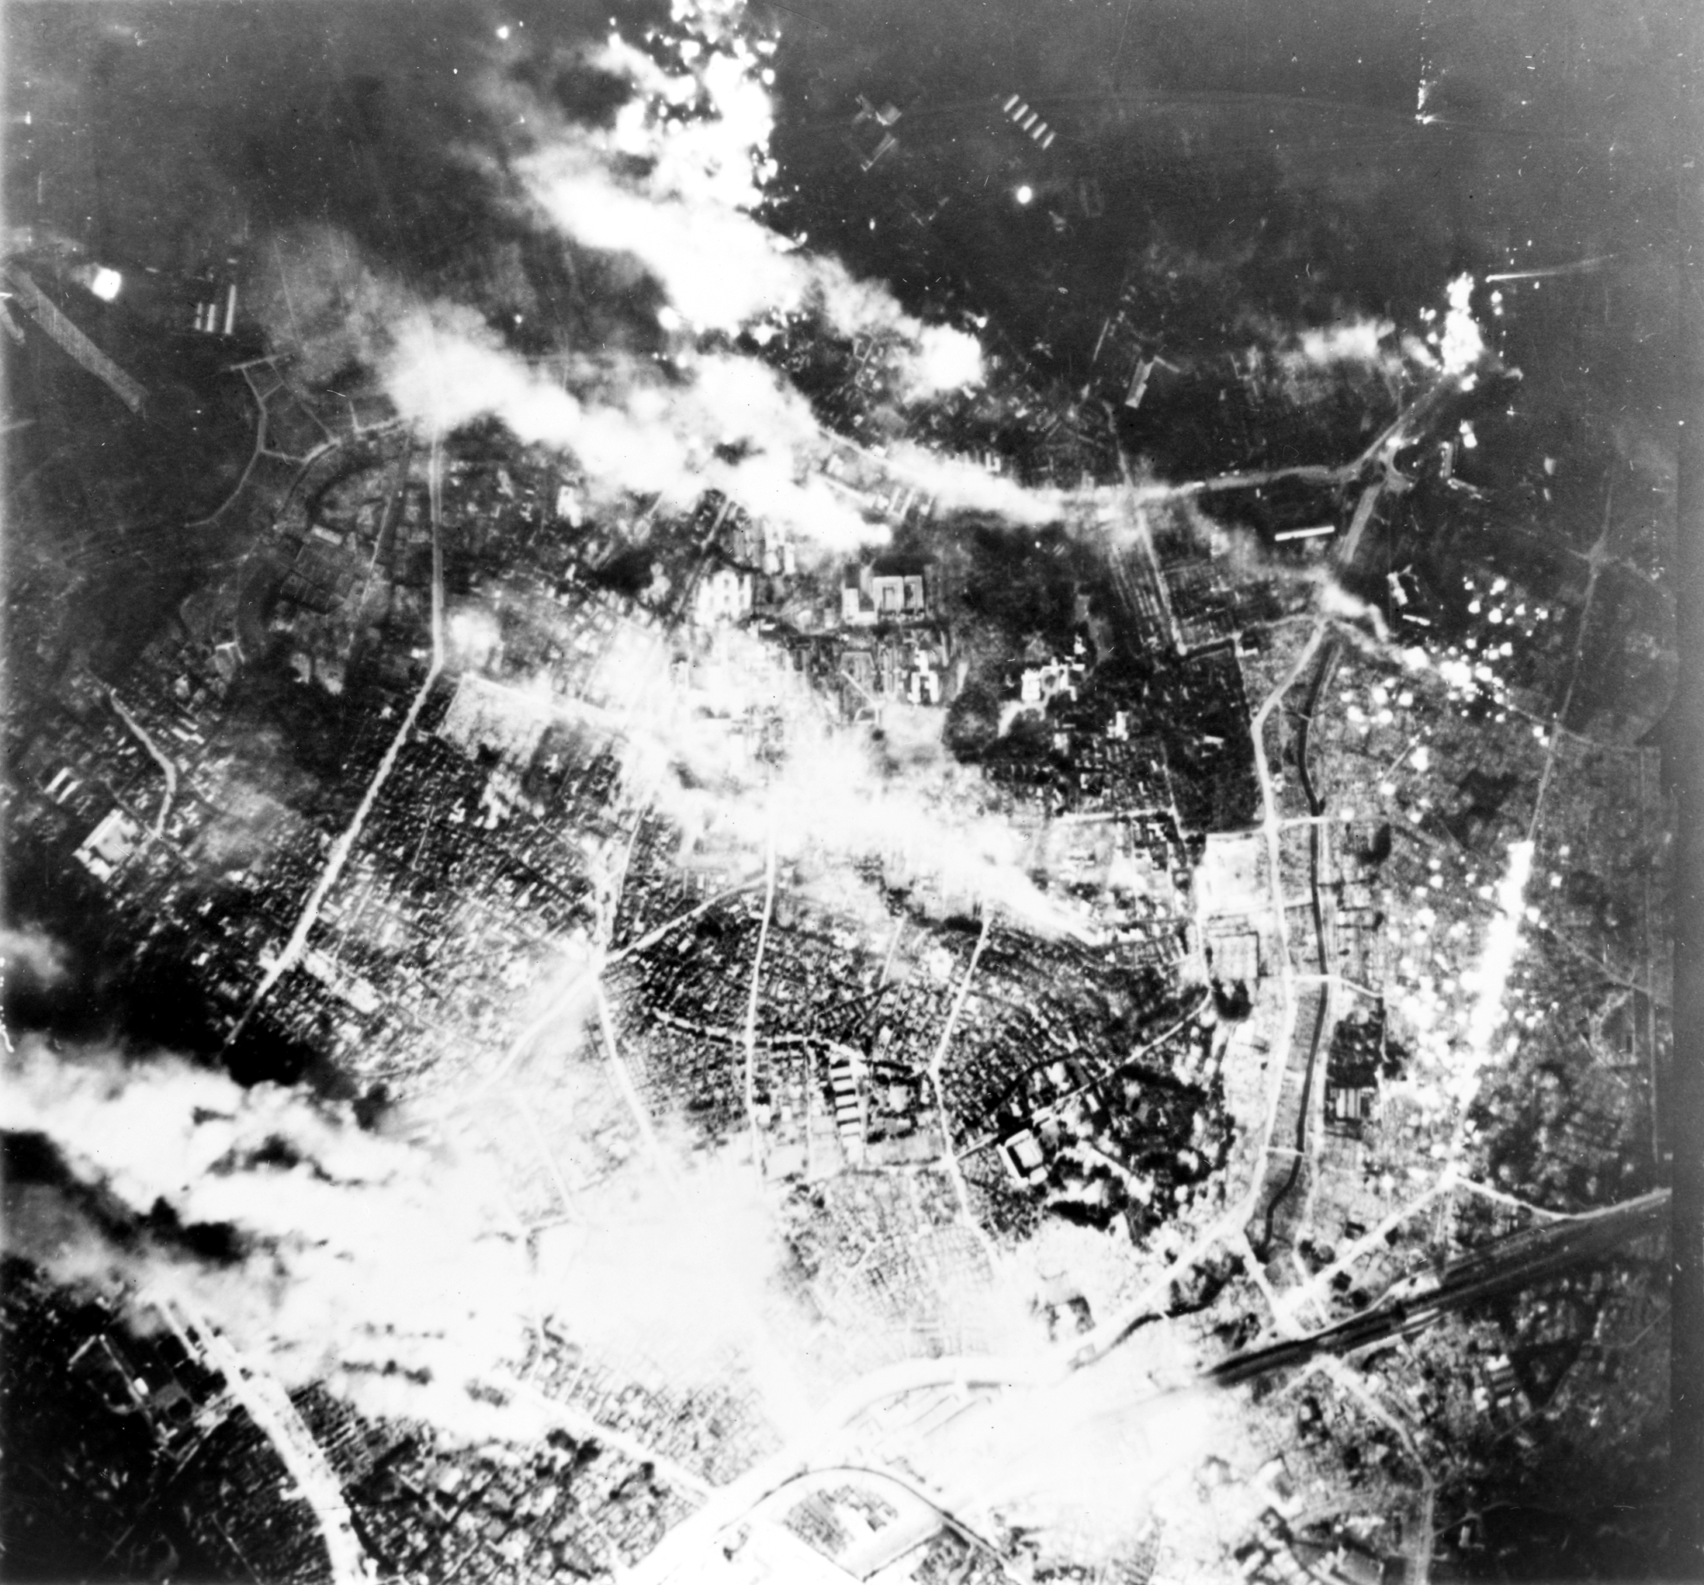
Tokyo burns under B-29 firebomb assault. May 26, 1945
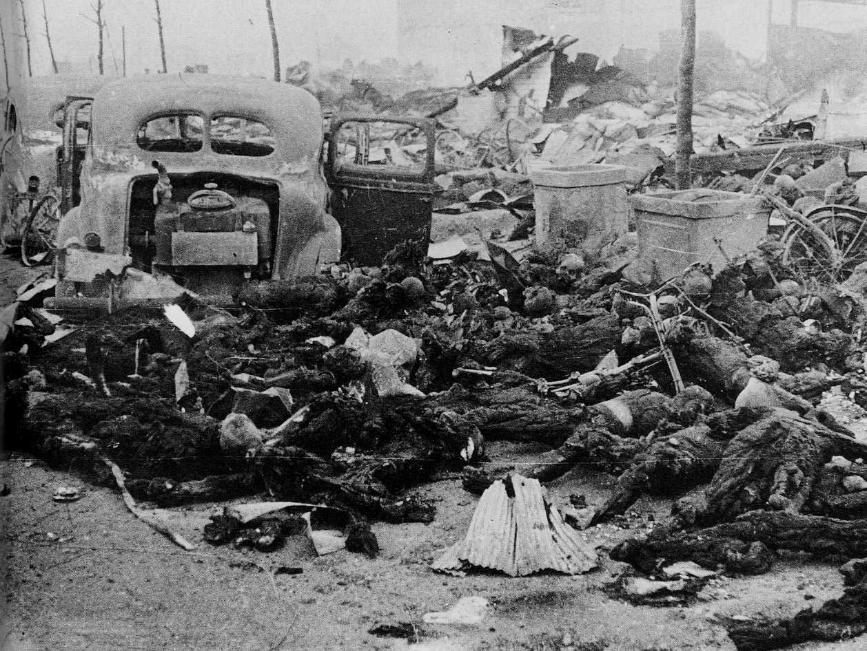
Incendiary bombs were small and light and spread over a wide area,
starting many small fires that grew into one large fire that killed thousands of people

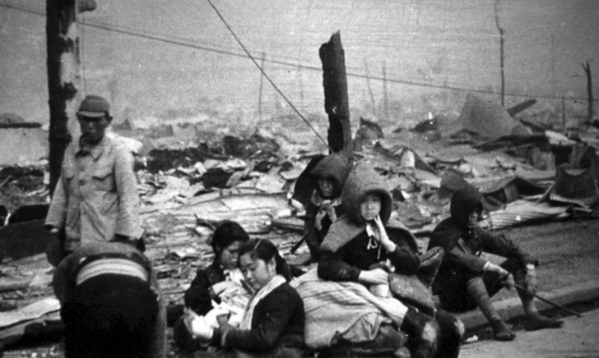 Tokyo residents who lost their homes as a result of the U.S. bombing of the city.

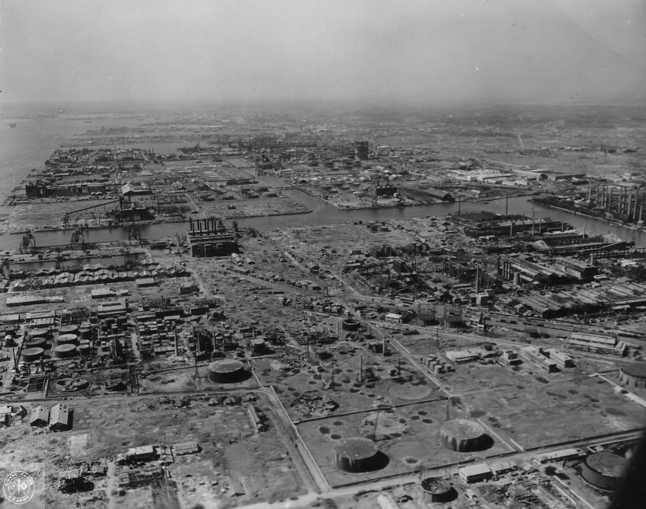

Tokyo after the U.S. bombing of the city.

