PrepUS History
End Unit – Post WWII America
Brown v. Board Reading and Questions

The 1896 Plessy v. Ferguson Supreme Court ruling had legally legitimized the “separate but equal” policy in American public life. The ruling stipulated that blacks and whites could receive separate services so long as they had equal access to resources. While ostensibly blacks may have been entitled to equivalent resources and opportunities, in actuality the policy preserved “separate and unequal” racial divisions.
By the early 1950s, the NAACP had decided to undermine the “separate but equal” doctrine through legal challenges to educational segregation in US public schools, primarily because the gaps between white and black educational institutions were so glaring. The NAACP legal team argued to the US Supreme Court that “separate but equal” violated the Fourteenth Amendment clause, which states that the freedoms and privileges of US citizens must be equally protected.

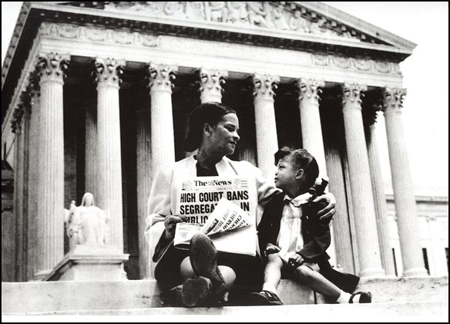
In the Brown v. Board of Education ruling, the US Supreme Court declared the doctrine of “separate but equal” unconstitutional on the grounds that it provided inferior education to African-Americans. The landmark decision initiated the process that dismantled the legal segregation of schools in America.

A mother explaining the Brown v. Board decision on the steps of the Supreme Court. The ruling declared that the doctrine “separate but equal” was unconstitutional.
Library of Congress, Prints & Photographs Division, LC-USZ62-127042

US Supreme Court
BROWN v. BOARD OF EDUCATION
347 U.S. 483
BROWN ET AL. v. BOARD OF EDUCATION OF TOPEKA ET AL.
APPEAL FROM THE UNITED STATES DISTRICT COURT FOR THE DISTRICT OF KANSAS. No. 1.
Segregation of white and Negro children in the public schools of a State solely on the basis of race, pursuant to state laws permitting or requiring such segregation, denies to Negro children the equal protection of the laws guaranteed by the Fourteenth Amendment - even though the physical facilities and other “tangible” factors of white and Negro schools may be equal.
(a) The history of the Fourteenth Amendment is inconclusive as to its intended effect on public education.
(b) The question presented in these cases must be determined, not on the basis of conditions existing when the Fourteenth Amendment was adopted, but in the light of the full development of public education and its present place in American life throughout the Nation.
(c) Where a State has undertaken to provide an opportunity for an education in its public schools, such an opportunity is a right which must be made available to all on equal terms.
(d) Segregation of children in public schools solely on the basis of race deprives children of the minority group of equal educational opportunities, even though the physical facilities and other “tangible” factors may be equal.
(e) The “separate but equal” doctrine adopted in Plessy v. Ferguson, 163 U.S. 537 has no place in the field of public education.
[...]
In approaching this problem, we cannot turn the clock back to 1868 when the Amendment was adopted, or even to 1896 when Plessy v. Ferguson was written. We must consider public education in the light of its full development and its present place in American life throughout the Nation. Only in this way can it be determined if segregation in public schools deprives these plaintiffs of the equal protection of the laws.
Today, education is perhaps the most important function of state and local governments. Compulsory school attendance laws and the great expenditures for education both demonstrate our recognition of the importance of education to our democratic society. It is required in the performance of our most basic public responsibilities, even service in the armed forces. It is the very foundation of good citizenship. Today it is a principal instrument in awakening the child to cultural values, in preparing him for later professional training, and in helping him to adjust normally to his environment. In these days, it is doubtful that any child may reasonably be expected to succeed in life if he is denied the opportunity of an education. Such an opportunity, where the state has undertaken to provide it, is a right which must be made available to all on equal terms.
We come then to the question presented: Does segregation of children in public schools solely on the basis of race, even though the physical facilities and other “tangible” factors may be equal, deprive the children of the minority group of equal educational opportunities?
We believe that it does.
[...]
To separate them [black children] from others of similar age and qualifications solely because of their race generates a feeling of inferiority as to their status in the community that may affect their hearts and minds in a way unlikely ever to be undone. [...]
We conclude that in the field of public education the doctrine of “separate but equal” has no place. Separate educational facilities are inherently unequal. Therefore, we hold that the plaintiffs and others similarly situated for whom the actions have been brought are, by reason of the segregation complained of, deprived of the equal protection of the laws guaranteed by the Fourteenth Amendment.

1. In Chief Justice Warren’s opinion, how valuable is education? Why does he think so?

______________________________________________________________________________

______________________________________________________________________________

______________________________________________________________________________

______________________________________________________________________________

______________________________________________________________________________

______________________________________________________________________________

2. Look up the definition of the word “tangible.” What does the Court mean by the “tangible” factors of equality?

______________________________________________________________________________

______________________________________________________________________________

______________________________________________________________________________

______________________________________________________________________________

______________________________________________________________________________

______________________________________________________________________________

3. According to the Supreme Court of the United States, what “intangible” factors play a role in whether school facilities are truly equal?

______________________________________________________________________________

______________________________________________________________________________

______________________________________________________________________________

______________________________________________________________________________

______________________________________________________________________________

______________________________________________________________________________

4. How would education be different for white and African American students if Brown had been decided differently and Plessy had never been reversed?

______________________________________________________________________________

______________________________________________________________________________

______________________________________________________________________________

______________________________________________________________________________

______________________________________________________________________________

______________________________________________________________________________

5. What consequences might still exist from schools being segregated in the past?

______________________________________________________________________________

______________________________________________________________________________

______________________________________________________________________________

______________________________________________________________________________

______________________________________________________________________________

______________________________________________________________________________

