PrepUS History
Unit 8 - WWII
The Battle of the Bulge

Early on the misty winter morning of 16 December 1944, over 200,000 German troops and nearly 1,000 tanks launched Adolf Hitler’s last bid to reverse the ebb in his fortunes that had begun when Allied troops landed in France on D-day. Seeking to drive to the English Channel coast and split the Allied armies as they had done in May 1940, the Germans struck in the Ardennes Forest, a seventy-five-mile stretch of the front characterized by dense woods and few roads, held by four inexperienced and battle-worn American divisions stationed there for rest and seasoning.

After a day of hard fighting, the Germans broke through the American front, surrounding most of an infantry division, seizing key crossroads, and advancing their spearheads toward the Meuse River, creating the projection that gave the battle its name.

Stories spread of the massacre of soldiers and civilians at Malmedy and Stavelot, of paratroopers dropping behind the lines, and of English-speaking German soldiers, disguised as Americans, capturing critical bridges, cutting communications lines, and spreading rumors. For those who had lived through 1940, the picture was all too familiar. Belgian townspeople put away their Allied flags and brought out their swastikas. Police in Paris enforced an all-night curfew. British veterans waited nervously to see how the Americans would react to a full-scale German offensive, and British generals quietly acted to safeguard the Meuse crossings. Even American civilians who had thought final victory was near were sobered by the Nazi onslaught.

But this was not 1940. The supreme Allied commander, General Dwight D. Eisenhower rushed reinforcements to hold the shoulders of the German penetration. Within days, Lt. Gen. George S. Patton, Jr. had turned his Third U.S. Army to the north and was counterattacking against the German flank. But the story of the battle of the Bulge is above all the story of American soldiers. Often isolated and unaware of the overall picture, they did their part to slow the Nazi advance, whether by delaying armored spearheads with obstinate defenses of vital crossroads, moving or burning critical gasoline stocks to keep them from the fuel-hungry German tanks, or coming up with questions on arcane Americana to stump possible Nazi infiltrators.

At the critical road junctions of St. Vith and Bastogne, American tankers and paratroopers fought off repeated attacks, and when the acting commander of the 101st Airborne Division in Bastogne was summoned by his German adversary to surrender, he simply responded, “Nuts!”

Within days, Patton’s Third Army had relieved Bastogne, and to the north, the 2d U.S. Armored Division stopped enemy tanks short of the Meuse on Christmas Day. Through January, American troops, often wading through deep snow drifts, attacked the sides of the shrinking bulge until they had restored the front and set the stage for the final drive to victory.

Never again would Hitler be able to launch an offensive in the West on such a scale. An admiring British Prime Minister Sir Winston Churchill stated, “This is undoubtedly the greatest American battle of the war and will, I believe, be regarded as an ever-famous American victory.” Indeed, in terms of participation and losses, the battle of the Bulge is arguably the greatest battle in American military history.

Courtesy The United States Army Center of Military History

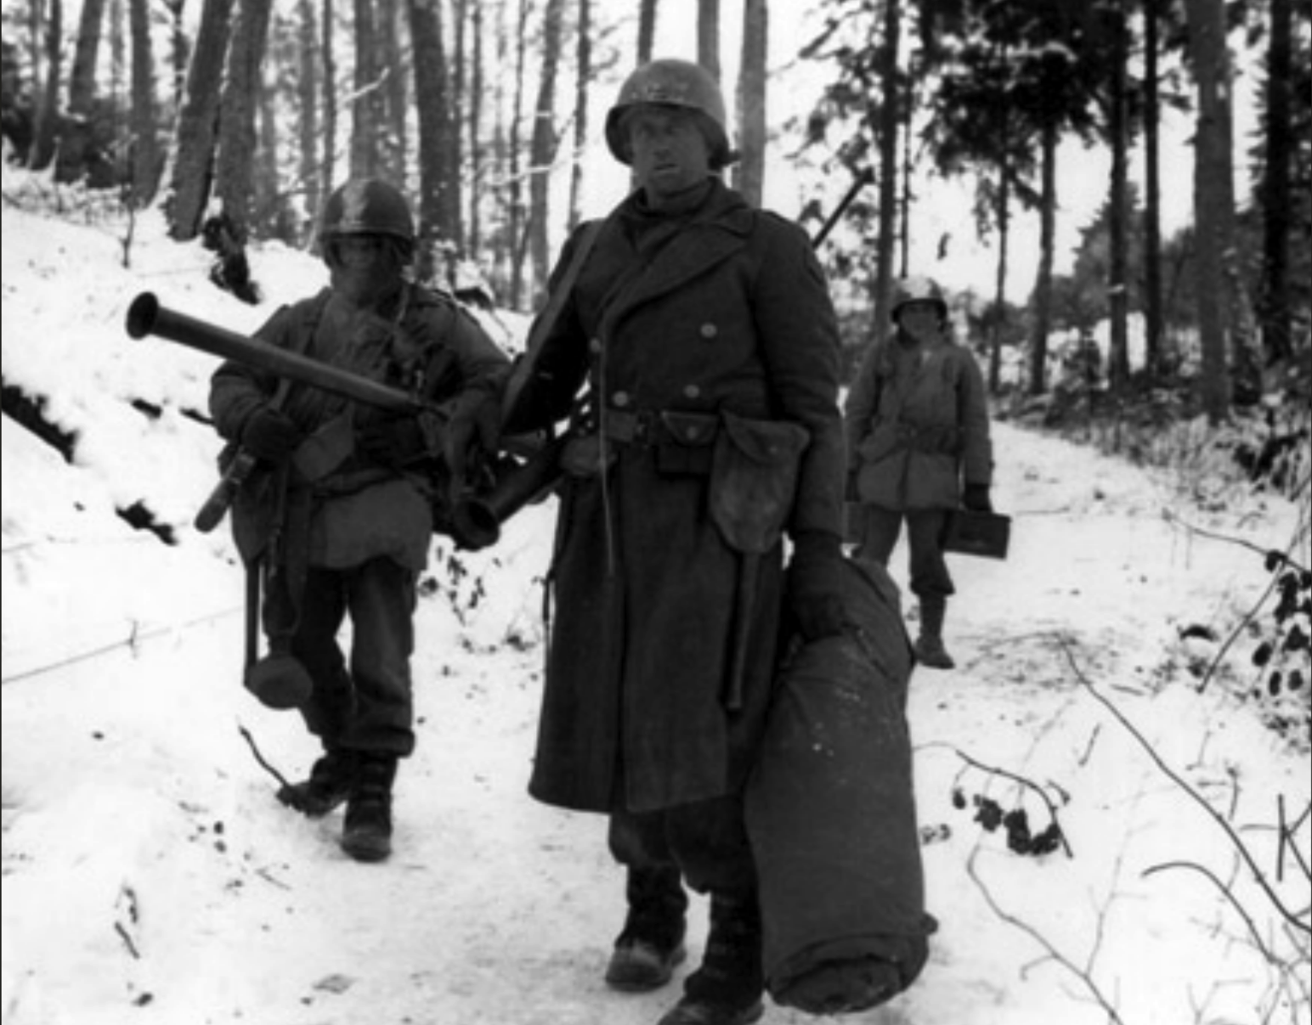
American engineers emerge from the woods and move out of defensive positions after fighting in vicinity of Bastogne, Belgium.

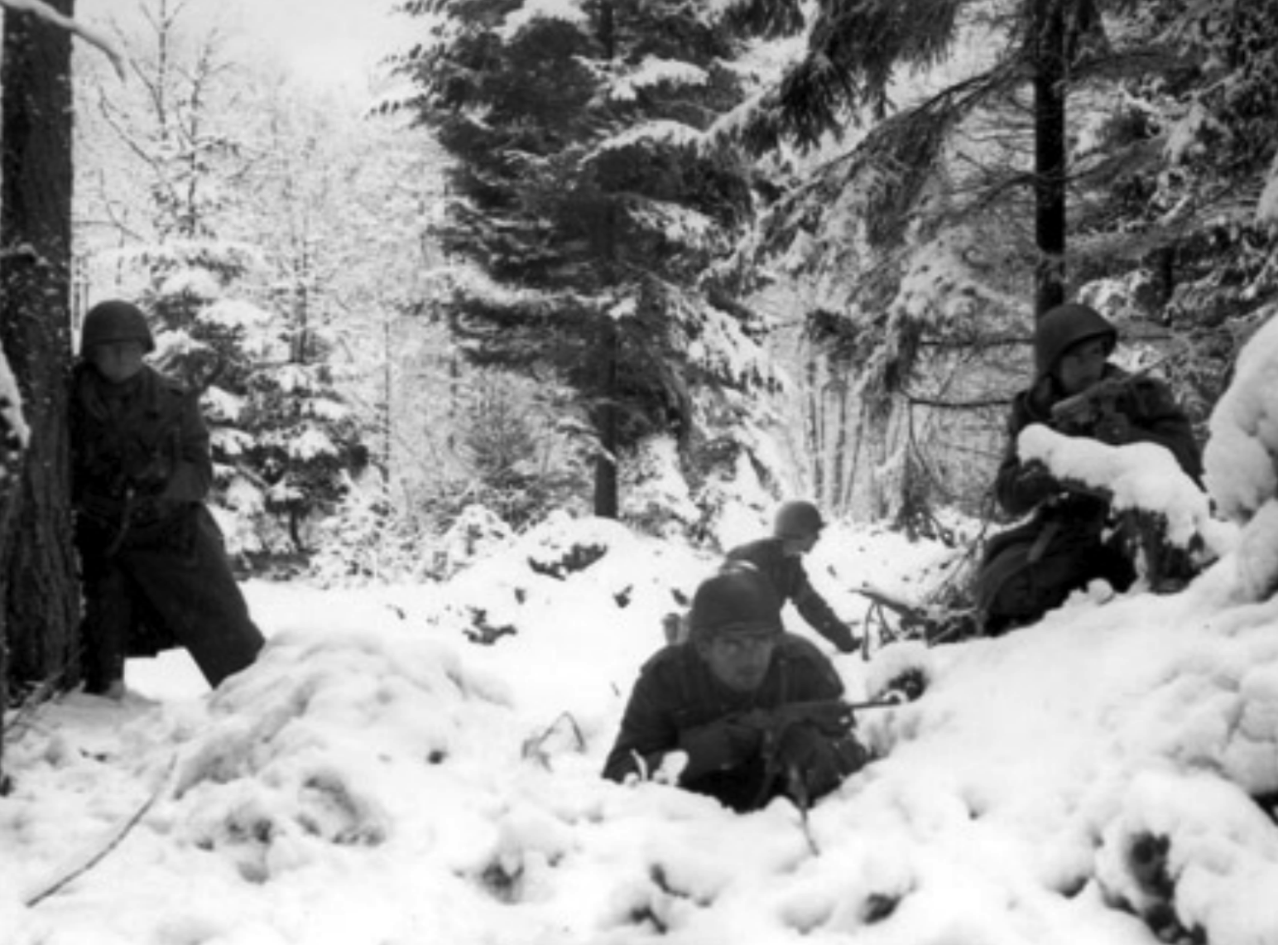
American soldiers taking up defensive positions in the Ardennes during the Battle of the Bulge.

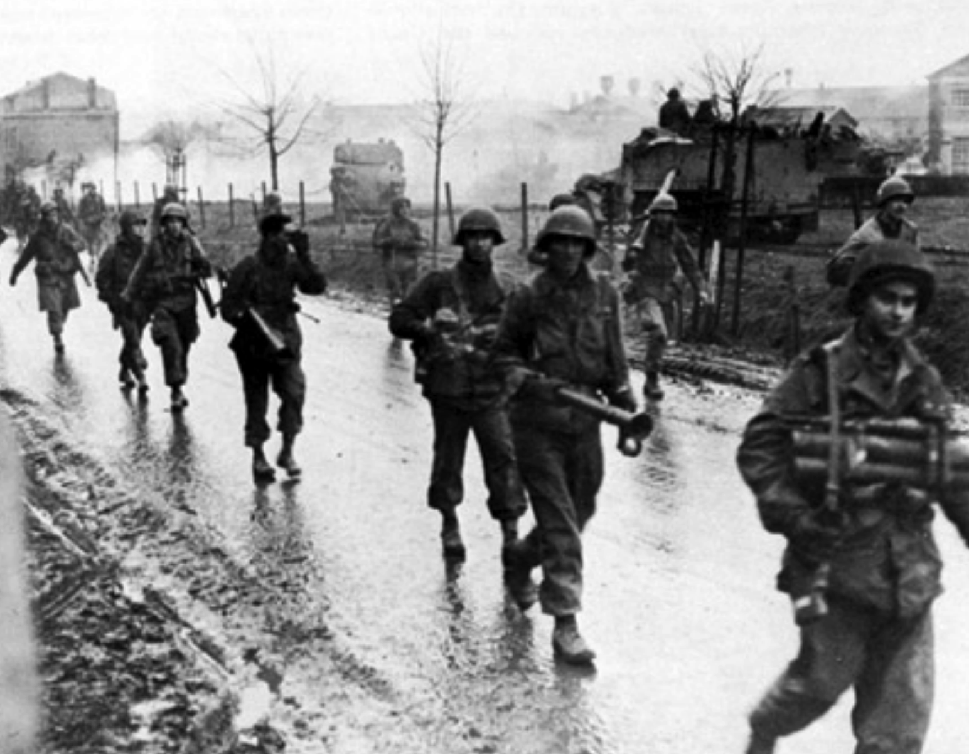
Screaming Eagles, Paratroopers of the 101st Airborne Division, heavily armed with Bazookas, move north from Bastogne to stop the German counteroffensive.

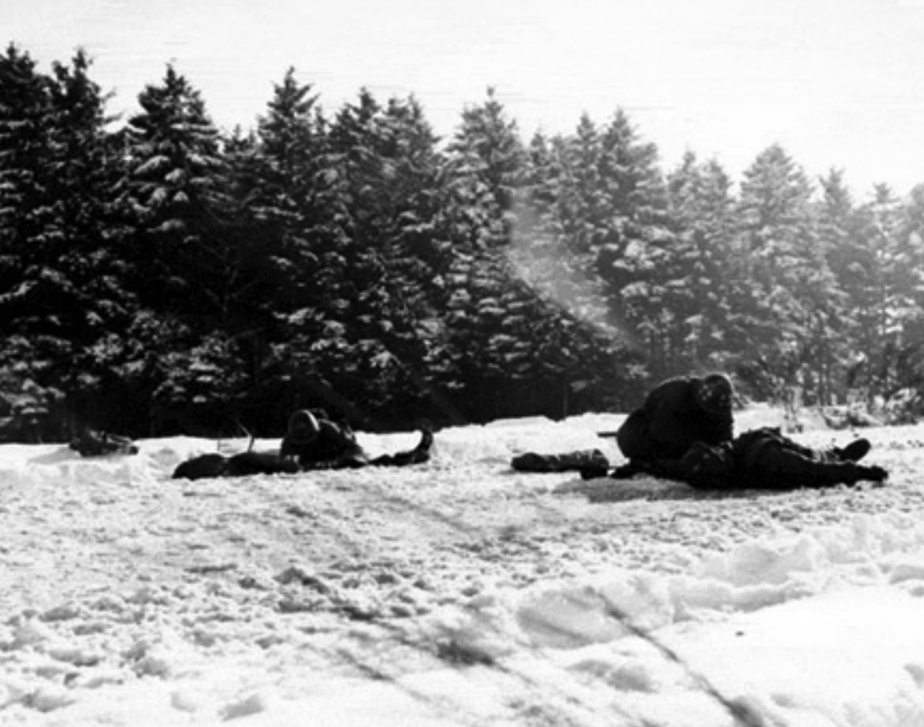

Two infantrymen receive medical attention while lying in the snow at the 84th Division sector of Belgium. They were hit during a mortar barrage a few minutes earlier. January 14, 1945.

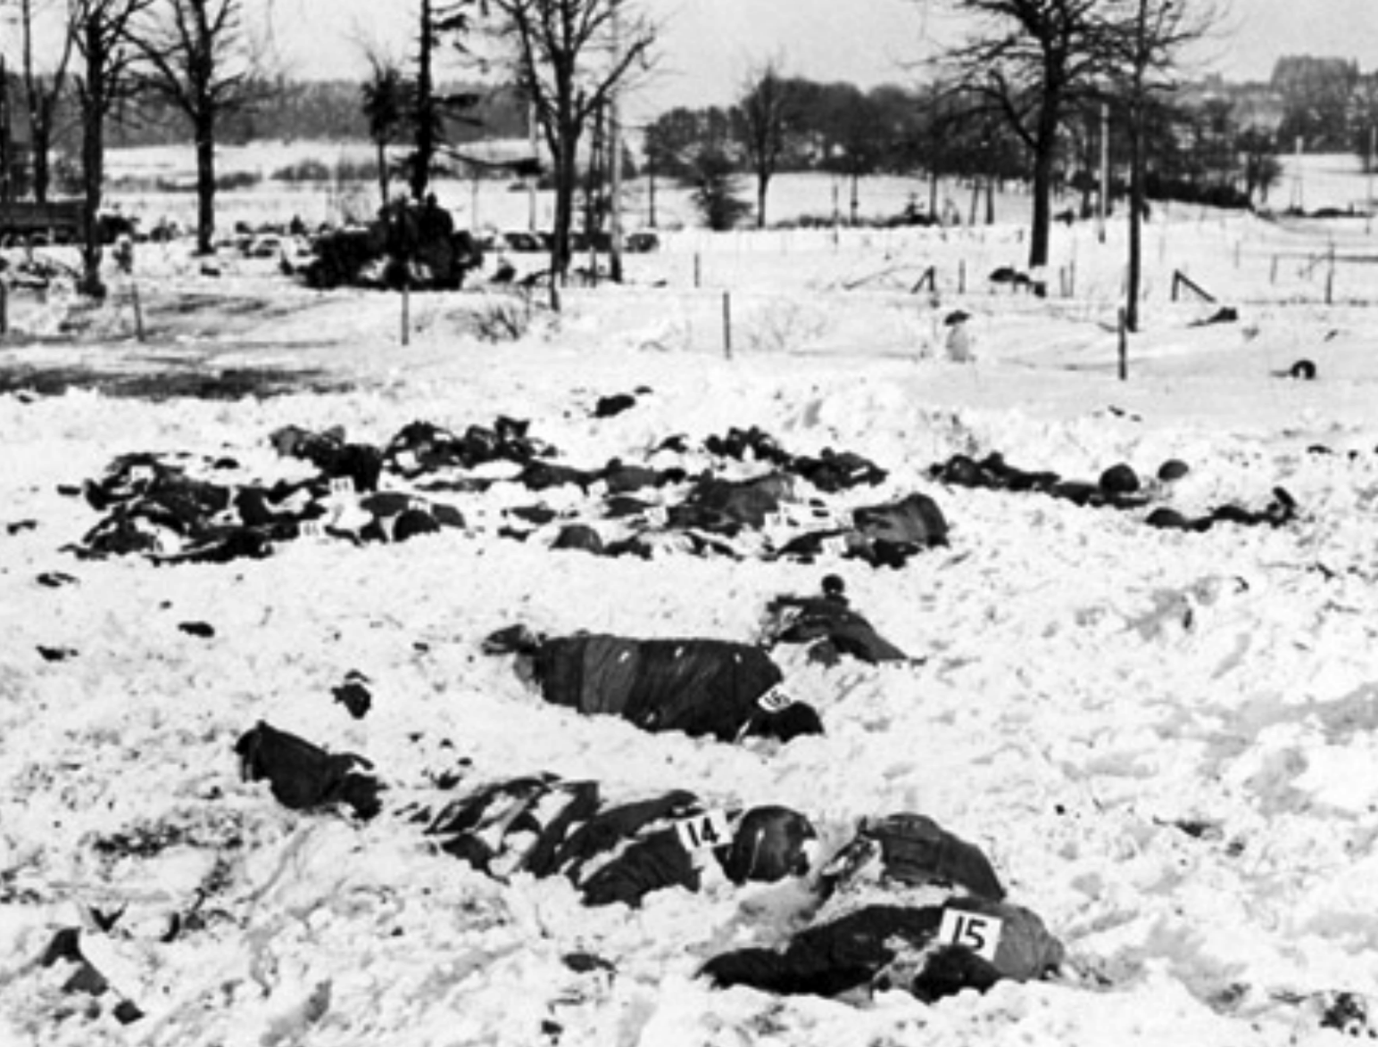
The massacre field at Malmady. German soldiers of the Kampfgruppe Peiper murdered at least 300 POWs and over 100 civilians in a dozen separate locations during their offensive.

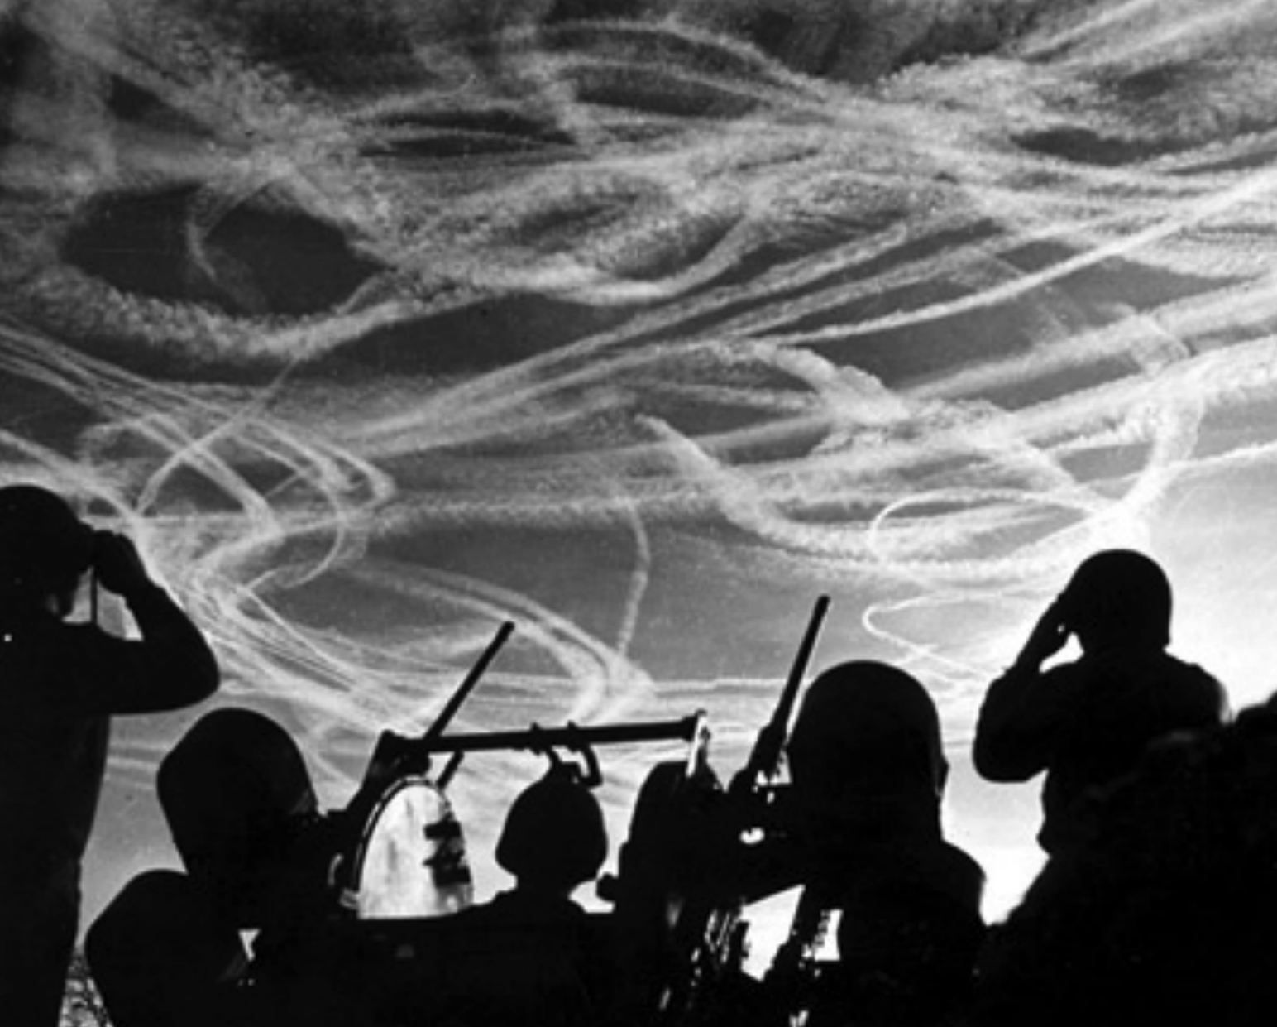
Alerted GIs of M-51 Anti-aircraft Battery are silhouetted against German sky streaked with vapor trails from allied and enemy planes engaged in Christmas Day dog-fight. Near Puffendorf, Germany.

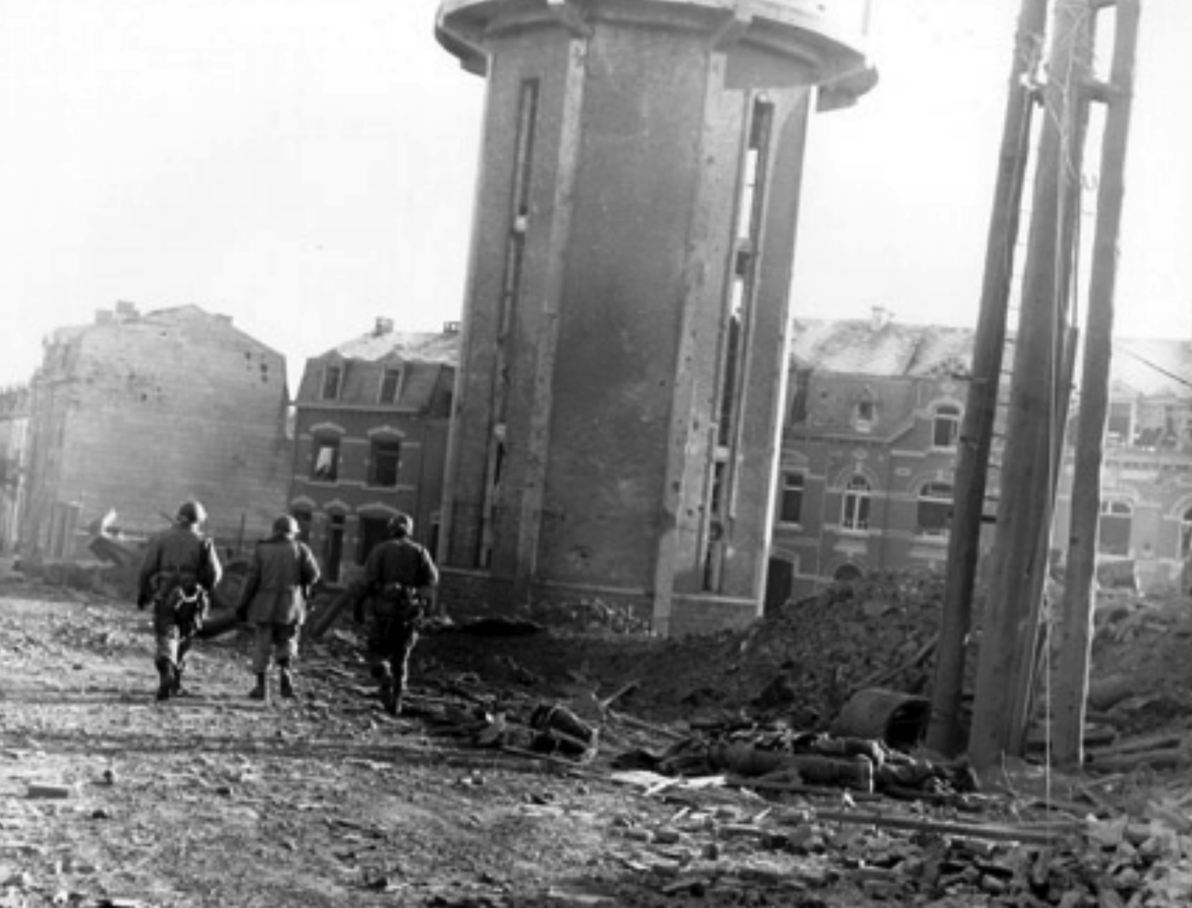
Members of the 101st Airborne Division walk past dead comrades killed during the Christmas Eve bombing of Bastogne. Ardennes Offensive 1944 - 45 taken 25 Dec 44

