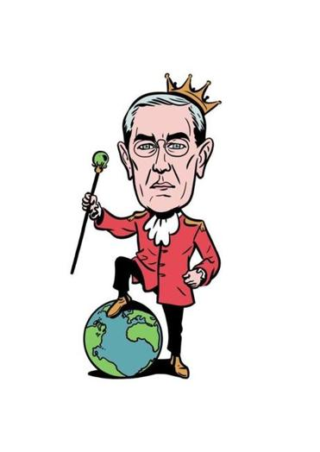
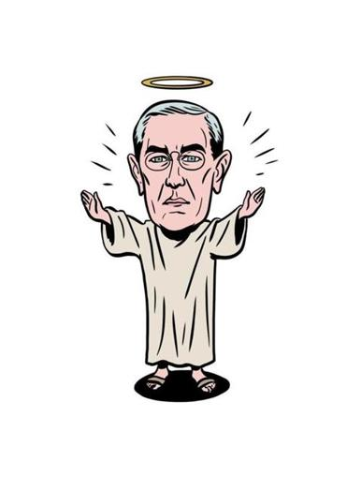
PrepUS History
Unit 7 – Changing America

10 ways of looking at Woodrow Wilson:
A century after taking office,
the 26th president is still a lightning rod.

By Jordan Michael Smith
Boston Globe
March 3, 2013

WOODROW WILSON took office on March 4, 1913, more than 100 years ago. He has never quite entered the pantheon of iconic presidents - no head on Mount Rushmore or memorial in Washington. Today, if anything, Wilson comes down to us as a bit bland and remote, a former university president and the bespectacled son of a Presbyterian minister. But in his day he was among the most controversial presidents in American history, sending millions of American troops to Europe in World War I and laying the groundwork for the United Nations.

In the century since his inauguration, the mild-looking Wilson has been labeled everything from Christ-like hero to Hitler-like villain. Today the argument over Wilson is still very much alive - and offers a striking picture of the wild swings and strange afterlife of political reputations.

Savior of Europe
After Wilson sent troops to aid the victory over Germany in WWI, the country had indisputably become a world power. When Wilson visited Europe to devise a peace treaty in 1918, 2 million French worshipers flooded the streets, and the mayor of Rome compared Wilson to Jesus Christ.

Hero of the Third World
Poor nations rejoiced when Wilson called for self-determination in a speech to Congress in 1917. People in Asia and Africa thought Wilson would deliver their dreams of security and freedom, in part because the United States, without a history of imperialism in the region, might liberate them from foreign masters.

Political failure
When Wilson failed to persuade Congress to join the League of Nations he had helped create, he “broke the heart of the world,” in his biographer’s phrase. In the 1920s and 1930s, political thinkers looked back and saw Wilson as responsible for the collapse of postwar peace. Wrote the economist John Maynard Keynes, “The disillusion was so complete, that some of those who had trusted most hardly dared speak of it.”

Anti-Communist hysteric
Though Wilson had initially been friendly to the Russian Revolution, his attitude changed once labor strikes, race riots, and anarchist attacks broke out across the United States in 1919. In response, Wilson’s attorney general deported left-wing activists, raided political groups, and arrested thousands. In the words of one historian, Wilson’s “legacy of repression lasted for decades”; his administration’s violation of civil liberties would provide a precedent for McCarthyism in the 1950s.

United Nations prophet
One man who didn’t see Wilson’s legacy as unsalvageable was his assistant Navy secretary, Franklin Roosevelt. FDR believed in Wilson’s vision of a global forum of countries ensuring peace through collective security, and eventually adapted the idea as the basis for the United Nations.

Iraq War architect
George W. Bush invaded Iraq in 2003, declaring his intention to democratize the country and spark a democratic revolution in the Middle East. Bush’s romantic rhetoric, if not his actions, were an updated version of Wilson’s. “Wilson would recognize George W. Bush as his natural successor,” wrote the historian David Kennedy in 2005. “Wilson’s ideas continue to dominate American foreign policy in the twenty-first century.”

Destructive naïf (a naive or ingenuous person)
To political science “realists,” a group that emerged in the late 1940s, Wilson’s belief that global violence could be prevented by laws and international negotiation rather than military deterrence was disastrously misguided. Thinkers such as Hans Morgenthau and George Kennan argued that whereas Winston Churchill saw that Hitler could be stopped only by strength, Wilson had fooled Americans into thinking they and Europe could avoid getting their hands dirty.

Imperialist
To some critics, including MIT professor Noam Chomsky, Wilson’s fingerprints were all over the Vietnam War. They saw his rhetoric about “making the world safe for democracy” as little more than a rationalization for imperialism, arguing that Wilson had led the United States into World War I primarily to maintain open European markets and intervened in South America to scare off challengers to US power.

Visionary
When the Cold War ended in the late 1980s, it seemed to demonstrate the universal power of the democratic ideal. Eastern Europeans brought down the Soviet Empire in large part because they wanted the self-determination and consensual government Wilson had promised them. Former critics now hailed his prescience. “I begin today in the light of just what has happened in the past few years to think that Wilson was ahead of his time,” said diplomat George Kennan in 1989.

Fascist
Of all Wilson’s reincarnations, that of a Hitler-like fascist is the most unusual. Yet that is how he was characterized in 2010 when radio show host Glenn Beck and the Tea Party pointed to Wilson as the man who put the United States on a path to mammoth-government tyranny. “The Nazis learned their propaganda from the progressive movement in the United States,” argued Beck. “They learned it from the progressives in America, Woodrow Wilson.”

Task: Now read the additional handout about Woodrow Wilson.

Highlight the GOOD things he did in YELLOW and the BAD things he did in RED (your opinion).

After reading about Wilson, do you believe he was a hero or villain? Why?

_____________________________________________________________________________________

_____________________________________________________________________________________

_____________________________________________________________________________________

_____________________________________________________________________________________

_____________________________________________________________________________________

_____________________________________________________________________________________

_____________________________________________________________________________________

