SOURCE #1

Visitor from Rotherham in 1801:
“The town is abominably filthy, the Steam Engine is pestiferous, the Dyehouses noisesome and offensive, and the water of the river as black as ink or the Stygian lake.”

Alexis de Tocqueville in the 1830s:
“From this foul drain, the greatest stream of human industry flows out to fertilize the world. From this filthy sewer pure gold flows. Here humanity attains its most complete development and its most brutish; here civilization works its miracles, and here civilized man is turned back almost into a savage.”

Hippolyte Taine in 1859:
“Manchester: a sky turned coppery red by the setting un; a cloud. Strangely shaped resting upon the plain; and under this motionless cover a bristling of chimneys by hundreds, as tall as obelisks. The a mass, a heap, blackish, enormous, endless rows of buildings; and you are there, at the heart of a Babel built of brick. . . .” “Earth and air seem impregnated with fog and soot. The factories extend their flanks of fouler brick one after another, bare, with shutterless windows, like economical and colossal prisons . . . and inside, lit by gas-jets and deafened by the uproar of their own labour, toil thousands of workmen, penned in, regimented, hands active, feet motionless, all day and every day, mechanically serving their machines. . . .” “What dreary streets! Through half-open windows we could see wretched rooms at ground level, or even below the damp earth’s surface. Masses of livid children, dirty and flabby of flesh, crowd each threshold and breathe the vile air of the street, less vile than that within. . . . Even to walk in the rich quarter of the town is depressing. . .

SOURCE #2

Quoted from Pike, Human Documents of the Industrial Revolution in Britain, 60-61, by Duiker and Spielvogel, World History, 780.

“In the centre of this street there is a gutter into which potato parings, the refuse of vegetable and animal matter of all kinds, the dirty water from the washing of clothes and of the houses are all poured, and where they stagnate and putrify . . . all the lanes and alleys of the neighborhood pour their contents into the centre of the main street . . . . Families live in the cellars and kitchens of these undrained houses.”

“Not only is there not a breath of sweet air in these truly infernal scenes, but . . . there is the abominable and pernicious stink of the gas to assist in the murderous effects of the heat. In addition to the noxious effluvia of the gas, mixed with the steam, there are the dust, and what is called cotton-flyings or fuz, which the unfortunate creatures have to inhale; and . . . the notorious fact is that well constitutioned men are rendered old and past labour at forty years of age, and that children are rendered decrepit and deformed, and thousands upon thousands of them slaughtered by consumptions, before they arrive at the age of sixteen. “

SOURCE #3
Two Women Miners From Great Britain, Parliamentary Papers, 1842, Vol. XV, p. 84, and ibid., Vol. XVII, p. 108.
Betty Harris, age 37: I was married at 23, and went into a colliery when I was married. I used to weave when about 12 years old; can neither read nor write. I work for Andrew Knowles, of Little Bolton (Lancs), and make sometimes 7s a week, sometimes not so much. I am a drawer, and work from 6 in the morning to 6 at night. Stop about an hour at noon to eat my dinner; have bread and butter for dinner; I get no drink. I have two children, but they are too young to work. I worked at drawing when I was in the family way. I know a woman who has gone home and washed herself, taken to her bed, delivered of a child, and gone to work again under the week.
I have a belt round my waist, and a chain passing between my legs, and I go on my hands and feet. The road is very steep, and we have to hold by a rope; and when there is no rope, by anything we can catch hold of. There are six women and about six boys and girls in the pit I work in; it is very hard work for a woman. The pit is very wet where I work, and the water comes over our clog-tops always, and I have seen it up to my thighs; it rains in at the roof terribly. My clothes are wet through almost all day long. I never was ill in my life, but when I was lying in.
My cousin looks after my children in the day time. I am very tired when I get home at night; I fall asleep sometimes before I get washed. I am not so strong as I was, and cannot stand my work so well as I used to. I have drawn till I have bathe skin off me; the belt and chain is worse when we are in the family way. My feller (husband) has beaten me many a times for not being ready. I were not used to it at first, and he had little patience.
I have known many a man beat his drawer [a child or woman employed by a coal miner to transport the coal that they had mined]. I have known men take liberties with the drawers, and some of the women have bastards.
Patience Kershaw, age 17, Halifax: I go to pit at 5 o’clock in the morning and come out at 5 in the evening; I get my breakfast, porridge and milk, first; I take my dinner with me, a cake, and eat it as I go; I do not stop or rest at any time for the purpose, I get nothing else until I get home, and then have potatoes and meat, not every day meat.

SOURCE #4
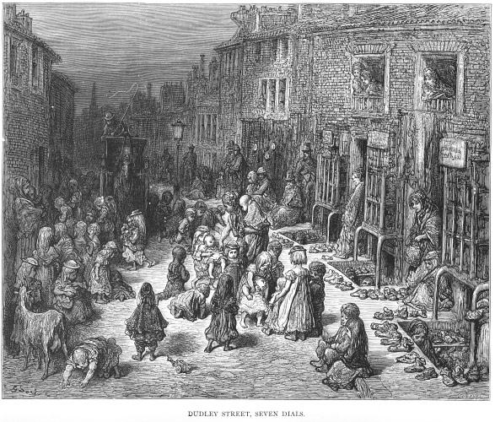
SOURCE #4
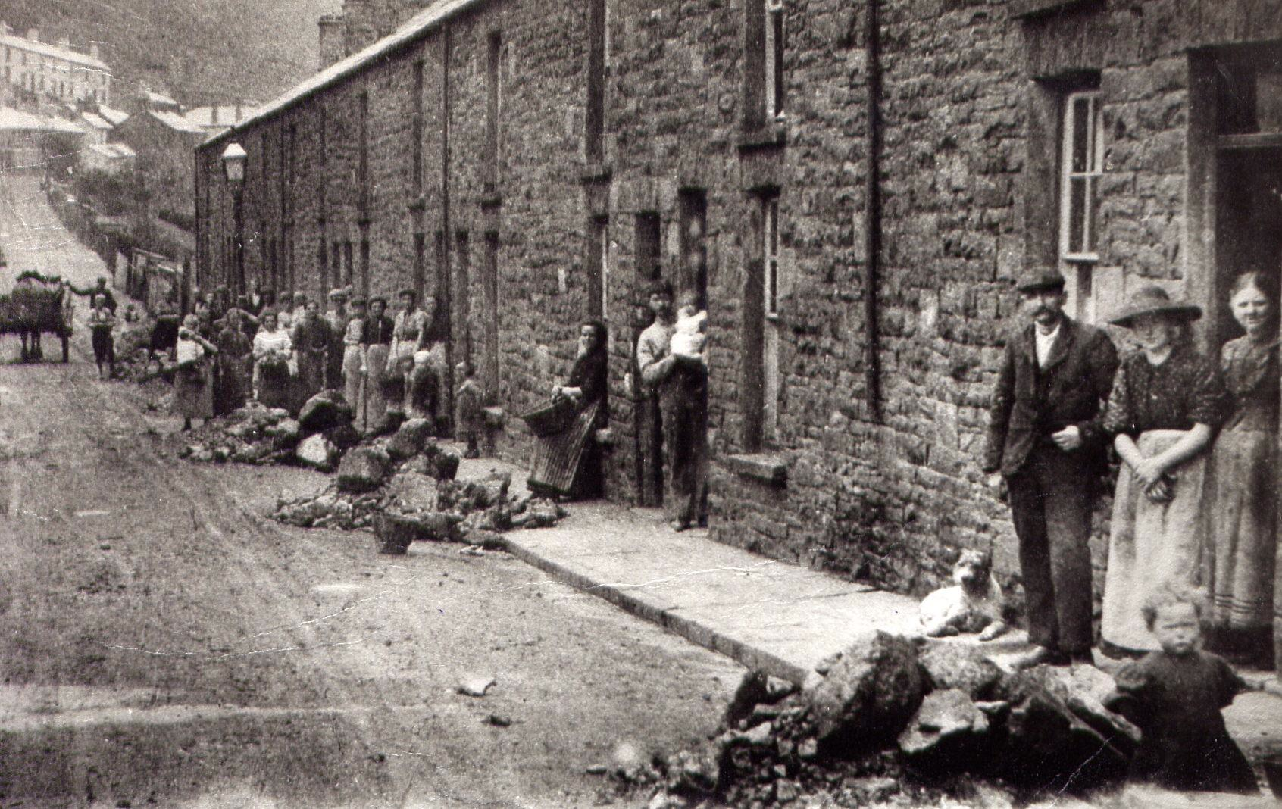

SOURCE #4
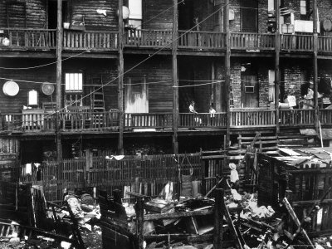

SOURCE #5

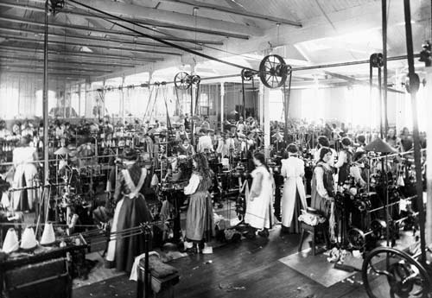

SOURCE #5
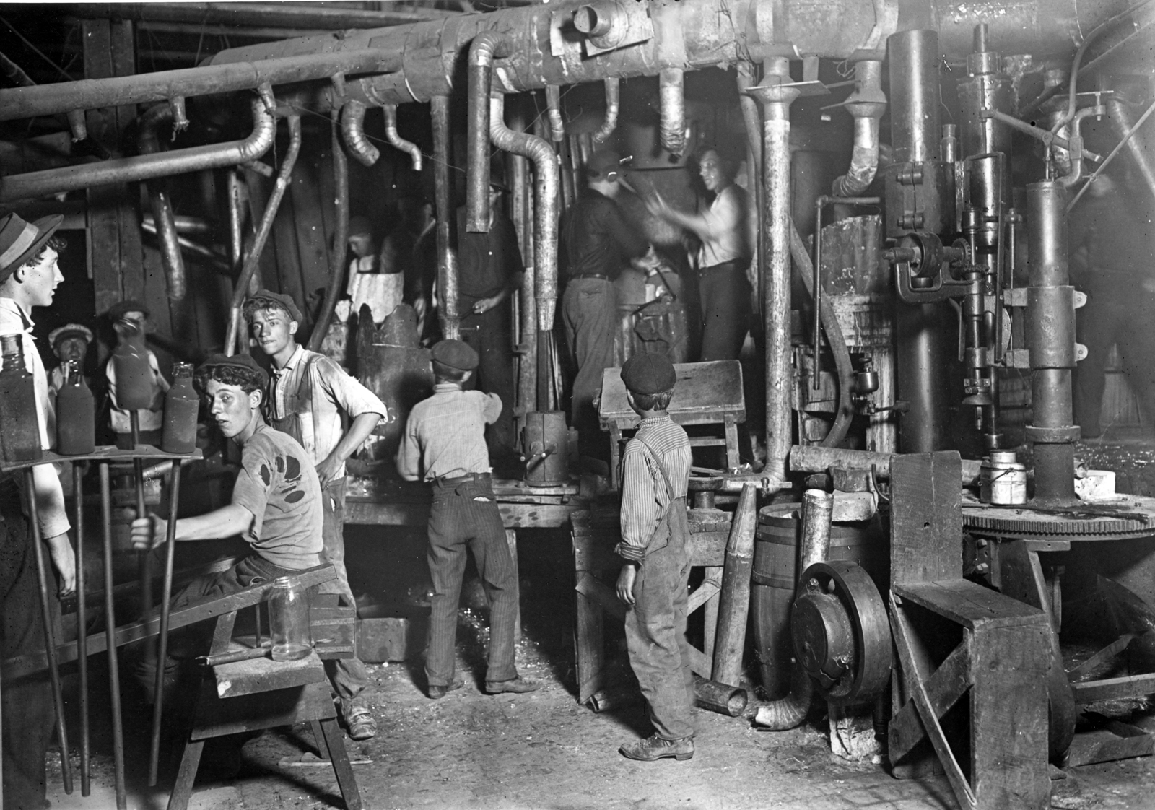

SOURCE #5
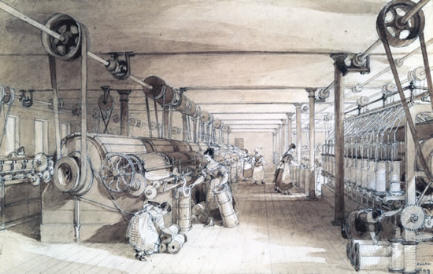

SOURCE #6
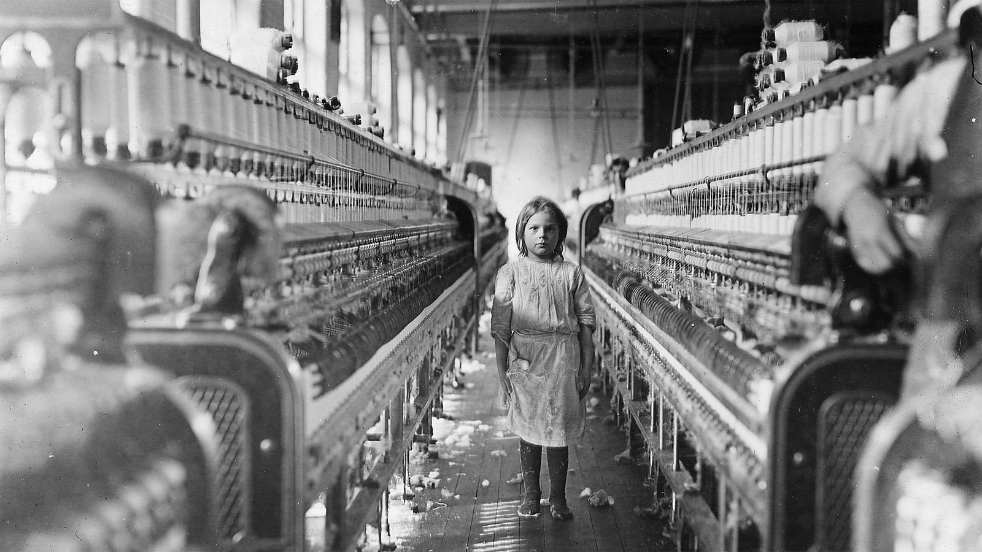

SOURCE #6
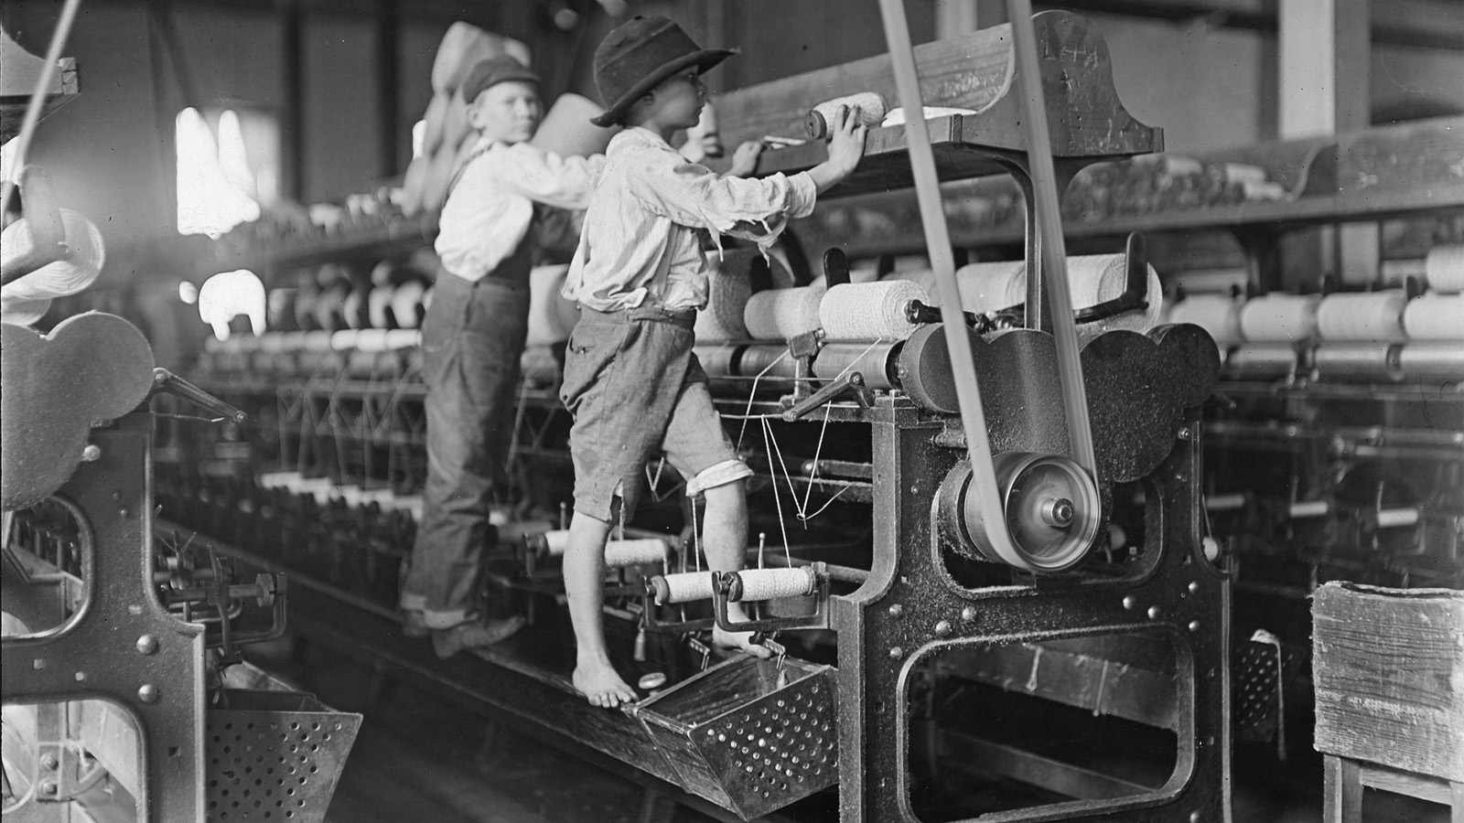

SOURCE #6
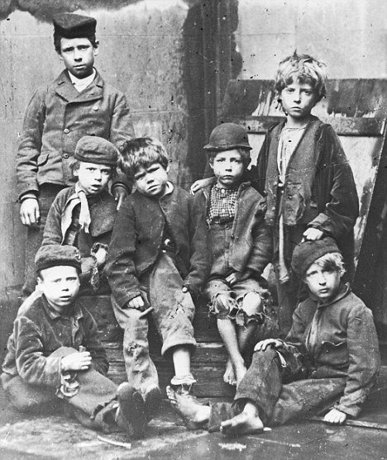

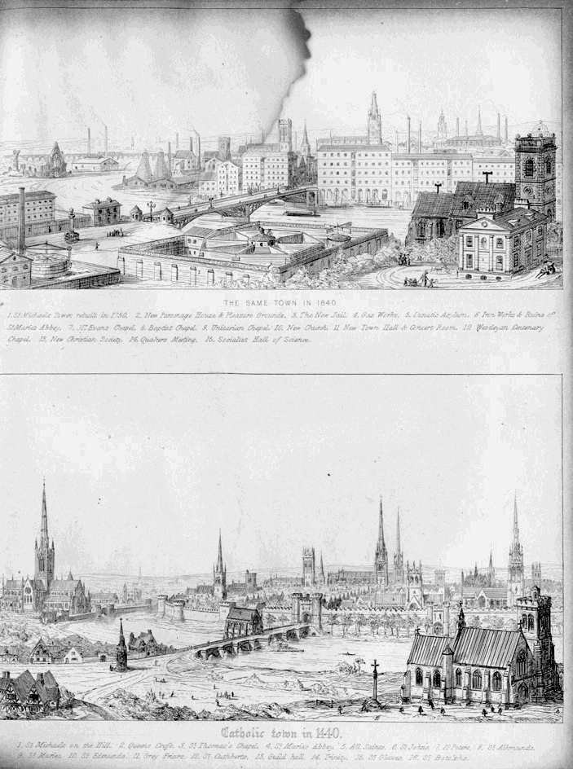
SOURCE #7

SOURCE #7
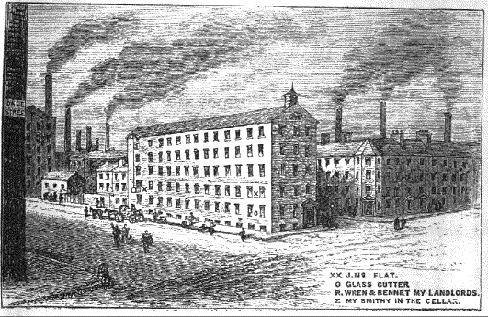

SOURCE #8

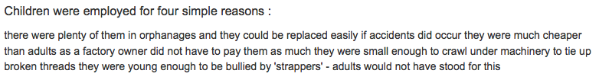

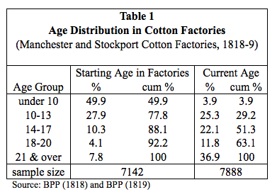

A Manchester manufacturer described to Robert Southey of the benefits of child labor.
“You see these children, sir. They get their bread almost as soon as they can walk about, and by the time they are seven or eight years old bring in money. There is no idleness amongst us; they come at five in the morning, we allow them half an hour for breakfast, and an hour for dinner; they leave work at six, and another set relieves them for the night; the wheels never stand still.”

