PrepUS History
Unit 6 – America Expands
John D. Rockefeller: Robber Baron or Captain of Industry?

John D. Rockefeller was born in 1839 in the small town of Moravia in western New York. His father practiced herbal medicine, professing to cure patients with remedies he had created from plants in the area. John’s mother instilled a devout Baptist faith in the boy, a belief system he took to his grave. After graduating from high school in 1855, the family sent him to a Cleveland business school.

Young John Rockefeller entered the workforce on the bottom rung of the ladder as a clerk in a Cleveland shipping firm. Always thrifty, he saved enough money to start his own business in produce sales. When the Civil War came, the demand for his goods increased dramatically, and Rockefeller found himself amassing a small fortune.

He took advantage of the loophole in the Union draft law by purchasing a substitute to avoid military service. When Edwin Drake discovered oil in 1859 in Titusville, Pennsylvania, Rockefeller saw the future. He slowly sold off his other interests and became convinced that refining oil would bring him great wealth.

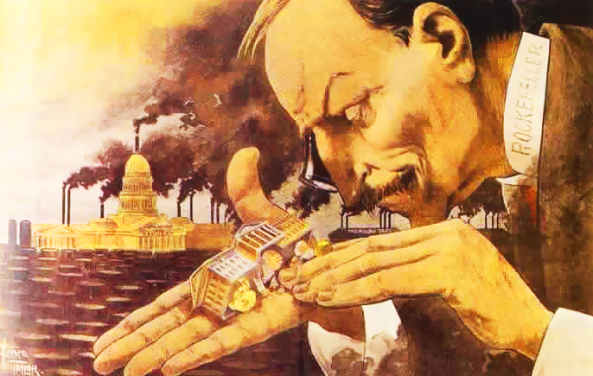
“What a Funny Little Government!”
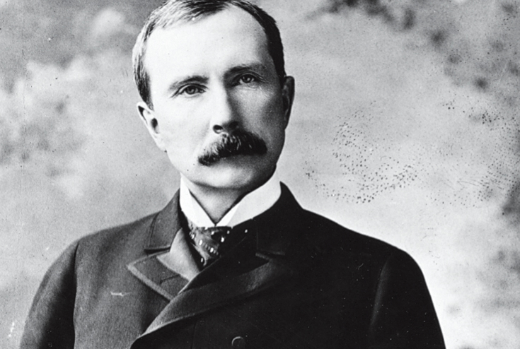
Cartoonist Horace Taylor pokes fun at John D. Rockefeller in this cartoon which appeared in 1899 in the magazine The Verdict.
John D. Rockefeller (1839-1937) was
America’s first billionaire.

Rockefeller introduced techniques that totally reshaped the oil industry. One of the most valuable by-products of the oil refining process was kerosene, which was usually sold off to the highest bidder. But this was not the only product that was marketable, and what others saw as waste, Rockefeller saw as gold. He sold paraffin to candlemakers, petroleum jelly he sold to medical supply companies, and other by-products as paving materials for roads. He shipped so many of these by-products to buyers that railroad companies drooled over the prospect of getting his business.

Because he was paying for so many goods to be transported by the railroads, Rockefeller demanded (and received) rebates, or discounted shipping rates. All of these money-making schemes allowed him to reduce the price of oil to his consumers – which increased their consumption. His profits soared and his competitors in the oil industry were crushed, one by one. As they began to go broke, Rockefeller forced these smaller companies to surrender their stock to his control. This sort of arrangement is called a trust, or a combination of businesses formed by legal agreement. Trusts often reduce fair business competition. As a result of Rockefeller’s shrewd business practices, his large corporation, the Standard Oil Company, became the largest business in the land.
As the new century dawned, Rockefeller’s investments mushroomed. With the advent of the automobile, gasoline replaced kerosene as the number one petroleum product and through the sales of gasoline, Rockefeller officially became a billionaire.

Standard Oil — a Trust-worthy Company?

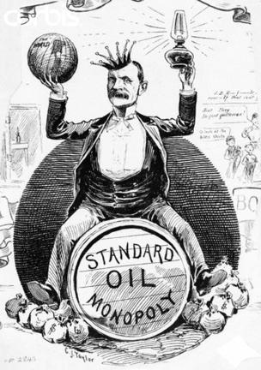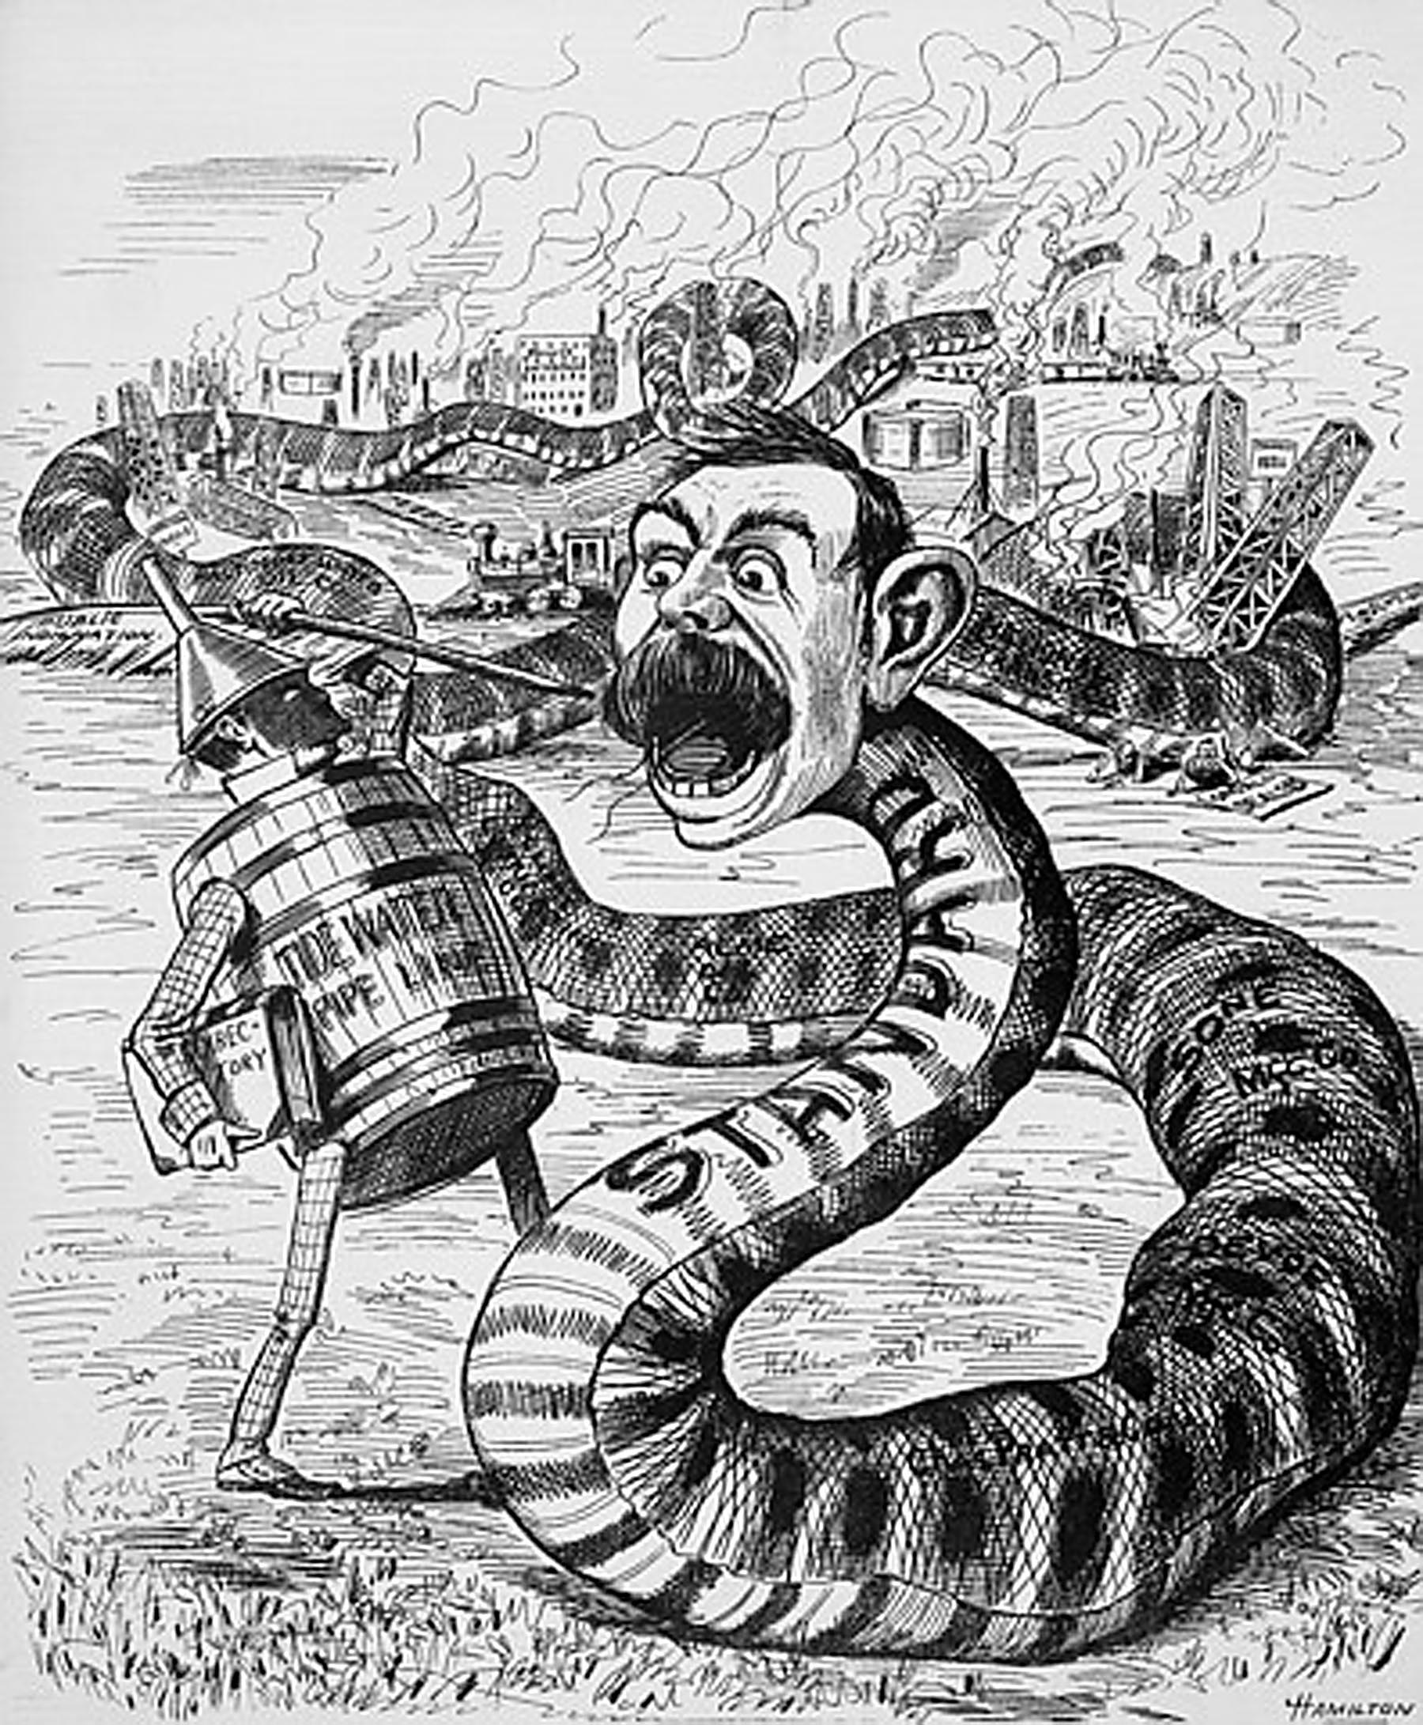

Rockefeller’s critics charged that his labor practices were unfair and employees pointed out that he could have paid his workers a fairer wage and settled for being a half-billionaire. Many called him a Robber Baron, or an American capitalist at the turn of the 19th century who enriched himself upon the sweat of others, exploited natural resources, or possessed unfair government influence. At that time that the average worker earned $8 to $10 per week, Rockefeller earned millions per year.

Supporters pointed out that in a pure sense, the goal of any capitalist was to make money. And John D. Rockefeller could serve as the poster child for capitalism. Overcoming humble beginnings, Rockefeller had the vision and the drive to become the richest person in America. And before his death in 1937 he had given away nearly half of his fortune. Churches, medical foundations, universities, and centers for the arts received hefty sums of oil money. Whether he was driven by good will, conscience, or his devout faith in God is unknown. Regardless, he became a hero to many enterprising Americans.

John D. Rockefeller had to perform a delicate balancing act to maintain his reputation as a philanthropist while living the live of a wealthy businessman. Is he to be placed on a pedestal for others as a “Captain of Industry” or should he be demonized as a “Robber Baron?”

