PrepUS History
Unit 5 – The Civil War
Glory Movie Questions
Main Characters:
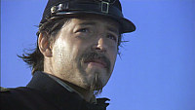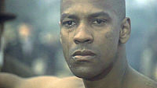
Col. Robert Gould Shaw (Matthew Broderick) Pvt. Trip (Denzel Washington)

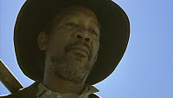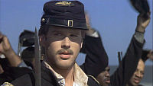
Sgt. Maj. John Rawlins (Morgan Freeman) Maj. Cabot Forbes (Cary Elwes)

Directions: You may answer the questions on another sheet of paper OR in the space provided. Be sure to answer each question thoroughly.

1. Where was Robert Shaw before and during the battle of Antietam?

2. What was Rawlins’ job?

3. Why did Col. Shaw and his majors have trouble forming companies of the men?

4. What was the Confederate Proclamation about “negroes” captured with arms? In uniform? What would happen to a white officer leading these soldiers?

5. What was the first military-issued supply the troops received? How did they react?

6. Why did Thomas have so much difficulty adjusting to military life?

7. Why was the standard military discipline measure for deserters especially difficult for the men of the 54th to deal with emotionally? Why was Trip deserting?

8. What change was made in regard to the troops’ pay? What was their reaction? What was the reaction of the white officers?

9. What honor was bestowed upon Rawlins?

10. Describe the difference between Montgomery’s “Contraband” regiment and the 54th.

11. Why did Shaw agree to have his men fire the town?

12. What did Shaw have to do to make sure that the 54th finally got into battle? How did they do in the battle of St. James Island?

13. What caution was given to the unit that would lead the attack on Fort Wagner?

14. Why is the fact that Shaw dismounted before the attack on Fort Wagner important?

15. Who picked up the flag when it fell and why was this person an unlikely one to do it?

16. What is important and/or symbolic about the fact that Trip and Shaw were buried next to each other?

