PrepUS History
Unit 6 – America Expands
Andrew Carnegie: Robber Baron or Captain of Industry?
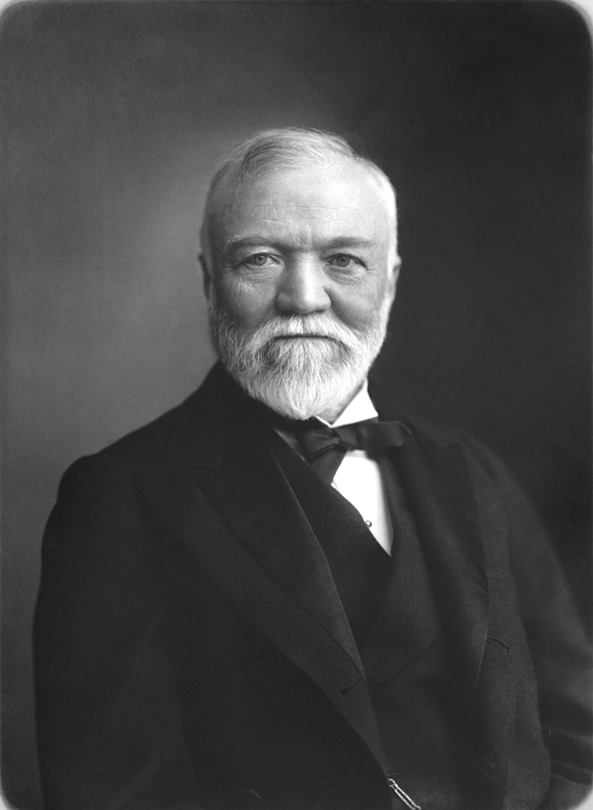
Born in Scotland, Andrew Carnegie (1835–1919) emigrated to the United States with his family when his father could no longer find work. They settled near Lake Erie, and Carnegie - only 13 - began working in a textile mill. He regretted not having had the chance to gain an education, so he took advantage of the offer of a local man who said he would provide access to his personal library to any working boys in the area. Carnegie borrowed more books than anyone else, maintaining his wide reading all his life.

Carnegie’s main goal, however, was to rise on the job. He became a telegraph messenger and gained attention by learning how to decipher messages by sound; he was promoted to telegraph operator. Soon a top manager in the Pennsylvania Railroad hired him as his personal secretary. Carnegie was only 18.

He advanced through many positions at the railroad, eventually taking his former boss’s job as head of the Pittsburgh division by age 30. He helped organize troop transportation and telegraph systems used in the Civil War. After the war, Carnegie resigned from the railroad and started his own company to build iron bridges. Railroad contacts helped him win business, and his company thrived.

By 1873, Carnegie was ready to launch a new business: making steel. He formed the Carnegie Company and led it to success. With strong organizational skills and a knack for spotting and promoting talent, Carnegie built a huge empire. His assistant, Henry Clay Frick, helped manage the Carnegie Steel Company on its way to success.

Carnegie became a tycoon because of shrewd business tactics. He bought other steel companies to eliminate competition. He also bought railroad companies and iron mines; if he owned the rails and mines, he could reduce his costs and produce cheaper steel.

He was committed to improving technology whenever possible. Shrewdly, he chose recessions as the time to improve his factories. The improvements cost less then, and when the economy improved he was ready to produce steel more cheaply than competitors. The strategy worked: his company earned $40 million in profits in 1900, of which $25 million was his.
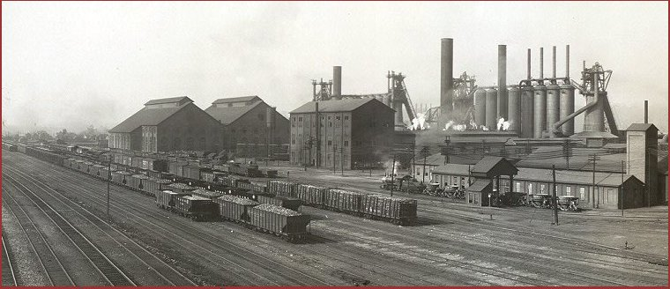
Carnegie also wanted productive workers. He wanted them to feel that they had a vested interest in company prosperity so he initiated a profit-sharing plan. All these tactics made the Carnegie Steel Company a multi-million dollar corporation.

Carnegie lost some of his good name in the Homestead strike of 1892. Steel workers were shut out of one of his plants and lost their jobs. Although he did not direct the company’s actions, he did nothing to help the situation, which cost him public support.

In 1889, he published an article called “Wealth,” also known as “The Gospel of Wealth.” In his essay, Carnegie argued that after accumulating a fortune, a wealthy man had a duty: he should use some of his money for “the improvement of mankind.” He sold his steel company in 1901 to J.P. Morgan, who paid him 500 million dollars to create U.S. Steel.

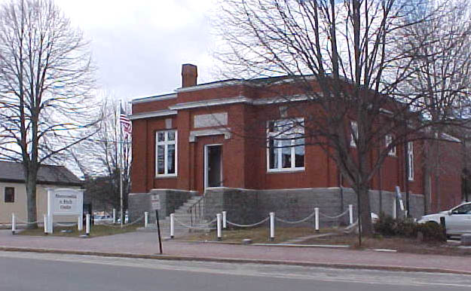
Carnegie donated about $350 million to various causes. More than a third went to endow the Carnegie Corporation, which could continue his generosity beyond his death. He gave some $20 million to U.S. colleges and another $10 million to Scottish universities. He created the Carnegie Institute of Pittsburgh, which had a library, an art museum, and a music hall, and the Carnegie Institute of Washington for science research. He also gave $60 million to create more than 3,000 public libraries. (Formerly the B. H. Bartol Library in Freeport, the library pictured above was closed in 1997 when a new library was built. It is now a private business, Abercrombie & Fitch.)

Carnegie wrote and spoke, hoping to spread his ideas about success and the responsibilities of the successful. He told students at a Pittsburgh business school how to succeed: “The rising man must do something exceptional, and beyond the range of his special department.” Carnegie spent most of the rest of his life fulfilling this “gospel.”

“Make no effort to increase fortune, but spend the surplus each year for benevolent purposes.
Cast aside business for ever, except for others.”
~Andrew Carnegie, memo to himself (1868)~

