PrepUS History
Unit 4 – The Nation Grows
Andrew Jackson Reading and Questions

DIRECTIONS: Read the following information about President Andrew Jackson. Find the answers to questions 1-10 in the text and underline the passages that contain the answers. Then write the answers in complete sentences in the spaces provided. You will then use the documents provided to answers questions 11-15 in complete sentences.

Andrew Jackson had become a respected figure in the United States after his decisive victory at the Battle of New Orleans during the War of 1812. His resilience as a military leader earned him the nickname, Old Hickory. Jackson was also known to Americans as the Common Man. Unlike previous presidential candidates, Jackson was born west of the Appalachian Mountains into a less fortunate home. This made him relatable and inspiring to most Americans, and brought hope that ordinary citizens could have an impact in the United States government.

Why was Andrew Jackson known as the Common Man?

_____________________________________________________________________________

_____________________________________________________________________________

_____________________________________________________________________________

After his controversial loss in the 1824 presidential election, Jackson and his supporters formed the Democrat party and campaigned throughout the United States to ensure that he would win the 1828 election, which he did. During the 1828 presidential election, voting rights had been expanded and more people voted than ever before. No longer did males have to own land to vote in presidential elections. The hope of Jackson becoming president and his campaign efforts encouraged more men to take advantage of their new voting opportunities than ever before. Therefore, in the election of 1828, approximately 1.1 million people voted in comparison with 350,000 voters in the election of 1824. In 1829, Andrew Jackson, with an intense belief of true democracy, was inaugurated as the President of the United States.

Andrew Jackson was the leader of what political party?
_____________________________________________________________________________

_____________________________________________________________________________

_____________________________________________________________________________

How did Andrew Jackson encourage more people to vote in the presidential election?
_____________________________________________________________________________

_____________________________________________________________________________

_____________________________________________________________________________

Continuing his quest to create a strong national government ruled by the people and their needs, Jackson instituted a spoils system. A spoils system is the practice of rewarding supporters with government jobs. Jackson replaced an estimated 10% of government officials with his supporters, despite their experience in the government. He even appointed many inexperienced supporters with Cabinet positions. According to Jackson, he wanted to provide ordinary citizens with the opportunity to take part in the government.

Define spoils system.
_____________________________________________________________________________

_____________________________________________________________________________

_____________________________________________________________________________

Prior to his inauguration, Jackson already opposed the National Bank. He believed that the National Bank was unconstitutional and that it was only beneficial for the wealthy, including the bank’s president, Nicholas Biddle. The National Bank was first chartered under Washington, and its’ charter was renewed under Madison. The bank’s charter was up for renewal again as Jackson was running for re-election. Although many supporters of the bank believed that Jackson would approve the renewal in order to ensure his re-election, Jackson vetoed the bank bill and closed the National Bank. The bank veto was the first presidential veto utilized on a government law/action that was not deemed unconstitutional. Under Washington, the National Bank was proven constitutional as part of the Elastic Clause (Necessary and Proper Clause). As a result, many supporters of the National Bank view Jackson’s veto as an abuse of his presidential powers.

Why did Andrew Jackson oppose the National Bank?
_____________________________________________________________________________

_____________________________________________________________________________

_____________________________________________________________________________

How did Jackson close the National Bank?
_____________________________________________________________________________

_____________________________________________________________________________

_____________________________________________________________________________

In addition to the controversy that surrounded the bank veto, Jackson’s use of power was also criticized in 1830 with his approval of the Indian Removal Act. For years, Native Americans had been displaced from the land they had inhibited for decades. Despite territory treaties signed between Americans and Native Americans, Americans felt entitled to the land. Many Native American tribes living in newly acquired Florida attempted to resist displacement from their land, and even were supported by the Supreme Court. In 1828, the Supreme Court decided that the Native Americans’ right to stay in their land was protected under the Constitution. This case was known as Worcester vs. Georgia. However, despite the Supreme Court ruling, Andrew Jackson was determined to rid the Native Americans of Florida and provide American farmers with more economic opportunity. In 1830, with Jackson’s approval, Congress passed the Indian Removal Act, which forced Native Americans to relocate to designated territory west of the Mississippi River. Native American tribes, including the Cherokee, refused to comply with the Indian Removal Act because of the support of the Supreme Court. Nevertheless, in 1838 Jackson sent the military to Florida to forcefully remove the Cherokee from Florida. The forced removal of over 15,000 Cherokee west of the Mississippi River became known as the Trail of Tears because of the thousands of Cherokee that died throughout the journey
west. Critics of Jackson considered the Indian Removal Act to be an abuse of power by Jackson, because he directly went against the decision made by the Supreme Court.

What decision was made as a result of the Worcester vs. Georgia Supreme Court case?
_____________________________________________________________________________

_____________________________________________________________________________

_____________________________________________________________________________

What was the Indian Removal Act?
_____________________________________________________________________________

_____________________________________________________________________________

_____________________________________________________________________________

Why was the Indian Removal Act considered to be controversial?
_____________________________________________________________________________

_____________________________________________________________________________

_____________________________________________________________________________

What was the Trail of Tears?
_____________________________________________________________________________

_____________________________________________________________________________

_____________________________________________________________________________

Use the documents to help you answer the questions that follow.

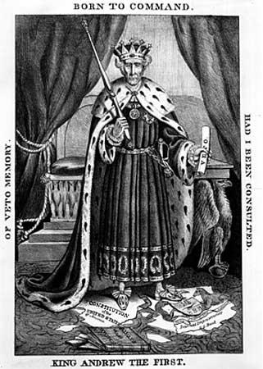
In the picture to the left, Andrew Jackson is holding the presidential power of a veto in his hand. Identify a controversial veto that Jackson used during his presidency.

____________________________________

____________________________________

____________________________________

____________________________________

____________________________________

____________________________________

____________________________________

____________________________________

Identify and explain one action or decision made by Jackson that would lead his critics to compare him to a king.

____________________________________

____________________________________

____________________________________

______________________________________________________________________________

______________________________________________________________________________

Worcester vs. Georgia-1828
The Cherokee nation... is a[n] [individual] community, occupying its own territory... in which the laws of Georgia have no force [to make the tribe leave].... The [actions] of Georgia are [disgusting] to the Constitution, laws, and treaties of the United States. They interfere forcibly with the relations established between the United States and the Cherokee Nation, the regulation of which according to the settled principles of our Constitution, are committed exclusively to the government of the [United States of America].
~Marshall, C.J., Opinion of the Court, Supreme Court of the United States, 31 U.S. 515

What decision did the Supreme Court make in the Worcester vs. Georgia case?

______________________________________________________________________________

______________________________________________________________________________

______________________________________________________________________________

______________________________________________________________________________

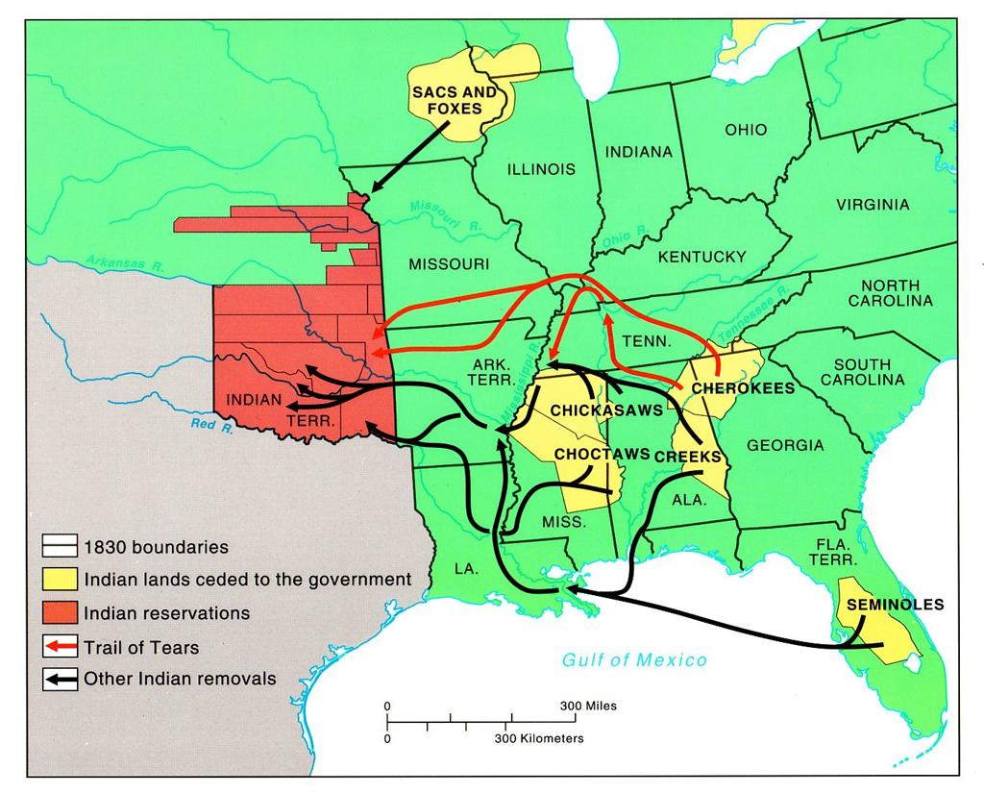
According to the map, what Native Americans tribes were forced to leave Florida and relocate west of the Mississippi River?

________________________

________________________

________________________

________________________

________________________

________________________

________________________

________________________

What law passed by Congress, under Andrew Jackson, forced the Native American tribes to relocate west of the Mississippi River?

______________________________________________________________________________

______________________________________________________________________________

______________________________________________________________________________

______________________________________________________________________________

