PrepUS History

Unit 3 – The Constitution

The Constitution Is Formed

**Directions:** Read the handout thoroughly.

**The Constitutional Convention**

The American Revolution had not created a united country. Some leaders liked strong, independent state governments. Other leaders wanted a strong national government. They wanted to change the Articles of Confederation. Two of these leaders were James Madison and Alexander Hamilton.

In September 1786, Hamilton called for a convention in Philadelphia to talk about trade issues. He also suggested that people at the convention should talk about how to change the Articles of Confederation.

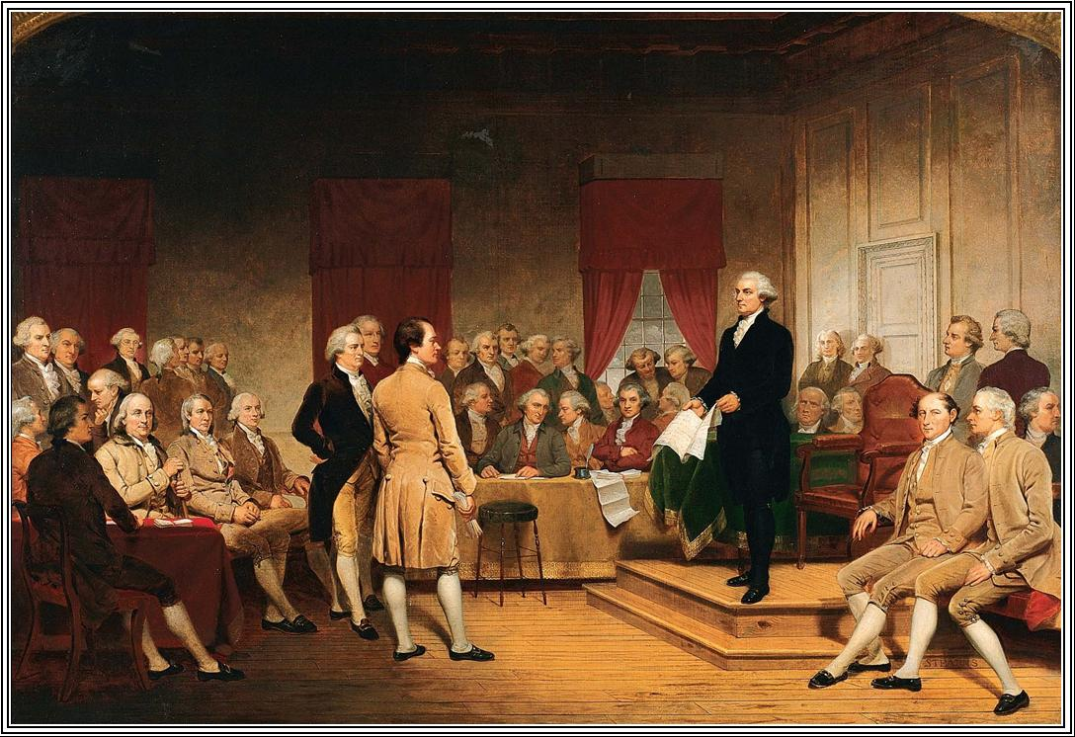The convention began in May 1787. George Washington and Benjamin Franklin were among those who attended. This helped people trust the convention’s work. Trust was important because the convention's purpose was to create an entirely new constitution. The delegates chose George Washington to lead the meetings.

Edmund Randolph of Virginia surprised the delegates at the convention. He proposed a plan created by James Madison, called the Virginia Plan. The Virginia plan would set up a strong national government. It would create a government with three branches. There would be a bicameral legislature, a chief executive chosen by the legislature, and a court system.

The plan also called for the number of members in both houses of the legislature to be proportional. The number of members would be based on each state's population. States with more people would have more representatives than states with fewer people.

Delegates from small states were against the Virginia Plan. They wanted all states to have equal representation. They supported the New Jersey Plan. Under the New Jersey plan, the legislature would be a one-house legislature. Each state would have one vote in the legislature.

**Agreeing to Compromise**

The delegates agreed to create a new constitution based on the Virginia Plan. The delegates still needed to deal with the issue of representation.

Roger Sherman came up with an agreement called the Great Compromise. A compromise is an agreement between two or more sides. Each side gives up some of what it wants. The Great Compromise called for a bicameral legislature. Each state would have two members in the Senate. The number of members in the House of Representatives would be based on the size of each state's population.

Southern states wanted to count enslaved people as part of their population. This would raise their population. It would give them more seats in Congress, and it would raise their taxes. Northern states did not want the South to count its enslaved people. The delegates agreed to the Three-Fifths Compromise. Each enslaved person would count as three-fifths of a free person. Northerners also agreed not to block the slave trade until 1808.

George Mason wanted more protection for citizens' rights. He asked for a bill of rights to part of the Constitution. Many delegates felt that the Constitution already protected people’s rights.

On September 17, 1787, the delegates gathered to sign the new Constitution. The Constitution was then sent to the states for approval. The new Constitution would take effect when 9 of the 13 states approved it.

**Creating the Constitution**

The Articles of Confederation had given most power to the states. The Constitution changed this. States had to give up some of their powers to the federal, or national, government. The Constitution was set up so federal and state governments share power. This is called Federalism.

The Constitution gave new powers to the federal government. It could tax, manage trade, control the supply of money, form an army, and declare war. The federal government could pass laws it decided were “necessary and proper.”

The Constitution let states keep some important powers. The states could still control trade inside their borders. They had the power to set up local governments and schools. States also made laws about marriage and divorce.

The Constitution allows some powers to be shared by the federal and state governments. Both the federal and state governments may tax their citizens. Both governments may arrest and punish criminals.

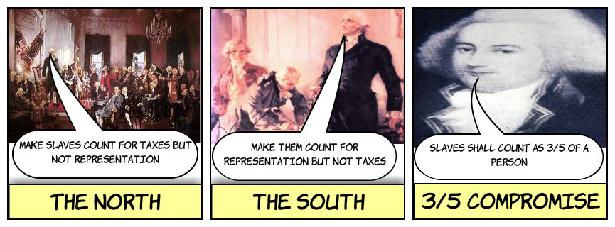The Constitution is the supreme, or highest, law of the land. Any disagreement between the federal government and the states was to be settled by the federal courts. They make decisions based on what the Constitution says.

**Government Structure**

The Framers of the Constitution divided the federal government into three branches. These are the legislative, executive, and judicial branches. The first three articles, or sections, of the Constitution explain the powers and tasks of these branches of the federal government.

Article I says the legislative (LEH•juhs•lay•tiv) branch, or lawmaking branch of the federal government is Congress. Congress has two parts: the Senate and the House of Representatives. Congress's powers include such tasks as deciding how much taxes will be, minting coins, and controlling trade.

Article II describes the executive branch. The president is in charge of this branch. The president's job is to carry out the nation's laws. A group called the Electoral (ee•lehk•TAWR•uhl) College elects the president and vice president. Its members are called electors. Electors are chosen by the voters of each state.

Article III describes the judicial (joo•DIH•shuhl) branch, or the court system. The Supreme Court is the top court in the nation. Congress sets up federal courts under the Supreme Court. Federal courts make decisions on cases that have to do with the Constitution, with federal laws, and with problems between states.

The Framers built in a system of checks and balances. Each branch of government has ways to check, or limit, the power of the others. This way, no branch can have too much control in the government.

**Debate and Adoption**

The Constitution could take effect after nine states ratified, or approved, it. People who supported the Constitution were called Federalists. James Madison, Alexander Hamilton, and John Jay were among the Federalists. They wrote a set of essays, called the Federalist Papers. The Federalist Papers explained and defended the Constitution.

People who did not like the new Constitution were called Anti-Federalists. They were afraid that a strong national government would take away freedoms. Anti-Federalists wanted local governments to have more power.

By June 21, 1788, the ninth state ratified the Constitution. That meant the new government could go into effect. New York and Virginia, the two largest states, still had not approved the Constitution.

People worried that the new government would not succeed if those states did not ratify the Constitution. Virginia ratified after it was promised that there would be a bill of rights amendment. The Bill of Rights was added in 1791. New York, North Carolina, and Rhode Island also ratified the Constitution.

NOW - go back through the reading and highlight as directed below, marking the text with the associated number.

1. Highlight the number of members each state would have in Congress be based on under the Virginia Plan.

2. Highlight the word *compromise* and its definition.

3. Highlight the word *federalism* and its definition.

4. Highlight three powers the U.S. Constitution gives to the states.

5. Highlight the three branches of government created by the new Constitution.

6. Highlight the name of the system developed to divide power among the branches of government.

7. Highlight the word *ratified* and its definition.

8. Highlight what Federalists support.

9. Highlight what Anti-Federalists believed in.

LAST - answer these questions using correct spelling and grammar and complete sentences.

10. Why did New Jersey's delegates object to the Virginia Plan?

_____________________________________________________________________________________

_____________________________________________________________________________________

_____________________________________________________________________________________

_____________________________________________________________________________________

_____________________________________________________________________________________

11. What was the Great Compromise?

_____________________________________________________________________________________

_____________________________________________________________________________________

_____________________________________________________________________________________

_____________________________________________________________________________________

_____________________________________________________________________________________

12. What was the Three-Fifths Compromise?

_____________________________________________________________________________________

_____________________________________________________________________________________

_____________________________________________________________________________________

_____________________________________________________________________________________

_____________________________________________________________________________________

13. What is the Electoral College?

_____________________________________________________________________________________

_____________________________________________________________________________________

_____________________________________________________________________________________

_____________________________________________________________________________________

_____________________________________________________________________________________

14. What did the Federalist Papers say?

_____________________________________________________________________________________

_____________________________________________________________________________________

_____________________________________________________________________________________

_____________________________________________________________________________________

15. Why was it important that the largest states ratify the constitution?

_____________________________________________________________________________________

_____________________________________________________________________________________

_____________________________________________________________________________________

_____________________________________________________________________________________

_____________________________________________________________________________________