Modern European History
Unit 1 – Post-Roman and Medieval Europe
Feats of Asceticism: Saint Simeon Stylites\Symeon the Stylite

asceticism: severe self-discipline and avoidance of all forms of indulgence, typically for religious reasons

stylite: one who lives on a pillar

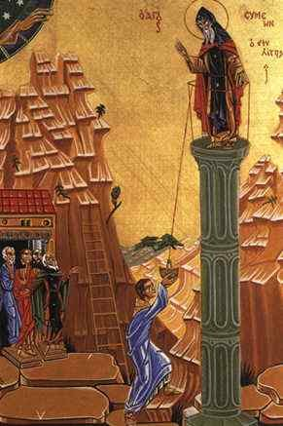
Simeon Stylites (390? - 459), we are told, used to go without food through the 40 days of Lent; during one Lent he was, at his own insistence, walled up in an enclosure with a little bread and water; on Easter he was unwalled, and the bread and the water were found untouched. At Kalat Seman, in northern Syria, about 422, Simeon built himself a column six feet high and lived on ever taller columns, until he made his permanent abode on a pillar 60 feet high. Its circumference at the top was little more than three feet; a railing kept the saint from falling to the ground in his sleep. On this perch Simeon lived uninterruptedly for 30 years, exposed to rain and sun and cold. A ladder enabled disciples to take him food and remove his waste. He bound himself to the pillar by a rope; the rope became embedded in his flesh, which putrefied around it, stank, and teemed with worms; Simeon picked up the worms that fell from his sores, and replaced them there, saying 2 them “Eat what God has given you.” From his high pulpit he preached sermons to the crowds that came to see him, converted barbarians, preformed marvelous cures, played ecclesiastical politics, and shamed the moneylenders into reducing their interest charges from 12 to 6 %. His exalted piety created a fashion of pillar hermits, which lasted for 12 centuries, and, in a thoroughly secularized form, persists today.

Adapted and revised from:
Durant, Will. The Age of Faith: A History of Medieval Civilization - Christian, Islamic, and Judaic - from Constantine to Dante, A.D. 325-1300. New York: Simon & Schuster, 1950. 60.

[http://www.orthodoxchristian.info/pages/St_Symeon.htm] "St Symeon the Stylite." St Symeon the Stylite. N.p., n.d. Web. 22 Sept. 2014.

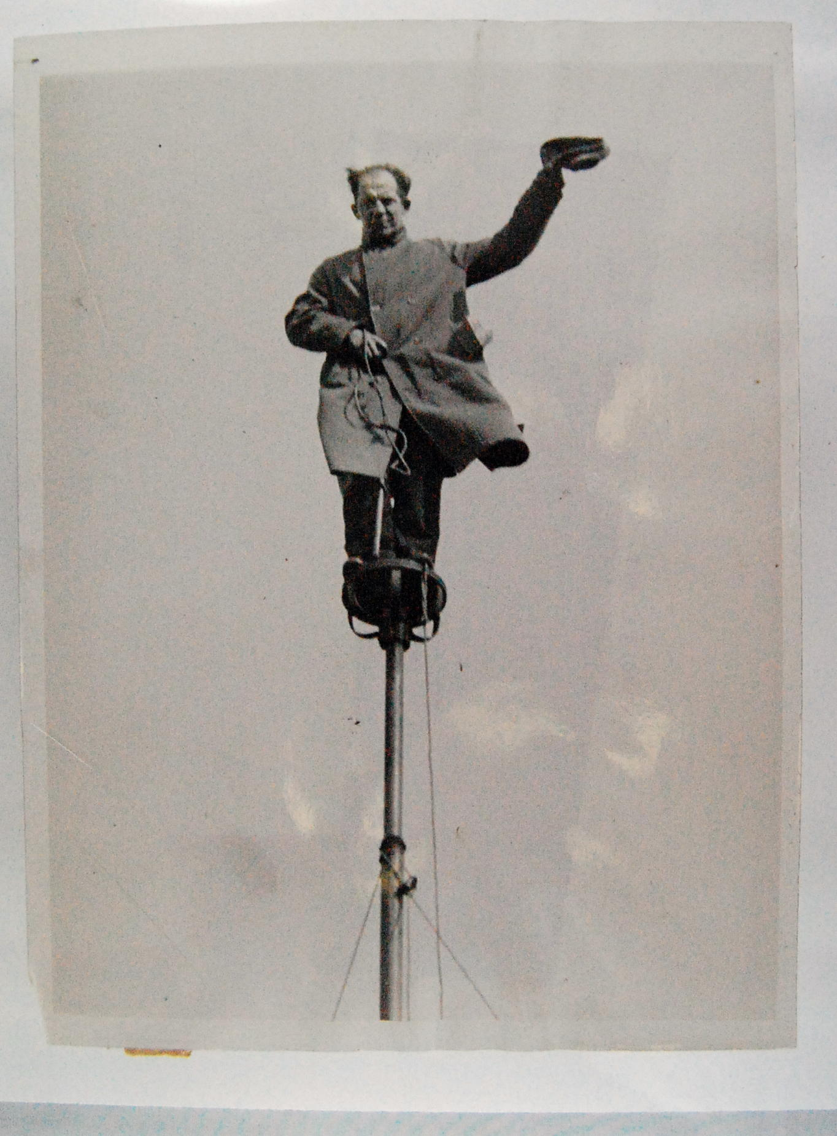
Flagpole-sitting was a fad in the early 20th century. The fad was begun by stunt actor and former sailor Alvin “Shipwreck” Kelly, who sat on a flagpole, either on a dare by a friend, or as a publicity stunt. Shipwreck's initial 1924 sit lasted 13 hours and 13 minutes. It soon became a fad with other contestants setting records of 12, 17 and 21 days. In 1929, Shipwreck decided to reclaim the title. He sat on a flagpole for 49 days in Atlantic City, New Jersey, setting a new record. The following year, 1930, his record was broken by Bill Penfield in Strawberry Point, Iowa who sat on a flag pole for 51 days and 20 hours, until a thunderstorm forced him down. From 1933 to 1963 Richard “Dixie” Blandy claimed various records as champion at 77, 78, and 125 days until he died in 1974 when his pole was snapped in half at the Dixie Square Mall. For the most part, pole sitting died out after 1929, with the onset of the Great Depression.

"Pole-sitting." Wikipedia. Wikimedia Foundation, 09 Jan. 2014. Web. 22 Sept. 2014.

