Modern European History
Unit 3 – Reformation and Exploration
Labeled Map of Reformation Europe

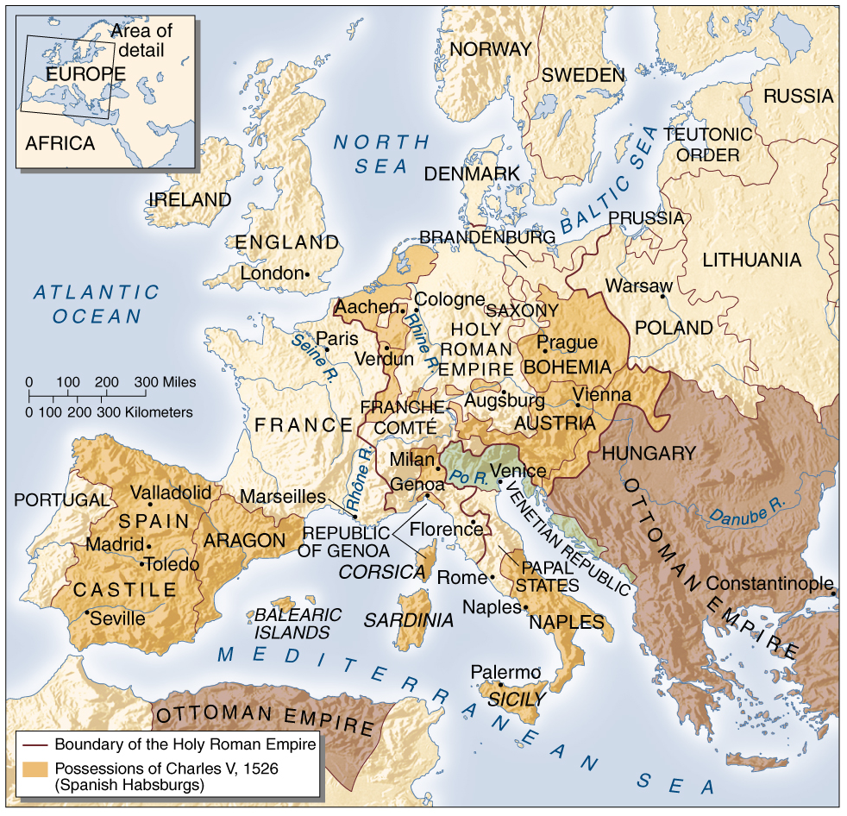

Modern European History
Unit 3 – Reformation and Exploration
Outline Map of Reformation Europe

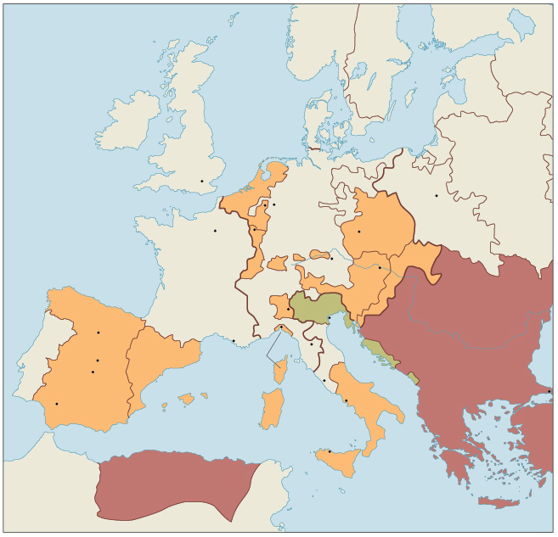
Modern European History
Unit 3 – Reformation and Exploration
Reformation Europe Map Activity

Use the labeled map to label the following on the outline map:

Label each of the following cities in BLACK:

Aachen
Augsburg
Cologne
Florence
London
Madrid
Marseilles
Naples
Paris
Prague
Rome
Seville
Toledo
Verdun
Vienna
Warsaw

Label each of the following bodies of water in BLACK and color them BLUE:

Atlantic Ocean
Baltic Sea
Mediterranean Sea
North Sea
Po River
Rhine River
Rhone River
Seine River

Label each of the following political entities in BLACK and color each a different color than bordering locations:

Aragon
Austria
Bohemia
Brandenburg
Castile
Denmark
England
France
Holy Roman Empire
Ireland
Naples
Ottoman Empire
Papal States
Portugal
Saxony
Sicily
Spain

