Muslim Towns and Trade in North Africa

Find and highlight the answers to these questions in the text.

1. In what three things did Kairouan surpass all other towns?

2. What were the similarities between Kairouan and Sijilmasa?

3. How would you characterize the major trade items of the Maghrib?

As their empire grew, the Muslims built fortified garrison towns in North Africa from which they controlled and administered their new conquests. In time these garrison towns became important centers of government, learning, commerce, and trade. The excerpt below provides a description of the Muslim towns of Kairouan and Sijilmasa, located in what is today Tunisia. As you read the excerpt, note the chief exports of the Maghrib region.
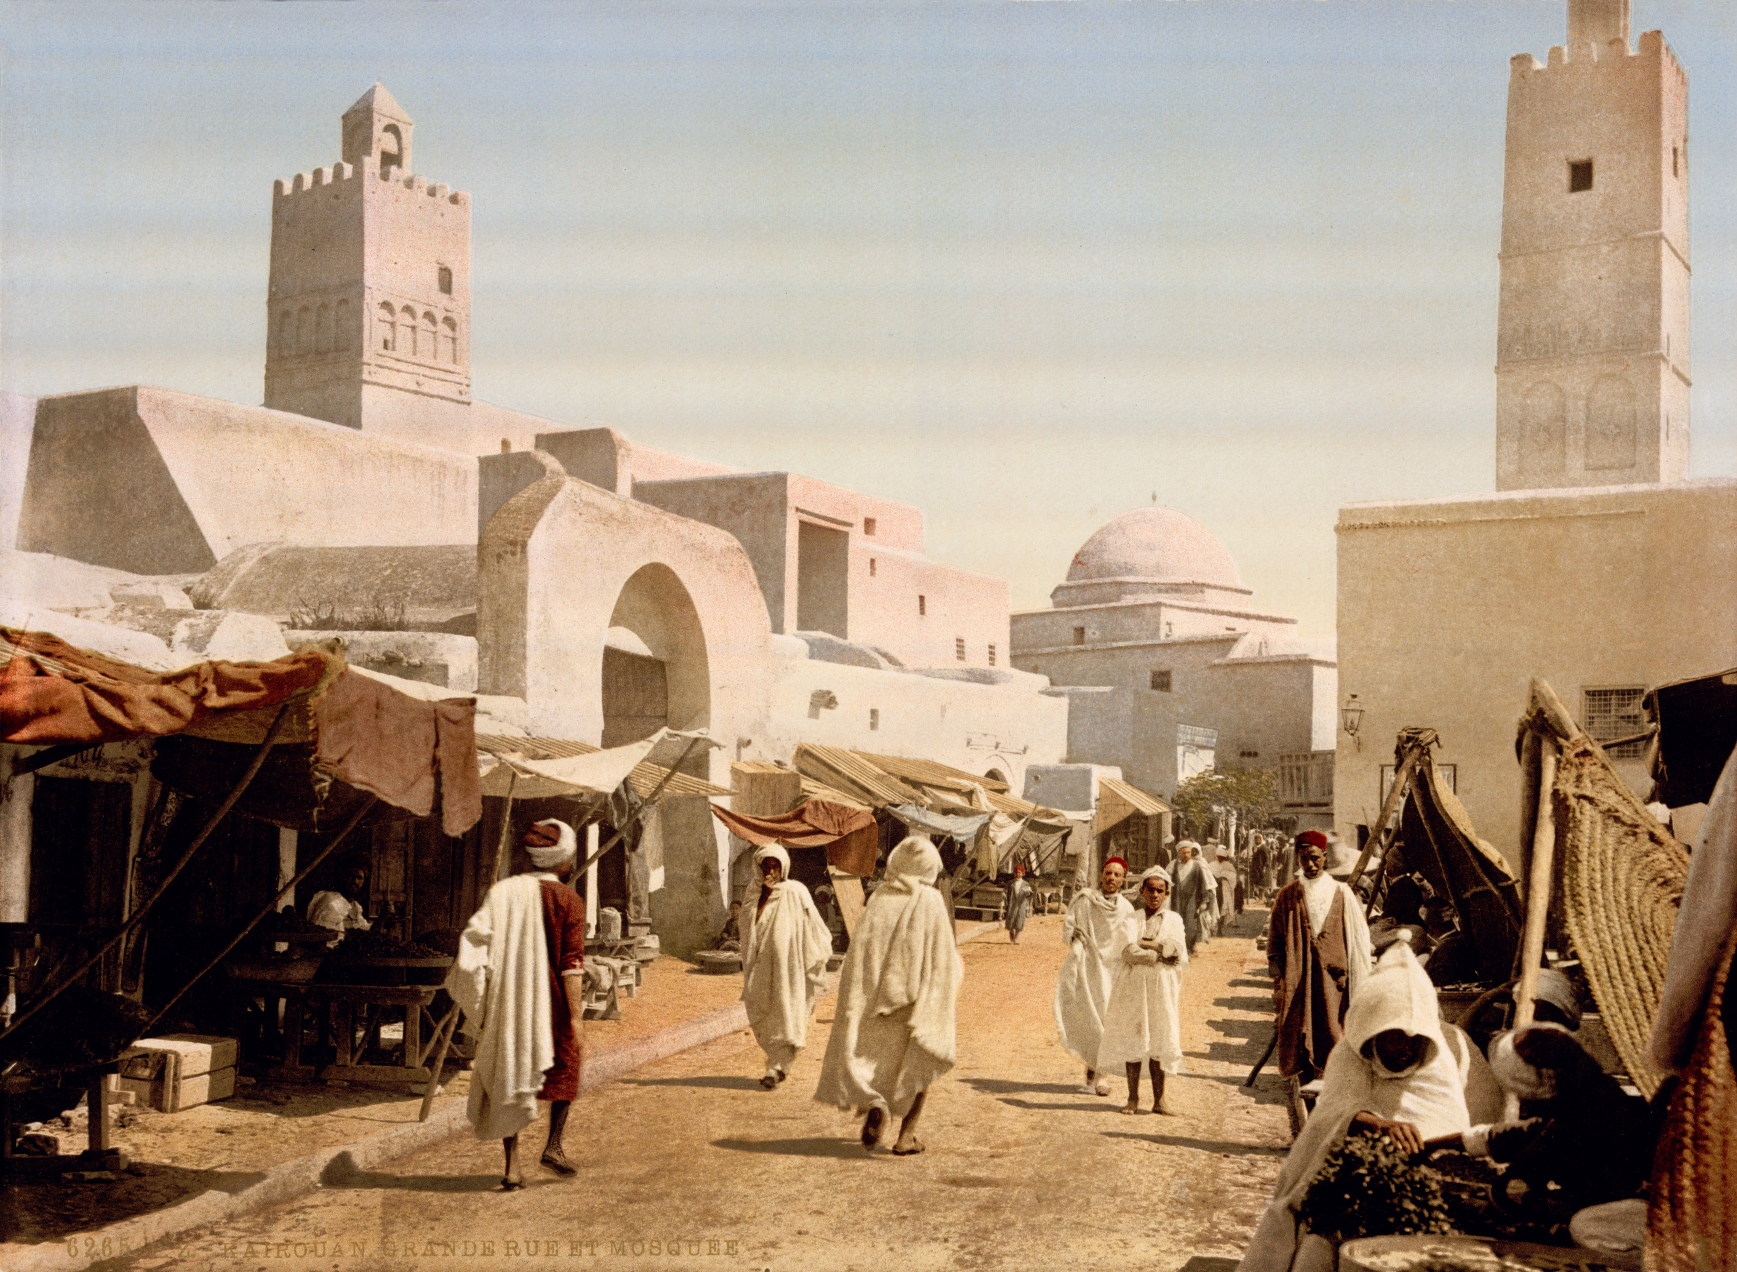
Commerce – trade

Bazaar – trading area

Sultan – leader

Treasury – bank

Dinars – coin used in the Islamic Empires

Mulatto – mixed ethnicity

Eunuchs – castrated men placed in charge of groups of women or religious duties

Inured – trained

Berbers – traveling people of North Africa

Salubrity – healthy air

Kairouan, the largest town of the Maghrib region, surpasses all others in its commerce, its riches, and the beauty of its buildings and bazaars. It is the seat of government of the whole Maghrib, the center to which flows the wealth of the land, and the residence of the sultan of that country. I heard from Abu al-Hasan, head of the public treasury (in 947-8 A.D.), that the income of all provinces and localities of the Maghrib…was between seven hundred and eight hundred million dinars…

The exports from the Maghrib to the East are fair mulatto girls,…young and handsome European slaves, amber, silks, suits of very fine wool, fineries, woolen skirts, carpets, iron, lead, mercury, eunuchs from the countries of the Negroes and of the Slavs. People there possess excellent draft horses and camels inured to fatigue, which they procure from the Berbers…

Kairouan and Sijilmasa are similar in salubrity of climate and in their nearness to the desert. Rich caravans constantly leave Sijilmasa for the Sudan and bring great profits to the inhabitants of that town…The inhabitants of other towns in [the Maghrib] perhaps resemble those of Sijilmasa in their characteristics and the conditions of the existence, but they are inferior to the latter in wealth and comforts.

