Leonardo, Renaissance Man
Leonardo da Vinci was a painter, sculptor, inventor, and scientist. A true “Renaissance man,” he was interested in how things worked. He studied how a muscle moves and how veins are arranged in a leaf. He filled his notebooks with observations and sketches. Then he incorporated his findings in his art.

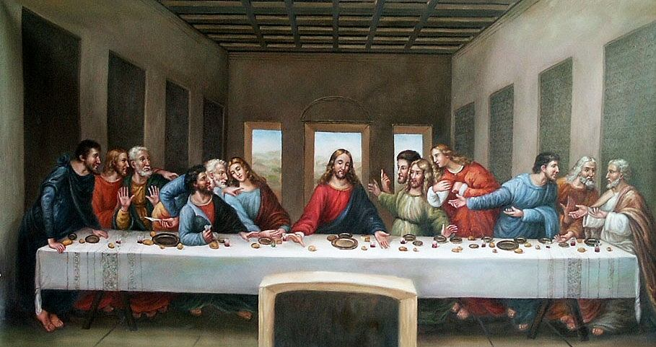
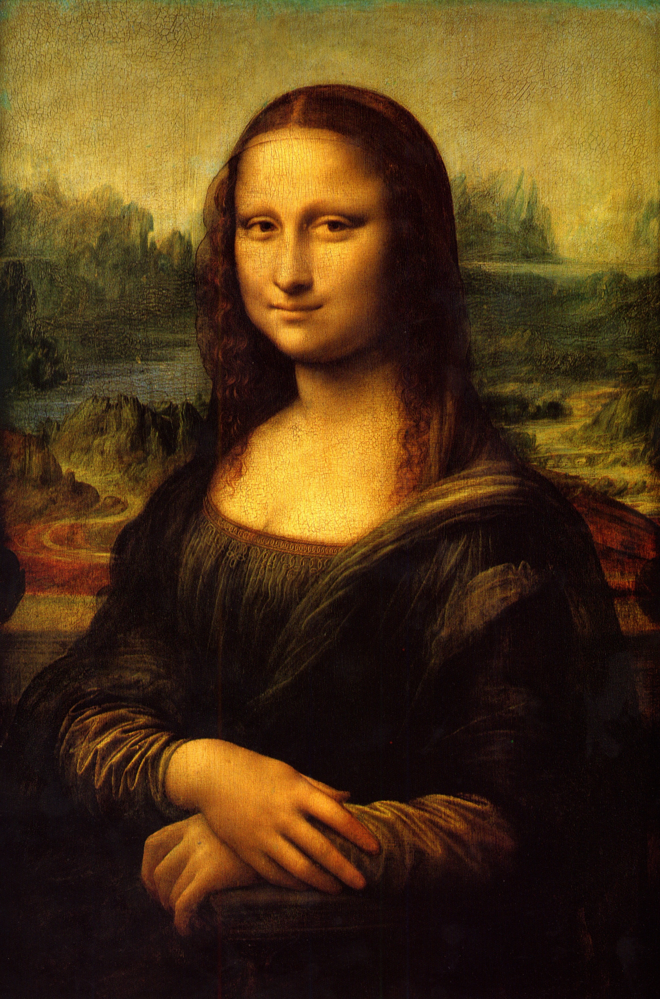
Among his many masterpieces, Leonardo painted one of the best known portraits in the world, the Mona Lisa. The woman in the portrait seems so real that many writers have tried to explain the thoughts behind her smile. Leonardo also produced a famous religious painting, The Last Supper. It shows the personalities of Jesus’ disciples through facial expressions.

Raphael Advances Realism
Raphael Sanzio was younger than Michelangelo and Leonardo. He learned from studying their works. One of Raphael’s favorite subjects was the Madonna and child. Raphael often portrayed their expressions as gentle and calm. He was famous for his use of perspective.
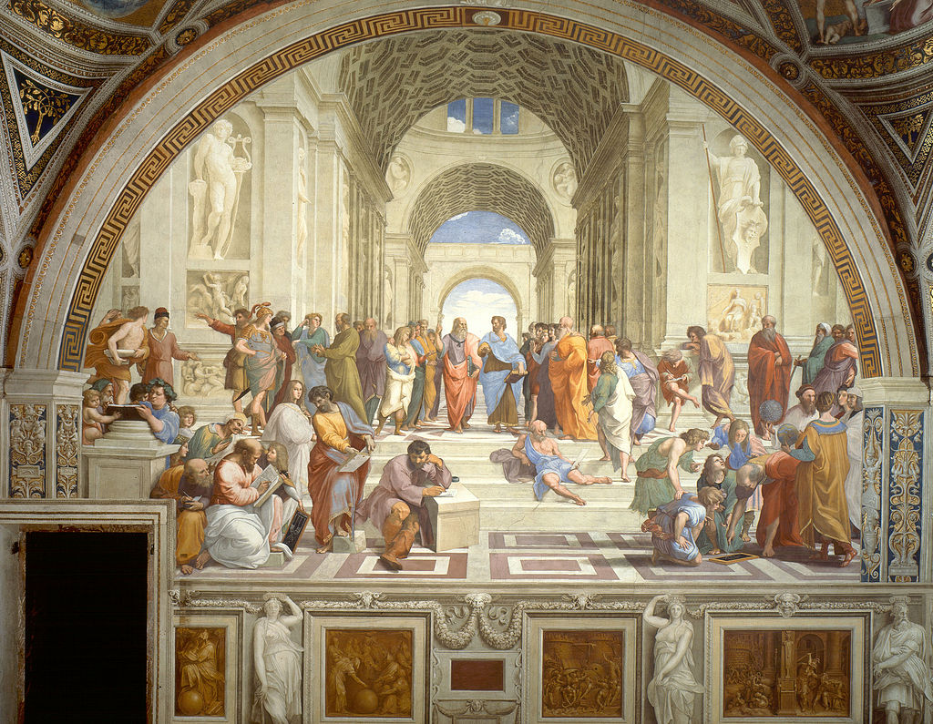

In his greatest achievement, Raphael filled the walls of Pope Julius II’s library with paintings. One of these, School of Athens, conveys the classical influence on the Renaissance. Raphael painted famous Renaissance figures, such as Michelangelo, Leonardo, and himself, as classical philosophers and their students.

Anguissola and Gentileschi
Renaissance society generally restricted women’s roles. However, a few Italian women became notable painters. Sofonisba Anguissola was the first woman artist to gain an international reputation. She is known for her portraits of her sisters and of prominent people such as King Philip II of Spain. Artemisia Gentileschi was another accomplished artist. She trained with her painter father and helped with his work. In her own paintings, Gentileschi painted pictures of strong, heroic women.

Renaissance Writers Change Literature

Leonardo da Vinci (1452–1519)
Leonardo da Vinci’s notebooks—and life—are mysterious. Some 3,500 pages closely covered with writings and drawings survive. His writing is clear and easy to read, but only if you look at it in a mirror. No one knows why he wrote backwards.

Leonardo planned scholarly works and great feats of engineering that were never completed. Only 17 of his paintings survive. And yet the work that Leonardo did produce is so amazing that it confirms his genius.

Michelangelo Buonarroti (1475–1564)
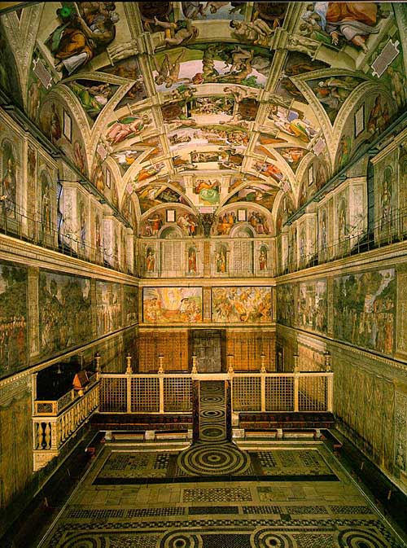
Like Leonardo, Michelangelo was a Renaissance man. He excelled as a painter, sculptor, architect, and poet. Michelangelo is most famous for the way he portrayed the human body in painting and sculpture. Influenced by classical art, he created figures that are forceful and show heroic grandeur. Among his achievements are the dome of St. Peter’s, the paintings on the ceiling of the Sistine Chapel, and the statue of David.

Renaissance writers produced works that reflected their time, but they also used techniques that writers rely on today. Some followed the example of the medieval writer Dante. He wrote in the vernacular, his native language, instead of Latin. Dante’s native language was Italian. In addition, Renaissance writers wrote either for self expression or to portray the individuality of their subjects. In these ways, writers of the Renaissance began trends that modern writers still follow.

Petrarch and Boccaccio
Francesco Petrarch was one of the earliest and most influential humanists. Some have called him the father of Renaissance humanism. He was also a great poet. Petrarch wrote both in Italian and in Latin. In Italian, he wrote sonnets, 14 line poems. They were about a mysterious woman named Laura, who was his ideal. (Little is known of Laura except that she died of the plague in 1348.) In classical Latin, he wrote letters to many important friends.

The Italian writer Giovanni Boccaccio is best known for the Decameron, a series of realistic, sometimes off color stories. The stories are supposedly told by a group of worldly young people waiting in a rural villa to avoid the plague sweeping through Florence. The Decameron presents both tragic and comic views of life. In its stories, the author uses cutting humor to illustrate the human condition. Boccaccio presents his characters in all of their individuality and all their folly.

Machiavelli Advises Rulers
The Prince (1513) by Niccolò Machiavelli also examines the imperfect conduct of human beings. It does so by taking the form of a political guidebook. In The Prince, Machiavelli examines how a ruler can gain power and keep it in spite of his enemies. In answering this question, he began with the idea that most people are selfish, fickle, and corrupt.

To succeed in such a wicked world, Machiavelli said, a prince must be strong as a lion and shrewd as a fox. He might have to trick his enemies and even his own people for the good of the state. In The Prince, Machiavelli was not concerned with what was morally right, but with what was politically effective. He pointed out that most people think it is praiseworthy in a prince to keep his word and live with integrity. Nevertheless, Machiavelli argued that in the real world of power and politics a prince must sometimes mislead the people and lie to his opponents. As a historian and political thinker, Machiavelli suggested that in order for a prince to accomplish great things, he must be crafty enough to not only overcome the suspicions but also gain the trust of others.

Vittoria Colonna
The women writers who gained fame during the Renaissance usually wrote about personal subjects, not politics. Yet, some of them had great influence. Vittoria Colonna (1492–1547) was born of a noble family. In 1509, she married the Marquis of Pescara. He spent most of his life away from home on military campaigns.

Vittoria Colonna exchanged sonnets with Michelangelo and helped Castiglione publish The Courtier. Her own poems express personal emotions. When her husband was away at the Battle of Ravenna in 1512, she wrote to him

Now go back through the reading and use a different colored highlighter to highlight the portion of the text that answers each of questions below. Mark the text with the question number [if you already highlighted this as part of your initial read, just put the question number next to your yellow highlighting].

1. Why did the Renaissance began in Italy?

2. How did humanism influence the growth of learning?

3. What role did patrons of the arts play in the development of Renaissance ideas?

4. How did artists reflect Renaissance values in their work?

5. How did the writing of Petrarch, Boccaccio, and Machiavelli demonstrate the values of humanism?

Once you have finished all necessary highlighting, write the answer to each of the questions from above in complete sentences in the space provided on the back (use additional paper if you’d prefer or if you need more space):

_________________________________________________________________________________________________________

_________________________________________________________________________________________________________

_________________________________________________________________________________________________________

_________________________________________________________________________________________________________

_________________________________________________________________________________________________________

_________________________________________________________________________________________________________

_________________________________________________________________________________________________________

_________________________________________________________________________________________________________

_________________________________________________________________________________________________________

_________________________________________________________________________________________________________

_________________________________________________________________________________________________________

_________________________________________________________________________________________________________

_________________________________________________________________________________________________________

_________________________________________________________________________________________________________

_________________________________________________________________________________________________________

_________________________________________________________________________________________________________

_________________________________________________________________________________________________________

_________________________________________________________________________________________________________

_________________________________________________________________________________________________________

_________________________________________________________________________________________________________

_________________________________________________________________________________________________________

_________________________________________________________________________________________________________

_________________________________________________________________________________________________________

_________________________________________________________________________________________________________

_________________________________________________________________________________________________________

_________________________________________________________________________________________________________

_________________________________________________________________________________________________________

_________________________________________________________________________________________________________

_________________________________________________________________________________________________________

