Modern European History
Unit 2 – The Renaissance
Italy: Birthplace of the Renaissance

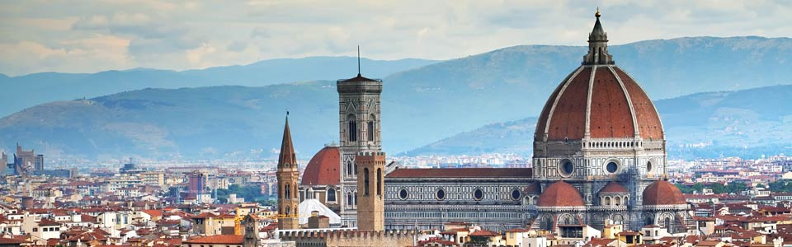

During the late Middle Ages, Europe suffered from both war and plague. Those who survived wanted to celebrate life and the human spirit. They began to question institutions of the Middle Ages, which had been unable to prevent war or to relieve suffering brought by the plague. Some people questioned the Church, which taught Christians to endure suffering while they awaited their rewards in heaven. In northern Italy, writers and artists began to express this new spirit and to experiment with different styles. These men and women would greatly change how Europeans saw themselves and their world.

Directions:
1. Read the following article thoroughly, using a YELLOW highlighter to highlight any important vocabulary/terms/names/events that you think might be historically important.

2. Write a vocabulary word/name/event title/special notation in the margin next to any text you have highlighted (be sure to write the definition of any words you may not know).

Italy’s Advantages
This movement that started in Italy caused an explosion of creativity in art, writing, and thought that lasted approximately from 1300 to 1600. Historians call this period the Renaissance. The term means rebirth, and in this context, it refers to a revival of art and learning. The educated men and women of Italy hoped to bring back to life the culture of classical Greece and Rome. Yet in striving to revive the past, the people of the Renaissance created something new. The contributions made during this period led to innovative styles of art and literature. They also led to new values, such as the importance of the individual.

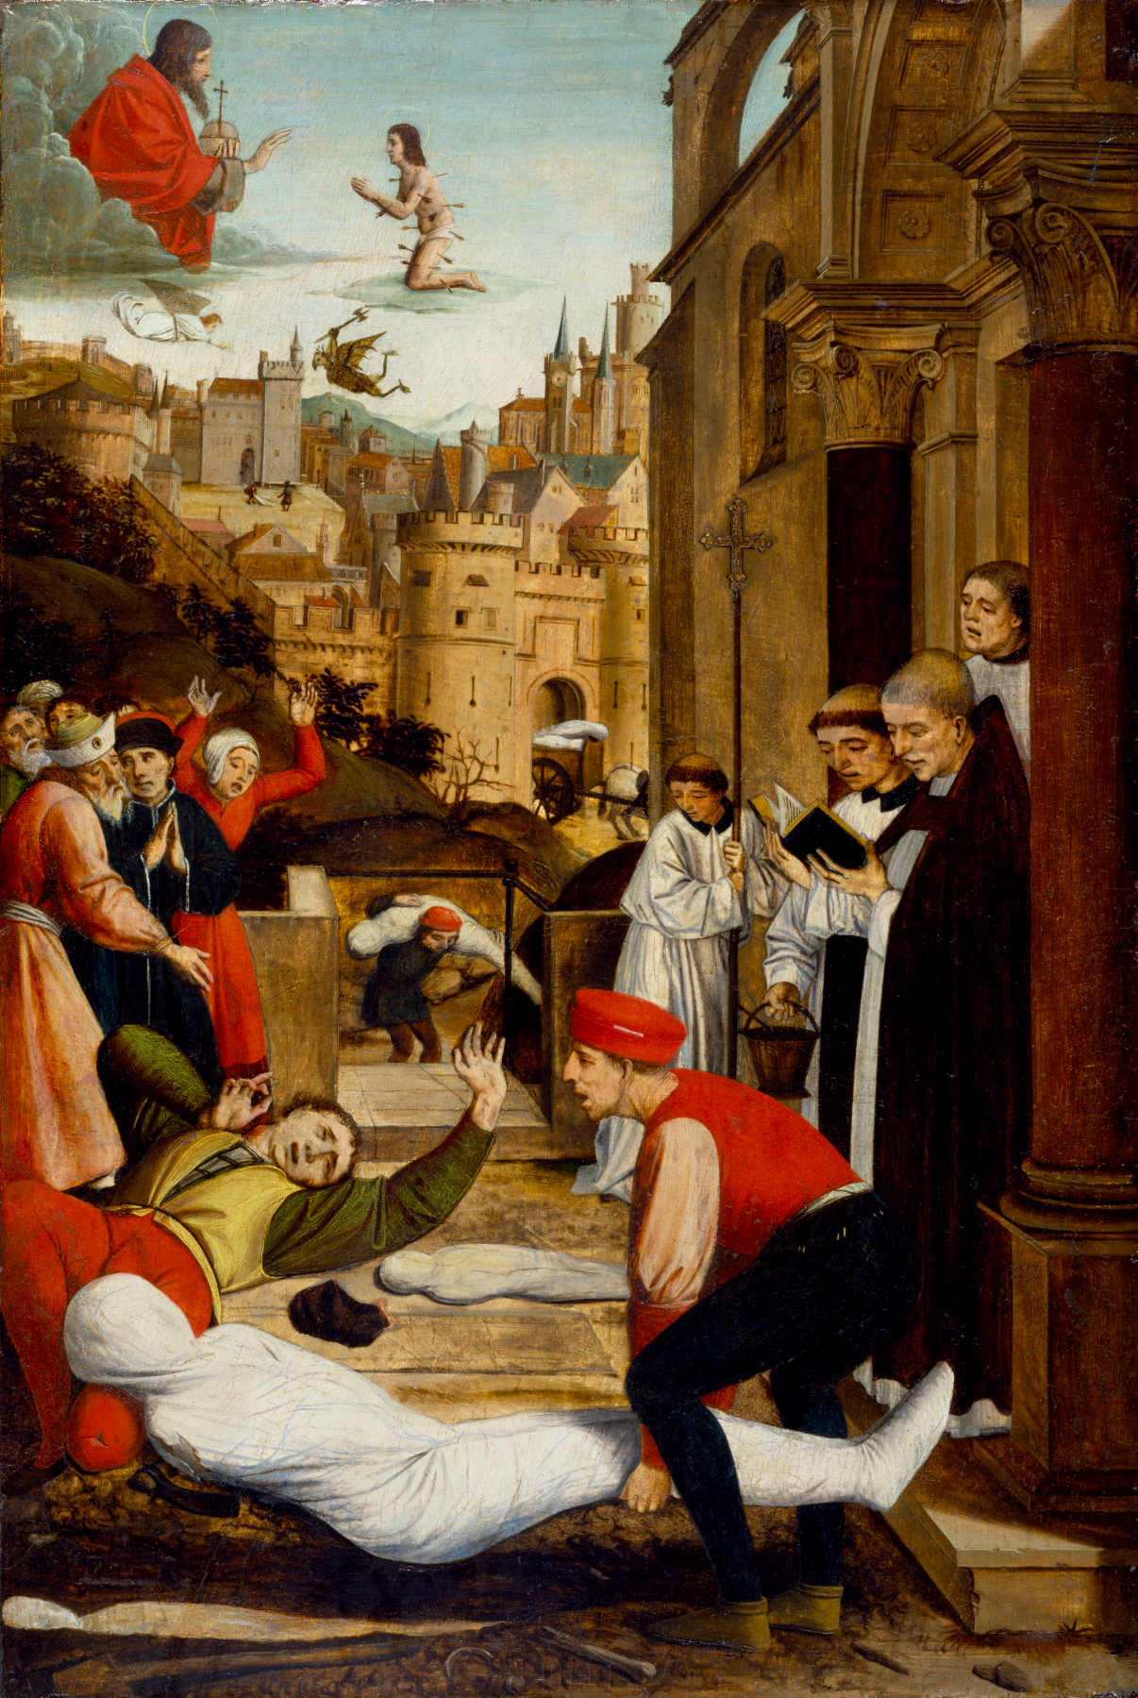
The Renaissance eventually spread from northern Italy to the rest of Europe. Italy had three advantages that made it the birthplace of the Renaissance: thriving cities, a wealthy merchant class, and the classical heritage of Greece and Rome.

City States
Overseas trade, spurred by the Crusades, had led to the growth of large city states in northern Italy. The region also had many sizable towns. Thus, northern Italy was urban while the rest of Europe was still mostly rural. Since cities are often places where people exchange ideas, they were an ideal breeding ground for an intellectual revolution.
In the 1300s, the bubonic plague struck these cities hard, killing up to 60 percent of the population. This brought economic changes. Because there were fewer laborers, survivors could demand higher wages. With few opportunities to expand business, merchants began to pursue other interests, such as art.

Merchants and the Medici
A wealthy merchant class developed in each Italian city state. Because city states like Milan and Florence were relatively small, a high percentage of citizens could be intensely involved in political life.

Merchants dominated politics. Unlike nobles, merchants did not inherit social rank. To succeed in business, they used their wits. As a result, many successful merchants believed they deserved power and wealth because of their individual merit. This belief in individual achievement became important during the Renaissance.
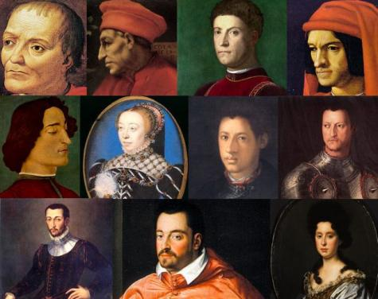
Since the late 1200s, the city state of Florence had a republican form of government. But during the Renaissance, Florence came under the rule of one powerful banking family, the Medici. The Medici family bank had branch offices throughout Italy and in the major cities of Europe. Cosimo de Medici was the wealthiest European of his time. In 1434, he won control of Florence’s government. He did not seek political office for himself, but influenced members of the ruling council by giving them loans. For 30 years, he was dictator of Florence.

Cosimo de Medici died in 1464, but his family continued to control Florence. His grandson, Lorenzo de Medici, came to power in 1469. Known as Lorenzo the Magnificent, he ruled as a dictator yet kept up the appearance of having an elected government.

Looking to Greece and Rome
Renaissance scholars looked down on the art and literature of the Middle Ages. Instead, they wanted to return to the learning of the Greeks and Romans. They achieved this in several ways. First, the artists and scholars of Italy drew inspiration from the ruins of Rome that surrounded them. Second, Western scholars studied ancient Latin manuscripts that had been preserved in monasteries. Third, Christian scholars in Constantinople fled to Rome with Greek manuscripts when the Turks conquered Constantinople in 1453.

Classical and Worldly Values
As scholars studied these manuscripts, they became more influenced by classical ideas. These ideas helped them to develop a new outlook on life and art.

Classics Lead to Humanism
The study of classical texts led to humanism, an intellectual movement that focused on human potential and achievements. Instead of trying to make classical texts agree with Christian teaching as medieval scholars had, humanists studied them to understand ancient Greek values. Humanists influenced artists and architects to carry on classical traditions. Also, humanists popularized the study of subjects common to classical education, such as history, literature, and philosophy. These subjects are called the humanities.
Worldly Pleasures
In the Middle Ages, some people had demonstrated their piety by wearing rough clothing and eating plain foods. However, humanists suggested that a person might enjoy life without offending God. In Renaissance Italy, the wealthy enjoyed material luxuries, good music, and fine foods.

Most people remained devout Catholics. However, the basic spirit of Renaissance society was secular—worldly rather than spiritual and concerned with the here and now. Even church leaders became more worldly. Some lived in beautiful mansions, threw lavish banquets, and wore expensive clothes.

Patrons of the Arts
Church leaders during the Renaissance beautified Rome and other cities by spending huge amounts of money for art. They became patrons of the arts by financially supporting artists. Renaissance merchants and wealthy families also were patrons of the arts. By having their portraits painted or by donating art to the city to place in public squares, the wealthy demonstrated their own importance.

The Renaissance Man
Renaissance writers introduced the idea that all educated people were expected to create art. In fact, the ideal individual strove to master almost every area of study. A man who excelled in many fields was praised as a “universal man.” Later ages called such people “Renaissance men.”

Baldassare Castiglione wrote a book called The Courtier (1528) that taught how to become such a person. A young man should be charming, witty, and well educated in the classics. He should dance, sing, play music, and write poetry. In addition, he should be a skilled rider, wrestler, and swordsman.

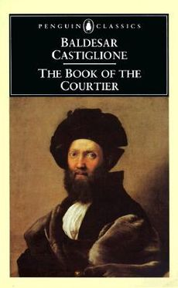
PRIMARY SOURCE
In The Courtier, Baldassare Castiglione described the type of accomplished person who later came to be called the Renaissance man:

Let the man we are seeking be very bold, stern, and always among the first, where the enemy are to be seen; and in every other place, gentle, modest, reserved, above all things avoiding ostentation [showiness] and that impudent [bold] self praise by which men ever excite hatred and disgust in all who hear them. . . .

I would have him more than passably accomplished in letters, at least in those studies that are called the humanities, and conversant not only with the Latin language but with Greek, for the sake of the many different things that have been admirably written therein. Let him be well versed in the poets, and not less in the orators and historians, and also proficient in writing verse and prose.
~ BALDASSARE CASTIGLIONE, The Courtier ~

The Renaissance Woman
According to The Courtier, upper class women also should know the classics and be charming. Yet they were not expected to seek fame. They were expected to inspire art but rarely to create it. Upper class Renaissance women were better educated than medieval women. However, most Renaissance women had little influence in politics.

A few women, such as Isabella d’Este, did exercise power. Born into the ruling family of the city state of Ferrara, she married the ruler of another city state, Mantua. She brought many Renaissance artists to her court and built a famous art collection. She was also skilled in politics. When her husband was taken captive in war, she defended Mantua and won his release.

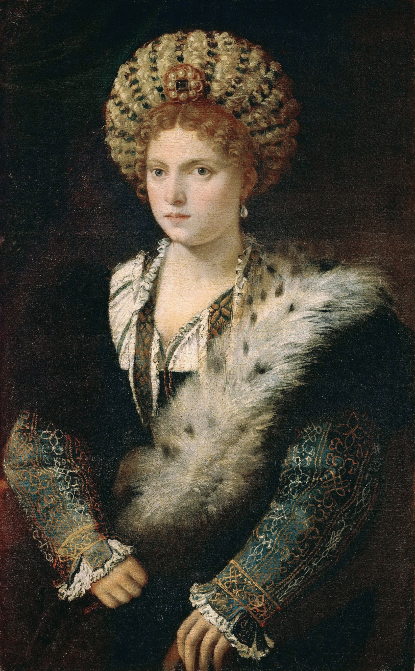
PRIMARY SOURCE
Although Renaissance women were not expected to create art, wealthy women often were patrons of artists, as this letter by Isabella d’Este demonstrates:

To Master Leonardo da Vinci, the painter: Hearing that you are settled at Florence, we have begun to hope that our cherished desire to obtain a work by your hand might be at length realized. When you were in this city and drew our portrait in carbon, you promised us that you would some day paint it in colors. But because this would be almost impossible, since you are unable to come here, we beg you to keep your promise by converting our portrait into another figure, which would be still more acceptable to us; that is to say, a youthful Christ of about twelve years . . . executed with all that sweetness and charm of atmosphere which is the peculiar excellence of your art. Mantua, May 14, 1504
~ ISABELLA D’ESTE, Letters ~

The Renaissance Revolutionizes Art
Supported by patrons like Isabella d’Este, dozens of artists worked in northern Italy. As the Renaissance advanced, artistic styles changed. Medieval artists had used religious subjects to convey a spiritual ideal. Renaissance artists often portrayed religious subjects, but they used a realistic style copied from classical models. Greek and Roman subjects also became popular. Renaissance painters used the technique of perspective, which shows three dimensions on a flat surface.

Realistic Painting and Sculpture
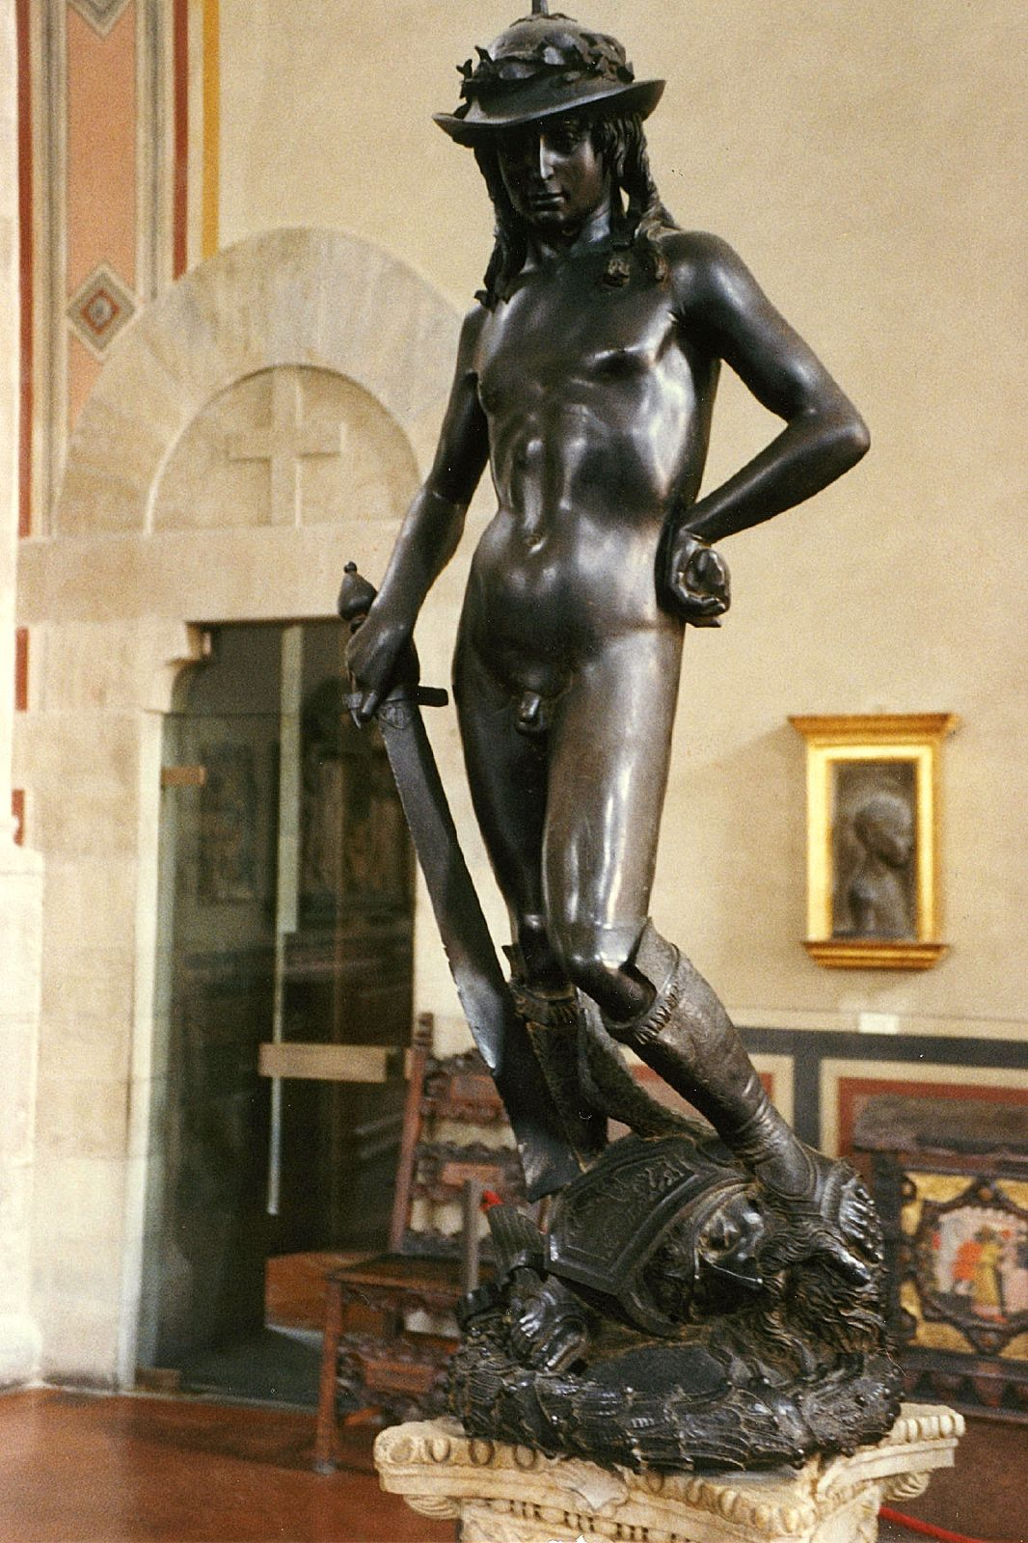
Following the new emphasis on individuals, painters began to paint prominent citizens. These realistic portraits revealed what was distinctive about each person. In addition, artists such as the sculptor, poet, architect, and painter Michelangelo Buonarroti used a realistic style when depicting the human body.

Donatello also made sculpture more realistic by carving natural postures and expressions that reveal personality. He revived a classical form in his statue of David (see left), a boy who, according to the Bible, became a great king. Donatello’s statue was created in the late 1460s. It was the first European sculpture of a large, free standing nude since ancient times. For sculptors of the period, including Michelangelo, David was a favorite subject.

