Modern European History
Unit 3 – Reformation and Exploration
Henry VIII - Catherine of Aragon Reading
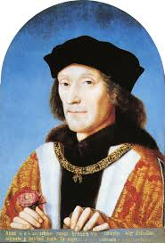
Henry VII (Henry Tudor)

Henry Tudor was born on 28 January 1457 in Pembroke, Wales. His father, Edmund Tudor, had died two months earlier and his mother, Margaret Beaufort, was just thirteen.

Henry was born into a country divided by conflict. He belonged to one branch of the Plantagenet Royal Family, the House of Lancaster, who were fighting another branch, the House of York, for control of the throne – the so-called Wars of the Roses. Henry’s mother Margaret was a descendant of Edward III, which gave Henry a real, although tenuous, claim to the throne.

Mindful of Henry's vulnerability, Margaret entrusted her son to the care of his uncle, Jasper Tudor. When Henry was 14, Edward IV won power for the House of York in the Battle of Tewkesbury. Many Lancastrians died or were executed as a result of the battle. Jasper fled with Henry to France.

Claim to the English Throne
Edward IV died in 1483, leaving his wife, Elizabeth Woodville (the 'White Queen') a widow. His brother Richard usurped the throne from his 12-year-old nephew Edward V, making himself Richard III. Henry was now the leading Lancastrian claimant to the English crown, and saw his support grow. He promised his supporters that if he became king he would marry Edward IV's daughter, Elizabeth of York; a move that would unite the warring houses of York and Lancaster, the opposing sides in the Wars of the Roses.

The Battle of Bosworth
In 1485, Henry landed at Milford Haven. He marched across Wales and England to meet Richard III's forces at the Battle of Bosworth Field in Leicestershire. In the battle Richard III was killed and Henry was crowned King Henry VII at the top of Crown Hill, near the village of Stoke Golding.

Having secured parliamentary recognition of his title as King of England he married Elizabeth of York thus uniting the House of Lancaster and the House of York. He adopted the Tudor rose as the emblem of England, combining the white rose of York with the red rose of Lancaster to symbolise an end to the dynastic war.

Consolidated Power
Henry VII's grip on power was far from secure. His claim to the throne was shaky and he was plagued by plots and conspiracies. He consolidated his position with a treaty with France that opened up trade between the two countries. His most important treaty was the 'Magnus Intercursus' or 'Great Intercourse', signed with the Netherlands, securing England's textile exports.

In 1503 he arranged the marriage of his daughter, Margaret Tudor, to James IV of Scotland in order to secure peace between the two countries. The marriage meant that James IV's descendants would have a claim to the English throne.

Henry also secured a marriage between his eldest son, Arthur, and the Spanish princess, Catherine of Aragon, in 1501. But in 1502 the 15-year-old Arthur Tudor died suddenly at Ludlow Castle, leaving Catherine a widow and making his younger brother, Henry, the new heir to the throne. It was suggested that Catherine should marry the young Henry instead, but this wasn't agreed upon during Henry VII's lifetime due to wrangling over Catherine's dowry.

Tudor State
Henry VII rebuilt the royal finances by avoiding war, promoting trade and enforcing royal taxes to the point of ruthlessness. This meant he was able to leave a fortune to his son, the future Henry VIII.

Henry VII began the work of building a modern administration. The Royal Council was reborn as the Court of Star Chamber, set up to deal with judicial matters. Arrangements were made to promote better order in Wales and the north through the creation of special councils and more powers were entrusted to the justices of the peace.

The combined impact of Henry VII's reforms would increase significantly the power of the King and open the way for medieval rule, with its local law and customs, to be gradually supplanted by a more centralised Tudor state.

Death
Henry VII died of tuberculosis on 21 April 1509 and was buried at Westminster Abbey. He left a safe throne, a solvent government and a prosperous and reasonably united country. Henry VII was succeeded by his second son, Henry VIII.

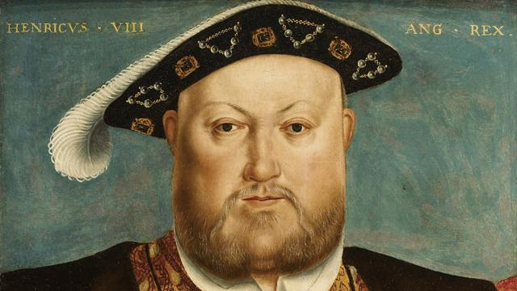
Henry VIII
Henry, the second son of King Henry VII and Elizabeth of York, was born on 28 June 1491 at Greenwich Palace. After the death of his elder brother Arthur in 1502, Henry became heir to the English throne.

King of England
When Henry VII died in 1509, this popular eighteen-year-old prince, known for his love of hunting and dancing, became King Henry VIII. Soon after he obtained the papal dispensation required to allow him to marry his brother's widow, Catherine of Aragon.

In the first years of his reign Henry VIII effectively relied on Thomas Wolsey to rule for him, and by 1515 Henry had elevated him to the highest role in government: Lord Chancellor.

In 1521 Pope Leo X conferred the title of Defender of the Faith on Henry for his book 'Assertio Septem Sacramentorum', which affirmed the supremacy of the Pope in the face of the reforming ideals of the German theologian, Martin Luther.

Military might
Henry VIII's early military campaigns began when he joined Pope Julius II's Holy League against France in 1511. Wolsey proved himself to be an outstanding minister in his organisation of the first French campaign and while the Scots saw this war as an opportunity to invade England, they were defeated at Flodden in 1513. However war with France ultimately proved expensive and unsuccessful.

Henry VIII is known as the 'father of the Royal Navy.' When he became king there were five royal warships. By his death he had built up a navy of around 50 ships. He refitted several vessels with the latest guns including the Mary Rose, which sank in 1545.

Henry also built the first naval dock in Britain at Portsmouth and in 1546 he established the Navy Board. This set up the administrative machinery for the control of the fleet.

A male heir
Henry was acutely aware of the importance of securing a male heir during his reign. He was worried that he had only one surviving child, Mary, to show for his marriage to Catherine, who was now in her 40s. So the king asked Cardinal Wolsey to appeal to Pope Clement VII for an annulment and it soon became clear he wanted to marry Anne Boleyn, who had been a lady-in-waiting to his first wife.

But, unwilling to anger Catherine of Aragon's nephew – the most powerful ruler in Europe, the Holy Roman Emperor Charles V – the Pope refused. Thomas Wolsey's ascendancy was cut short by this failure.

In 1533, Henry VIII broke with the church and married the now pregnant Anne Boleyn in a secret ceremony. Henry was excommunicated by the Pope. The English reformation had begun.

Head of the Church
After Wolsey's downfall, Thomas Cromwell became Henry's chief minister and earned the confidence of the King by helping him to break with Rome and establish Henry VIII as head of the Church of England. This act also brought him much needed wealth through the dissolution of the well-funded monasteries. Over four years Cromwell ordered that 800 monasteries be disbanded and their lands and treasures taken for the crown.

The cultural and social impact was significant, as much of the land was sold to the gentry and churches and monasteries were gutted and destroyed. Henry's personal religious beliefs remained Catholic, despite the growing number of people at court and in the nation who had adopted Protestantism.

Catherine of Aragon
Humble and Loyal

BORN: 16 DECEMBER 1485; MARRIED: 11 JUNE 1509; DIVORCED/ANNULLED: 1533; DIED: 7 JANUARY 1536

There has probably been more interest in the wives of Henry VIII than in the King himself, although it is impossible not to wonder about the man that brought these six women together in history. Their lives were all unique, yet all had fates ultimately decided by the same man. Two were divorced, with one getting a much better deal than the other. Two were beheaded, one falsely accused, the other probably not. One died shortly after giving birth to the male heir Henry so desperately longed for. One survived as his widow.

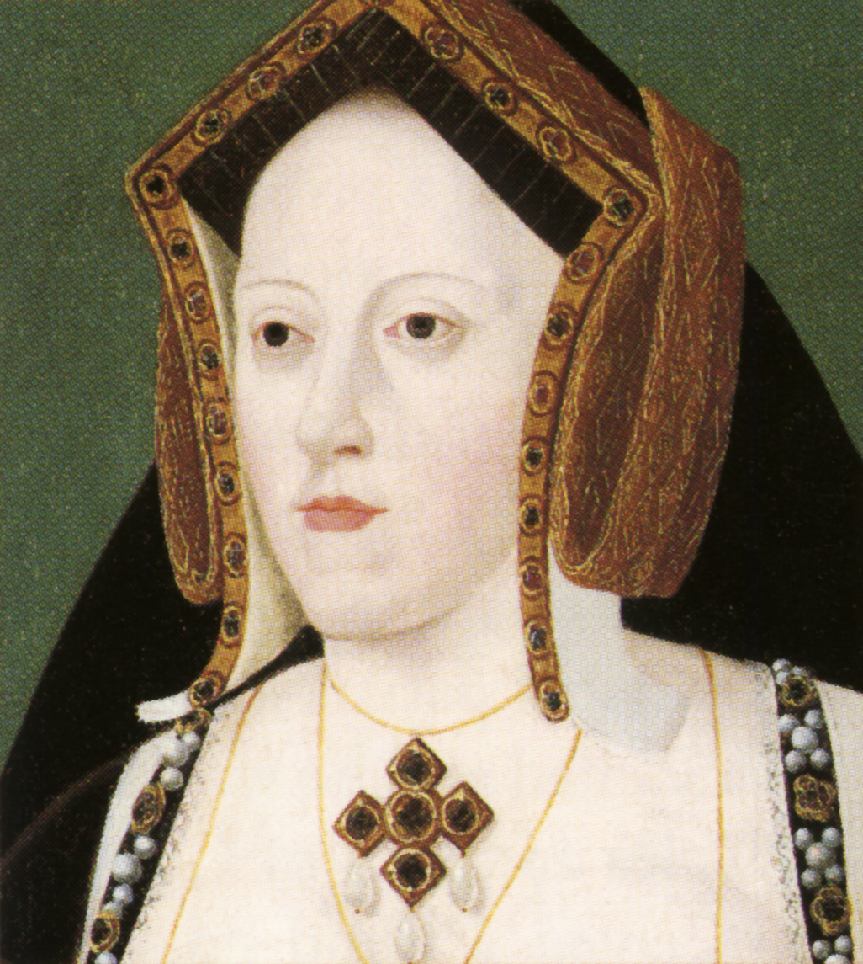
Catherine of Aragon was the youngest surviving child of Ferdinand and Isabella of Spain. As was common for princesses of the day, her parents almost immediately began looking for a political match for her. When she was three year old, she was betrothed to Arthur, the son of Henry VII of England. Arthur was not even quite two at the time.

When she was almost 16, in 1501, Catherine made the journey to England. It took her three months, and her ships weathered several storms, but she safely made landfall at Plymouth on October 2, 1501. Catherine and Arthur were married on 14 November 1501 in Old St. Paul's Cathedral, London. Catherine was escorted by the groom's younger brother, Henry.

After the wedding and celebrations, the young couple moved to Ludlow Castle on the Welsh border. Less than six months later, Arthur was dead, possibly of the 'sweating sickness'. Although this marriage was short, it was very important in the history of England, as will be apparent.

Catherine was now a widow, and still young enough to be married again. Henry VII still had a son, this one much more robust and healthy than his dead older brother. The English king was interested in keeping Catherine's dowry, so 14 months after her husband's death, she was betrothed to the future Henry VIII, who was too young to marry at the time.

By 1505, when Henry was old enough to wed, Henry VII wasn't as keen on a Spanish alliance, and young Henry was forced to repudiate the betrothal. Catherine's future was uncertain for the next four years. When Henry VII died in 1509 and one of the new young king's actions was to marry Catherine. She was finally crowned Queen of England in a joint coronation ceremony with her husband Henry VIII on June 24, 1509.

Shortly after their marriage, Catherine found herself pregnant. This first child was a stillborn daughter born prematurely in January 1510. This disappointment was soon followed by another pregnancy. Prince Henry was born on January 1, 1511 and the was christened on the 5th. There were great celebrations for the birth of the young prince, but they were halted by the baby's death after 52 days of life. Catherine then had a miscarriage, followed by a short-lived son. On February 1516, she gave birth a daughter named Mary, and this child lived. There were probably two more pregnancies, the last recorded in 1518.

Henry was growing frustrated by his lack of a male heir, but he remained a devoted husband. He had at least two mistresses that we know of: Bessie Blount and Mary Boleyn. By 1526 though, he had begun to separate from Catherine because he had fallen in love with one of her ladies (and sister of one of his mistresses): Anne Boleyn.

It is here that the lives of Henry's first and second wives begin to interweave. By the time his interest in Anne became common knowledge, Catherine was 42 years old and was no longer able to conceive. Henry's main goal now was to get a male heir, which his wife was not able to provide. Somewhere along the way, Henry began to look at the texts of Leviticus which says that if a man takes his brother's wife, they shall be childless. As evidenced above, Catherine and Henry were far from childless, and still had one living child. But, that child was a girl, and didn't count in Henry's mind. The King began to petition the Pope for an annulment.
At first, Catherine was kept in the dark about Henry's plans for their annulment. When the news got to Catherine, she was very upset. She was also at a great disadvantage since the court that would decide the case was far from impartial. Catherine then appealed directly to the Pope, which she felt would listen to her case since her nephew was Charles V, the Holy Roman Emperor.

The political and legal debate continued for six years. Catherine was adamant in saying that she and Arthur, her first husband and Henry's brother, did not consummate their marriage and therefore were not truly husband and wife. Catherine sought not only to retain her position, but also that of her daughter Mary.

Things came to a head in 1533 when Anne Boleyn became pregnant. Henry had to act, and his solution was to reject the power of the Pope in England and to have Thomas Cranmer, the archbishop of Canterbury grant the annulment. Catherine was to renounce the title of Queen and would be known as the Princess Dowager of Wales, something she refused to acknowledge through to the end of her life.

Catherine and her daughter were separated and she was forced to leave court. She lived for the next three years in several dank and unhealthy castles and manors with just a few servants. However, she seldom complained of her treatment and spent a great deal of time at prayer.

On January 7, 1536, Catherine died at Kimbolton Castle and was buried at Peterborough Abbey with the ceremony due for her position as Princess Dowager, not as a Queen of England.

