Modern European History
Unit 3 – Reformation and Exploration
Henry VIII - Anne of Cleves Reading
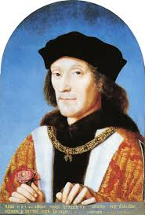
Henry VII (Henry Tudor)

Henry Tudor was born on 28 January 1457 in Pembroke, Wales. His father, Edmund Tudor, had died two months earlier and his mother, Margaret Beaufort, was just thirteen.

Henry was born into a country divided by conflict. He belonged to one branch of the Plantagenet Royal Family, the House of Lancaster, who were fighting another branch, the House of York, for control of the throne – the so-called Wars of the Roses. Henry’s mother Margaret was a descendant of Edward III, which gave Henry a real, although tenuous, claim to the throne.

Mindful of Henry's vulnerability, Margaret entrusted her son to the care of his uncle, Jasper Tudor. When Henry was 14, Edward IV won power for the House of York in the Battle of Tewkesbury. Many Lancastrians died or were executed as a result of the battle. Jasper fled with Henry to France.

Claim to the English Throne
Edward IV died in 1483, leaving his wife, Elizabeth Woodville (the 'White Queen') a widow. His brother Richard usurped the throne from his 12-year-old nephew Edward V, making himself Richard III. Henry was now the leading Lancastrian claimant to the English crown, and saw his support grow. He promised his supporters that if he became king he would marry Edward IV's daughter, Elizabeth of York; a move that would unite the warring houses of York and Lancaster, the opposing sides in the Wars of the Roses.

The Battle of Bosworth
In 1485, Henry landed at Milford Haven. He marched across Wales and England to meet Richard III's forces at the Battle of Bosworth Field in Leicestershire. In the battle Richard III was killed and Henry was crowned King Henry VII at the top of Crown Hill, near the village of Stoke Golding.

Having secured parliamentary recognition of his title as King of England he married Elizabeth of York thus uniting the House of Lancaster and the House of York. He adopted the Tudor rose as the emblem of England, combining the white rose of York with the red rose of Lancaster to symbolise an end to the dynastic war.

Consolidated Power
Henry VII's grip on power was far from secure. His claim to the throne was shaky and he was plagued by plots and conspiracies. He consolidated his position with a treaty with France that opened up trade between the two countries. His most important treaty was the 'Magnus Intercursus' or 'Great Intercourse', signed with the Netherlands, securing England's textile exports.

In 1503 he arranged the marriage of his daughter, Margaret Tudor, to James IV of Scotland in order to secure peace between the two countries. The marriage meant that James IV's descendants would have a claim to the English throne.

Henry also secured a marriage between his eldest son, Arthur, and the Spanish princess, Catherine of Aragon, in 1501. But in 1502 the 15-year-old Arthur Tudor died suddenly at Ludlow Castle, leaving Catherine a widow and making his younger brother, Henry, the new heir to the throne. It was suggested that Catherine should marry the young Henry instead, but this wasn't agreed upon during Henry VII's lifetime due to wrangling over Catherine's dowry.

Tudor State
Henry VII rebuilt the royal finances by avoiding war, promoting trade and enforcing royal taxes to the point of ruthlessness. This meant he was able to leave a fortune to his son, the future Henry VIII.

Henry VII began the work of building a modern administration. The Royal Council was reborn as the Court of Star Chamber, set up to deal with judicial matters. Arrangements were made to promote better order in Wales and the north through the creation of special councils and more powers were entrusted to the justices of the peace.

The combined impact of Henry VII's reforms would increase significantly the power of the King and open the way for medieval rule, with its local law and customs, to be gradually supplanted by a more centralised Tudor state.

Death
Henry VII died of tuberculosis on 21 April 1509 and was buried at Westminster Abbey. He left a safe throne, a solvent government and a prosperous and reasonably united country. Henry VII was succeeded by his second son, Henry VIII.

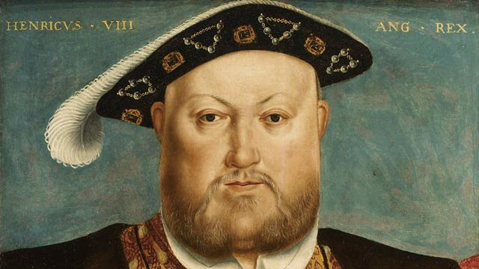
Henry VIII
Henry, the second son of King Henry VII and Elizabeth of York, was born on 28 June 1491 at Greenwich Palace. After the death of his elder brother Arthur in 1502, Henry became heir to the English throne.

King of England
When Henry VII died in 1509, this popular eighteen-year-old prince, known for his love of hunting and dancing, became King Henry VIII. Soon after he obtained the papal dispensation required to allow him to marry his brother's widow, Catherine of Aragon.

In the first years of his reign Henry VIII effectively relied on Thomas Wolsey to rule for him, and by 1515 Henry had elevated him to the highest role in government: Lord Chancellor.

In 1521 Pope Leo X conferred the title of Defender of the Faith on Henry for his book 'Assertio Septem Sacramentorum', which affirmed the supremacy of the Pope in the face of the reforming ideals of the German theologian, Martin Luther.

Military might
Henry VIII's early military campaigns began when he joined Pope Julius II's Holy League against France in 1511. Wolsey proved himself to be an outstanding minister in his organisation of the first French campaign and while the Scots saw this war as an opportunity to invade England, they were defeated at Flodden in 1513. However war with France ultimately proved expensive and unsuccessful.

Henry VIII is known as the 'father of the Royal Navy.' When he became king there were five royal warships. By his death he had built up a navy of around 50 ships. He refitted several vessels with the latest guns including the Mary Rose, which sank in 1545.

Henry also built the first naval dock in Britain at Portsmouth and in 1546 he established the Navy Board. This set up the administrative machinery for the control of the fleet.

A male heir
Henry was acutely aware of the importance of securing a male heir during his reign. He was worried that he had only one surviving child, Mary, to show for his marriage to Catherine, who was now in her 40s. So the king asked Cardinal Wolsey to appeal to Pope Clement VII for an annulment and it soon became clear he wanted to marry Anne Boleyn, who had been a lady-in-waiting to his first wife.

But, unwilling to anger Catherine of Aragon's nephew – the most powerful ruler in Europe, the Holy Roman Emperor Charles V – the Pope refused. Thomas Wolsey's ascendancy was cut short by this failure.

In 1533, Henry VIII broke with the church and married the now pregnant Anne Boleyn in a secret ceremony. Henry was excommunicated by the Pope. The English reformation had begun.

Head of the Church
After Wolsey's downfall, Thomas Cromwell became Henry's chief minister and earned the confidence of the King by helping him to break with Rome and establish Henry VIII as head of the Church of England. This act also brought him much needed wealth through the dissolution of the well-funded monasteries. Over four years Cromwell ordered that 800 monasteries be disbanded and their lands and treasures taken for the crown.

The cultural and social impact was significant, as much of the land was sold to the gentry and churches and monasteries were gutted and destroyed. Henry's personal religious beliefs remained Catholic, despite the growing number of people at court and in the nation who had adopted Protestantism.

Anne of Cleves
God Send Me Well To Keep

BORN: 1515; MARRIED: 6 JANUARY 1540; DIVORCED: JULY 1540; DIED: 16 JULY 1557

There has probably been more interest in the wives of Henry VIII than in the King himself, although it is impossible not to wonder about the man that brought these six women together in history. Their lives were all unique, yet all had fates ultimately decided by the same man. Two were divorced, with one getting a much better deal than the other. Two were beheaded, one falsely accused, the other probably not. One died shortly after giving birth to the male heir Henry so desperately longed for. One survived as his widow.

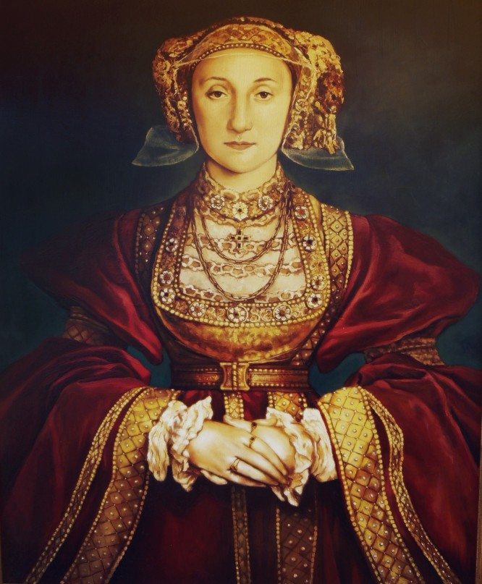
Henry VIII remained single for over two years after Jane Seymour's death, possibly giving some credence to the thought that he genuinely mourned for her. However, it does seem that someone, possibly Thomas Cromwell, began making inquiries shortly after Jane's death about a possible foreign bride for Henry.

Henry's first marriage had been a foreign alliance of sorts, although it is almost certain that the two were truly in love for some time. His next two brides were love matches and Henry could have had little or no monetary or political gain from them.

But the events of the split from Rome left England isolated, and probably vulnerable. It was these circumstances that led Henry and his ministers to look at the possibility of a bride to secure an alliance. Henry did also want to be sure he was getting a desirable bride, so he had agents in foreign courts report to him on the appearance and other qualities of various candidates. He also sent painters to bring him images of these women.

Hans Holbein, probably the most famous of the Tudor court painters, was sent to the court of the Duke of Cleves, who had two sisters: Amelia and Anne. When Holbein went in 1539, Cleves was seen as an important potential ally in the event France and the Holy Roman Empire (who had somewhat made a truce in their long history of conflict) decided to move against the countries who had thrown off the Papal authority. England then sought alliances with countries who had been supporting the reformation of the church. Several of the Duchys and principalities along the Rhine were Lutheran. Holbein painted the sisters of the Duke of Cleves and Henry decided to have a contract drawn up for his marriage to Anne.

Although the King of France and the Emperor had gone back to their usual state of animosity, Henry proceeded with the match. The marriage took place on January 6, 1540. By then, Henry was already looking for ways to get out of the marriage.

Anne was ill-suited for life at the English court. Her upbringing in Cleves had concentrated on domestic skills and not the music and literature so popular at Henry's court. And, most famously, Henry did not find his new bride the least bit attractive and is said to have called her a 'Flanders Mare'. In addition to his personal feelings for wanting to end the marriage, there were now political ones as well. Tension between the Duke of Cleves and the Empire was increasing towards war and Henry had no desire to become involved. Last but not least, at some point, Henry had become attracted to young Kathryn Howard.

Anne was probably smart enough to know that she would only be making trouble for herself if she raised any obstacles to Henry's attempts to annul the marriage. She testified that the match had not been consummated and that her previous engagement to the son of the Duke of Lorraine had not been properly broken.

After the marriage had been dissolved, Anne accepted the honorary title as the 'King's Sister'. She was given property, including Hever Castle, formerly the home of Anne Boleyn.

Anne lived away from court quietly in the countryside until 1557, and attended the coronation of her former step-daughter, Mary I.

She is buried in a somewhat hard to find tomb in Westminster Abbey.

