Modern European History
Unit 2 – The Renaissance
Renaissance Artists – Da Vinci and Michelangelo

Directions:
1. Read the following article thoroughly, using a YELLOW highlighter to highlight any important vocabulary/terms/names/events that you think might be historically important.

2. Write a vocabulary word/name/event title/special notation in the margin next to any text you have highlighted (be sure to write the definition of any words you may not know).

Leonardo da Vinci
The most famous artist in the world, Leonardo was nurtured by Lorenzo de Medici. Botticelli, Michelangelo and da Vinci equaled unparalleled genius, now known as the “High Renaissance.” Leonardo was more than just an artist. It is argued that no man has ever studied more subjects or generated more ideas, than Leonardo da Vinci.

Leonardo the artist
Born in 1450, the son of a lawyer and his peasant lover, Leonardo, like thousands of talented boys, was drawn to Florence. He was soon employed by the painter and sculptor Verrochio, whose busy workshop served many powerful families, including the Medici. Even as an apprentice, Leonardo's talent was hard to ignore. His contribution to the “Baptism of Christ” was so vivid, it was said that Verrochio threatened to give up painting.
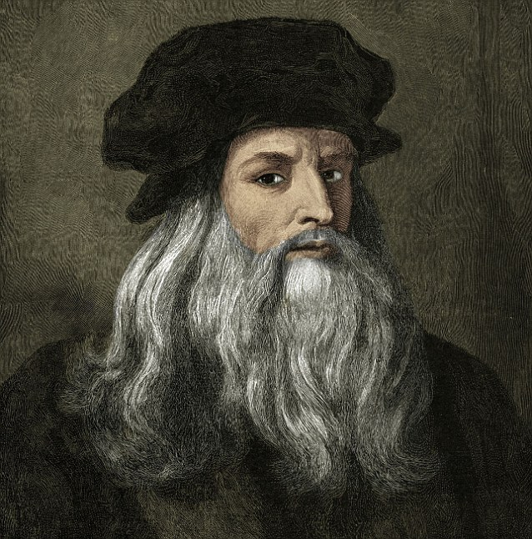
Leonardo was experimenting with oils, a radical technique previously known only in the Northern Europe. Traditionally, Italian artists had painted with egg tempera (pigment mixed with egg yolk or whites), a messy and smelly mixture which dried quickly and often appeared to crack. By mixing his pigment with oil, Leonardo discovered a more versatile color, which could be built up in layers to add depth and tone, or even painted over, to cover mistakes. It was the start of an artistic revolution.

Baptism of Christ
By 1481, Leonardo had outgrown Florence. He approached Lorenzo de Medici for help. Lorenzo referred him to his friend, the Duke of Milan, whose needs were more practical than artistic. This suited Leonardo perfectly, as he had surpassed the need for just a studio and was desperate to build marvelous inventions. Once in Milan, he couldn't resist a commission that became the most famous fresco in history, “The Last Supper.”

Leonardo returned to Florence in 1504, and was drawn into a competition with the upstart, Michelangelo. Both artists were offered a wall of the government palace on which to paint frescoes of famous Florentine battles. Leonardo experimented unsuccessfully with his new technique, and his fresco soon fell off the wall. All that remains is a copy of his original design, or ‘cartoon’, a freeze-frame of a gruesome, action scene.

Italy soon descended into chaos, with warring armies carving their way from Milan to Rome. Leonardo fled to the French court of Francis I, where he ended his days working on the most famous portrait in the world, the “Mona Lisa.”

Leonardo the scientist
To be the ultimate Renaissance man, one had to master every discipline, from natural science, engineering and architecture through to philosophy and art. Leonardo wrote detailed notes on all of these subjects, and in the margins he often left tantalizing doodles of astonishing machines, tanks, parachutes, helicopters, many of which might actually have worked.

Unlike his rival, Botticelli, who took inspiration from philosophical ideals and poetry, Leonardo was obsessed with the natural world. From a young age he was determined to reflect every detail.
“Nature is the source of all true knowledge. She has her own logic, her own laws, she has no effect without cause nor invention without necessity,” he said.

Throughout his life, Leonardo produced thousands of plant and animal studies particularly about horses. He struggled to capture the chaotic behavior of water and also embarked on the most controversial practice of the day, the study of anatomy. Procuring corpses from the hospitals of Florence, Leonardo engaged in private dissection and research. He secretly discovered many features of human anatomy more than 200-years before they became common knowledge.
The Medieval Church condemned Leonardo's work, claiming it was anti-Christian and occult. Accused of black magic, he was forced to leave Italy and seek refuge at the more liberal court of the King of France.
Leonardo died on May 2, 1519 in Cloux, France. Legend has it that King Francis was at his side when he died, cradling Leonardo's head in his arms.

Michelangelo Buonarotti
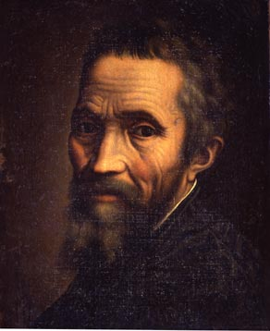
Michelangelo was responsible for some of the finest works of art in Western history including “David,” the ceiling of the Sistine Chapel, “Pieta” and the “Last Judgment.”

He was one of the greatest painters of the Renaissance who owed his early career to the foresight of Lorenzo de Medici.

Brought into the Medici home at the age of 13, the boy-genius was raised amongst future princes and popes and absorbed cutting-edge intellectual theories. He crossed paths with the Medici for the rest of his life, caught in a constant struggle to escape their control.

Michelangelo, sculptor
Michelangelo's talent was spotted at the age of just 13. He was one of the first students in Lorenzo de Medici's original school of art. Legend has it that the boy was learning to carve marble by copying the head of a satyr (antique faun). Lorenzo was impressed by the sculpture but teased the young Michelangelo by pointing out that old creature wouldn't have had a full set of teeth. Mortified, the young perfectionist hacked off a tooth and had Lorenzo re-examine it.

Charmed, Lorenzo invited Michelangelo into his home, so that the Medici could guide and shape the young artist's career. The boy was exposed to the greatest artistic legacy in Florence, and to a social whirlwind of dinner parties, salons, lectures and debates. These early classical influences stayed with him forever.

After Lorenzo's death, Michelangelo's world was thrown into chaos. The Medici boys were expelled from Florence, and Michelangelo fled into hiding. But, in 1501, the 25-year-old sculptor was lured back to Florence by a single, enigmatic block of Carrara marble.

Desperate to outdo his rival Leonardo, Michelangelo undertook the mammoth task of taming the 13-foot marble block. A constant shower of water fell to keep the dust contained and the sculptor cool.

Michelangelo created a wax model of his design, submerged in water. Each day he let the level drop, and using just three chisels, sculpted what he could see emerging. For two and a half years Michelangelo toiled alone. He slept sporadically and rarely ate. He didn't change his boots, and eventually the leather fell off, taking layers of dead skin with them.

On January 25, 1504 “David,” his masterpiece, was introduced to the world. Installed outside the Palazzo Vecchio, this remarkable statue of the proud slayer of Goliath instantly became a symbol of the city, and challenged the power of the overbearing Medici.

When Giovanni de Medici was made Pope Leo X, he and his cousin Giulio made Michelangelo an offer he couldn't refuse. They demanded huge marble tombs be made for their fathers, Lorenzo il Magnifico, and his murdered brother Giuliano de Medici. Michelangelo could not refuse a request from the Pope.
By the end Michelangelo had truly turned his back on the Medici family. His former student, Giorgio Vasari, was now working for Cosimo I, an autocratic monarch he despised. In fury and frustration Michelangelo tried to destroy his last work, the “Pieta” by hacking away at the left arm of Christ. He also captured his own tortured self-portrait, frozen forever in the face of Nicodemus.

Michelangelo, Painter
The man who always signed his name “Michelangelo, sculttore," was also, in spite of himself, a painter. Although Pope Julius II tempted him to Rome with the prospect of a huge marble mausoleum, in fact, the Pope really needed someone to paint the entire ceiling of the Sistine Chapel.

Michelangelo was appalled. He knew nothing about frescoes, and the ceiling spanned more than 3,200 square feet. He was convinced his enemies had recommended him for a job he could never complete. But Michelangelo could not refuse the demands of a Pope. In 1508 he began.

The art of fresco was infamous for separating the great from the merely good. Michelangelo employed assistants for the most demanding work but sometimes would have to destroy a whole week's work and start again due to plaster drying or other imperfections.

Drawing on his bitterness and frustration, Michelangelo crafted brilliance in four short years. He covered the ceiling with 300 figures and stories from the Bible, including the creation of Earth and the stars, the Great Flood, and the creation of Adam. His monumental figures were based on fragments of classical sculptures, and inspired by the perfection and beauty of the ancient world. The frescoes in the Sistine Chapel were arguably the greatest works of Renaissance art.

As his career escalated, Michelangelo became a hard-nosed businessman and by the time of his death had become one of the wealthiest men in Italy. In 1507 his friend, Agnolo Doni, ordered a beautiful portrait of the Holy Family. Michelangelo used especially vibrant colors to achieve both complex perspective and an unusually touching intimacy. It was another masterpiece, although his friend ended up paying Michelangelo twice the cost of the original quote.

In 1534 Michelangelo's childhood friend, Pope Clement VII, was dying. Desperate to make one last grand gesture, he summoned Michelangelo to complete his work in the Sistine Chapel. This was the perfect opportunity to express years of fear and resentment. Across the altar of the Sistine Chapel, he composed a vicious tableau of terror and pain: “The Last Judgment.”

Michelangelo was no longer a friend to this Medici Pope. In 1530 the artist had cowered beneath the tombs he had built for the Medici cousins, as Pope Clement VII laid siege to Florence.
Michelangelo reflected on the horror and war the Medici had inflicted on Italy. When it was unveiled the altarpiece contained especially “shocking material:” it was full of nudes. To maintain requisite modesty a new artist was paid to cover the offending parts.

Michelangelo, Hero
After his death, Michelangelo was reclaimed by the Medici dynasty. Bundled into a hay-basket, his corpse was smuggled to Florence for a magnificent funeral. The artist's life story became the climax of Vasari's art history textbook - “The Lives of the Artists.” Vasari christened his former master and hero “the divine Michelangelo,” and so he has remained.

http://www.pbs.org/empires/medici/renaissance

