Modern European History
Unit 1 – Post-Roman and Medieval Europe
Crash Course on the Crusades
by Steve Weidenkopf
Crisis Magazine: A Voice for the Faithful Catholic Laity
July 24, 2012

Directions: Read the following article thoroughly, using a YELLOW highlighter to highlight any important vocabulary/terms/names/events that you think might be historically important. Write the vocabulary word/name/event title in the margins next to the highlighted text (be sure to write the definition of any words you may not know).

Then go back through the reading and use a different colored highlighter to highlight the portion of the text that answers each of questions below, marking the text with the question number [if you already highlighted this as part of your initial read, just put the question number next to your yellow highlighting].

Lastly, write the answer to each of the following questions in complete sentences on another sheet of paper:

1. Identify and describe each of the four essential ingredients that classified an armed expedition as a Crusade.

2. What evidence does the author use to disprove Myth #1: The Crusades were wars of unprovoked aggression?

3. What evidence does the author use to disprove Myth #2: The Crusades were about European greed for booty, plunder, and the establishment of colonies?

4. What evidence does the author use to disprove Myth #3: When Jerusalem was captured in 1099 the crusaders killed all the inhabitants - so many were killed that the blood flowed ankle deep through the city?

5. What evidence does the author use to disprove Myth #4: The Crusades were also wars against the Jews and should be considered the first Holocaust?

6. What evidence does the author use to disprove Myth #5: The Crusades are the source of the modern tension between Islam and the West?

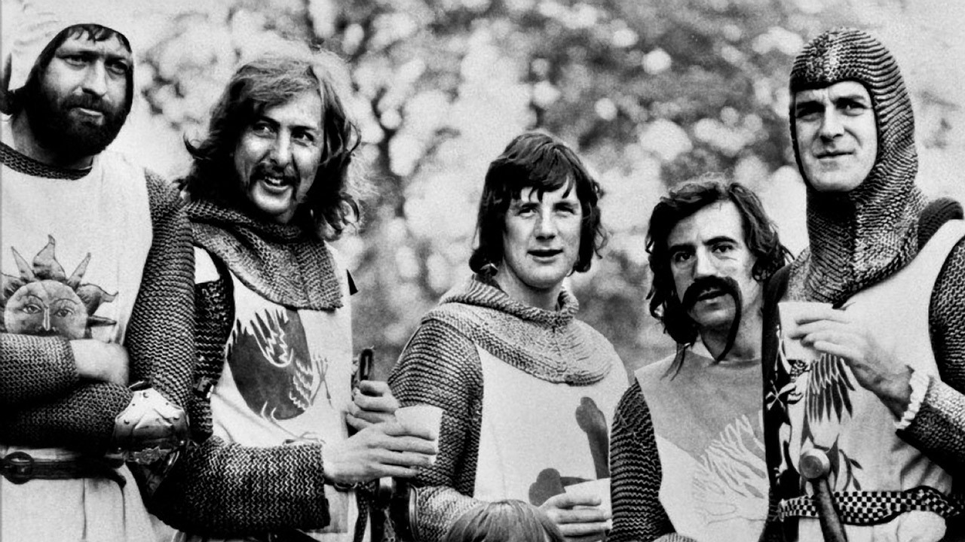
The Crusades are one of the most misunderstood events in Western and Church history. The very word “crusades” conjures negative images in our modern world of bloodthirsty and greedy European nobles embarked on a conquest of peaceful Muslims. The Crusades are considered by many to be one of the “sins” the Christian Faith has committed against humanity and with the Inquisition are the go-to cudgels for bashing the Church.

While the mocking and generally nasty portrayal of the Crusades and Crusaders on the big screen ranges from Monty Python farce to the cringe worthy big budget spectacles like Kingdom of Heaven (2005), it is the biased and bad scholarship such as Steven Runciman’s History of the Crusades, or the BBC/A&E documentary, The Crusades, hosted by Terry Jones (of Monty Python acclaim) that does real damage. From academia to pop-culture, the message is reinforced and driven home with resounding force: the Crusades were bad and obviously so. The real story is of course far more complicated and far more interesting.

It is worth our time to be versed in the facts and especially to recall the tremendous faith, sacrifice, and courage that inspired the vast majority of the Crusaders to act in defense of Christendom.

What were the Crusades?
When answering the question “what were the Crusades” one has to keep in mind that Crusading took on many different forms throughout the movement, which spanned a significant portion of European history lasting from 1095 – 1798.

There were Crusades against the Muslims (in the Holy Land, in Spain, in the Balkans and even in Austria); against pagan tribes in the Baltic regions; against heretics (notably in southern France); and even against enemies of the Pope (e.g. the Holy Roman Emperor Frederick II).
Despite the many different forms, there were four essential ingredients that classified an armed expedition as a Crusade:

The taking of the Cross
Participants took a public, binding ecclesiastical vow to join a military expedition with defined aims. As a sign of their vow, they sewed a red cross onto their garments. The cross could only be removed upon successful completion of their armed pilgrimage.

Papal endorsement
A Crusade had to be called by the Pope or endorsed by him.

Privileges
A crusader received certain privileges from the Church, specifically, the protection of family and property. Those who attacked a crusader’s land were subject to severe ecclesiastical penalties (including excommunication). Additional privileges included the right to demand and receive hospitality from the Church on the journey, exemption from tolls and taxes, immunity from arrest, and exemption from interest payments.
Indulgence
Crusaders were granted a partial or plenary indulgence for completion of their armed pilgrimage.

With this backdrop, we can now address the five most enduring modern myths regarding the Crusades.

Myth #1: The Crusades were wars of unprovoked aggression
From its beginnings, Islam has been a violent and imperialistic movement. Within 100 years of the death of Mohammed, Islamic armies had conquered ancient Christian lands in the Middle East, North Africa, and Spain. The Holy City of Jerusalem was captured in 638. Islamic armies launched raids throughout the Mediterranean and even attacked Rome in 846. Life in the conquered regions for Christians was not easy; many were forced to convert, others converted due to societal pressure (Christians and Jews were considered to be barely above the status of slaves in Islamic society); still others maintained the Faith at great risk.

Although there were periods of relative peace and calm between Muslims and Christians, including Christian pilgrims from Europe, the situation radically changed in the early 11th century when the Egyptian Muslim ruler of Jerusalem ordered the destruction of the Church of the Holy Sepulchre.

The church was later rebuilt, but the arrival of the Seljuk Turks (non-Arab Muslims), who conquered Jerusalem from the Egyptian Muslims in the late 11th century, negatively altered the landscape for the Christians. In 1065 the Seljuks began a campaign of persecution against Christian pilgrims in the Holy Land in which the Bishop of Bamberg and 12,000 pilgrims were massacred by the Muslims only two miles from Jerusalem. They waged war against the Christian Byzantine Empire, winning a decisive victory at the Battle of Manzikert (1071). It was this event that one historian has described as “the shock that launched the Crusades.”[1]

After losing the Battle of Manzikert, the Byzantine Emperor wrote the Pope a letter requesting western aid. It was for this reason and for the liberation of Jerusalem and other ancient Christian lands that eventually led Pope Bl. Urban II to call the First Crusade at the Council of Clermont on November 27, 1095.

The Crusaders understood they were participating in an armed pilgrimage for the restoration of ancient Christian lands. The Crusades were defensive wars aimed at the restoration of property not unprovoked aggressive campaigns of conquest.

Myth #2: The Crusades were about European greed for booty, plunder and the establishment of colonies.
Scholarship over the last forty years has clearly demonstrated the fallacy of this modern myth, yet it still persists. The myth postulates the reason for the Crusades grew out of the European population boom experienced in the mid 11th century, which saw the rise of numerous second and third born sons who could not inherit the family land. As a result, European society became violent and the Church channeled this violence by directing the attention of these latter born sons to the Holy Land where they could acquire land and wealth through violent conquest. In short, the Crusades were colonial enterprises aimed at increasing European wealth. This sounds logical; however, the facts do not fit the myth.

Modern scholars have shown through meticulous research that it was the first-born sons, not the second and third, who made up the majority of Crusaders. As one historian has remarked, “it was not those with the least to lose who took up the cross, but rather those with the most.”[2] The vast majority of Crusaders actually left the Holy Land and returned home upon completion of their vows; just as pilgrims today go to a church or shrine and then return home.

Of the 60,000 fighting men who went on the First Crusade, only 300 knights and 2,000 infantry remained after the liberation of Jerusalem.

If the Crusades were an ancient land-grab, then why did so many European knights travel 2,500 miles, finance four times their annual income for expenses and risk certain death to go?

It is hard for the modern mind to grasp the reality that the society of the late 11th and early 12thcentury was a society rooted in the Catholic Faith. Men left the comfort of home to engage in an armed pilgrimage because of their love for Christ and a concern for their souls.

Records left by these first Crusaders show they were motivated by the granting of a plenary indulgence in reparation for their sins. One crusader, Odo of Burgundy, undertook “the journey to Jerusalem as a penance for my sins… Since divine mercy inspired me that owing to the enormity of my sins I should go to the Sepulchre of Our Savior, in order that this offering of my devotion might be more acceptable in the sight of God, I decided not unreasonably that I should make the journey with the peace of all men and most greatly of the servants of God.” [3] Indeed, one contemporary chronicler remarked, “the Crusader set himself the task of winning back the earthly Jerusalem in order to enjoy the celestial Jerusalem.”[4]

Although many crusaders were motivated by piety, of course not all participants had such pure motives. As with any human undertaking, the Crusades also drew men more concerned with temporal affairs than spiritual affairs. “A crusade army was a curious mix of rich and poor, saints and sinners, motivated by every kind of pious and selfish desire…”[5]

Recognizing this reality does not give credence to the modern myth, rather it acknowledges human nature. The fact remains that the vast majority of crusaders were pious warriors fighting to liberate the land of Christ from the yoke of the Muslims in order to bring peace.

Myth #3: When Jerusalem was captured in 1099 the crusaders killed all the inhabitants – so many were killed that the blood flowed ankle deep through the city.

Soon after the September 11, 2001 terrorist attacks, former President Bill Clinton gave a speech at Georgetown University wherein he embraced this modern myth and said one reason why Muslims dislike the Western world was because of the massacre of the inhabitants of Jerusalem in 1099.

Despite the obvious physical inability for blood to flow ankle-deep through a city, this myth fails to take into account the harsh reality and rules of 11th century warfare. Standard practice at the time dictated that a city that refused to surrender at the sight of a siege army would suffer any and all consequences of a successful siege; this is why many cities agreed to terms before commencement of the siege.

Both Christian and Muslim armies followed this policy. If a city surrendered before the siege, the inhabitants were allowed to remain in the city and keep their possessions. Crusaders allowed Muslims to keep their faith and practice it openly upon surrender. In the case of Jerusalem, most of the city had fled at the news of the incoming Christian army. When the Crusaders broke through the defenses and took the city, they did kill many inhabitants, including non-combatants; others were ransomed and some were expelled.
Myth #4: The Crusades were also wars against the Jews and should be considered the first Holocaust.
As the First Crusaders marched through Europe on their way to the Holy Land via Constantinople, many smaller bands of armed men followed in their wake. A leader of one of these bands, Count Emich took it upon himself to march down the Rhine valley targeting various Jewish communities.

Emich embraced the anti-Semitic notion that it was pointless for Crusaders to march 2,500 miles to fight Islam when there were “enemies of Christ” in their midst. His force engaged in pogroms in numerous German towns in search of money and a misguided and unsanctioned sense of holiness. The Church in no way endorsed Count Emich’s tactics and many bishops tried to protect local Jews; indeed, the Bishop of Speyer had those engaged in pogroms arrested, tried and punished. The Bishop of Mainz allowed local Jews to take up refuge in his palace; unfortunately, Count Emich violated this sanctuary, stormed the palace and killed them all. It is important to note that numerous contemporary chronicles condemn the actions of Emich and like-minded men. The Church also actively spoke out against such outrages.

During the time of the Second Crusade (1147 – 1149), St. Bernard of Clairvaux, who after the Pope was the most well-known and respected churchman in Christendom, spoke out strongly against anti-Semitism. He wrote, “We have heard with joy that zeal for God burns in you, but wisdom must not be lacking from this zeal. The Jews are not to be persecuted, nor killed, nor even forced to flee.”[6]

A Cistercian monk named Radulf preached and exhorted the people to engage in pogroms in the Rhineland. Upon hearing reports of Radulf’s preaching, St. Bernard went to Germany, severely rebuked Radulf and sent him back to his monastery.

None of the anti-Jewish “armies” made it to the East, after their rampage of murder and plunder, the brigands dispersed. So, these groups cannot accurately be called Crusaders. Although numerous Jewish populations were harmed during the time of the crusading movement, these attacks were not directly part of the movement as none of the main armies participated in them and the Church did not sanction the attacks, rather, she worked to stop them.

Myth #5: The Crusades are the source of the modern tension between Islam and the West
Those searching for answers to explain the September 11, 2001 terrorist attacks have turned to the Crusades. They cite the Crusades as the reason for Islamic hatred of the West and believe Muslims are trying to “right the wrongs” of centuries of oppression stemming from the Crusades. Little do these individuals know that the Crusades were mostly forgotten in the Islamic world until the 20th Century.

From an Islamic perspective, the Crusades were an insignificant historical period, only lasting 195 years (from 1096 – 1291); interestingly, the first Arabic history of the Crusades was not written until 1899. The main reason for this lack of interest stemmed from the fact that the Crusades were unsuccessful in establishing the permanent liberation of the Holy Land.
As an example of the lack of import Islam placed on the Crusades concerns Kaiser Wilhelm II (1888 –1918) and the Muslim general Saladin.

Saladin was the great liberator of Jerusalem, re-conquering the city from the Christians in 1187 after a decisive victory over a large Christian army at the Battle of Hattin. He also fought battles against the legendary King Richard I, the Lionheart, during the Third Crusade, as a result, the name and fame of Saladin was well remembered in Europe throughout the centuries. In 1899, Kaiser Wilhelm traveled to Damascus and while there desired to visit the tomb of Saladin. When he found it, he was shocked at its dilapidated state. The tomb of the man who had united Islam in the 12th century and re-conquered most of the Crusader states, had been forgotten and allowed to decay. The Kaiser laid a wreath with the inscription, “to the Hero Sultan Saladin” and then paid for the restoration of the tomb. [7]

It wasn’t until widespread European colonialism after the breakup of the Ottoman Turkish Empire in the early 20th century that the Crusades came to be used as anti-imperialist propaganda both in European academia and in the Muslim world. This propaganda has, unfortunately, found widespread acceptance and focus in the Muslim world and has led to a gross historical misunderstanding.

One Crusade historian has remarked how “generations of Arab school children have been taught that the crusades were a clear case of good vs. evil. Rapacious and zealous crusaders swept into a peaceful and sophisticated Muslim world leaving carnage and destruction in their wake.”[8]
This false history was exploited by the likes of Osama bin Laden and continues with other Jihadists groups today, which frequently use crusading imagery and even the term “crusaders” in relation to the Western world. Mehmet Ali Ağca, the man who attempted to assassinate Pope John Paul II, was enamored with this false history as he stated, “I have decided to kill Pope John Paul II, supreme commander of the crusades.”[9]

There are many reasons for the current tension between Islam and the West but the Crusades are not one of them. In The New Concise History of the Crusades Thomas Madden summarizes the situation today well: “…that led to the attacks of September 11, but the artificial memory of the crusades constructed by modern colonial powers and passed down by Arab nationalists and Islamists. They stripped the medieval expeditions of every aspect of their age and dressed them up instead in the tattered rags of 19th century imperialism. As such, they have become an icon for modern agendas that medieval Christians and Muslims could scarcely have understood, let alone condoned.”[10]

Pope Benedict XVI has emphasized the need for a “New Evangelization” to re-spread the Faith to areas of the world where it has been lost or forgotten. Part of the New Evangelization is learning the authentic history of the Church and Western Civilization. No greater example, of an area where authentic learning is paramount, is found than the Crusades.

[1] Hilaire Belloc, The Crusades – the World’s Debate, ( Rockford, IL: TAN Books and Publishers, Inc., 1992), 17.
[2] Thomas Madden, New Concise History of the Crusades, (New York, NY: Rowan & Littlefield Publishers, Inc., 2005), 12.
[3] Quoted in Ibid., 148.
[4] Quoted in Regine Pernoud, The Crusaders – the Struggle for the Holy Land, trans. Enid Grant, (San Francisco, CA: Ignatius Press, 2003) 23.
[5] Madden, New Concise History, 13.
[6] St. Bernard, Epistolae, quoted in Chronicles of the Crusades, ed. Elizabeth Hallam, (New York, NY: Weidenfeld and Nicolson, 1989), 126.
[7] Jonathan Riley-Smith, The Crusades – A History, 2nd ed., (New Haven, CT: Yale University Press, 2005), 305.
[8] Madden, New Concise History, 220.
[9] Madden, editor, Crusades the Illustrated History, (Ann Arbor, MI: The University of Michigan Press, 2004), 208.
[10] Madden, New Concise History, 222.

