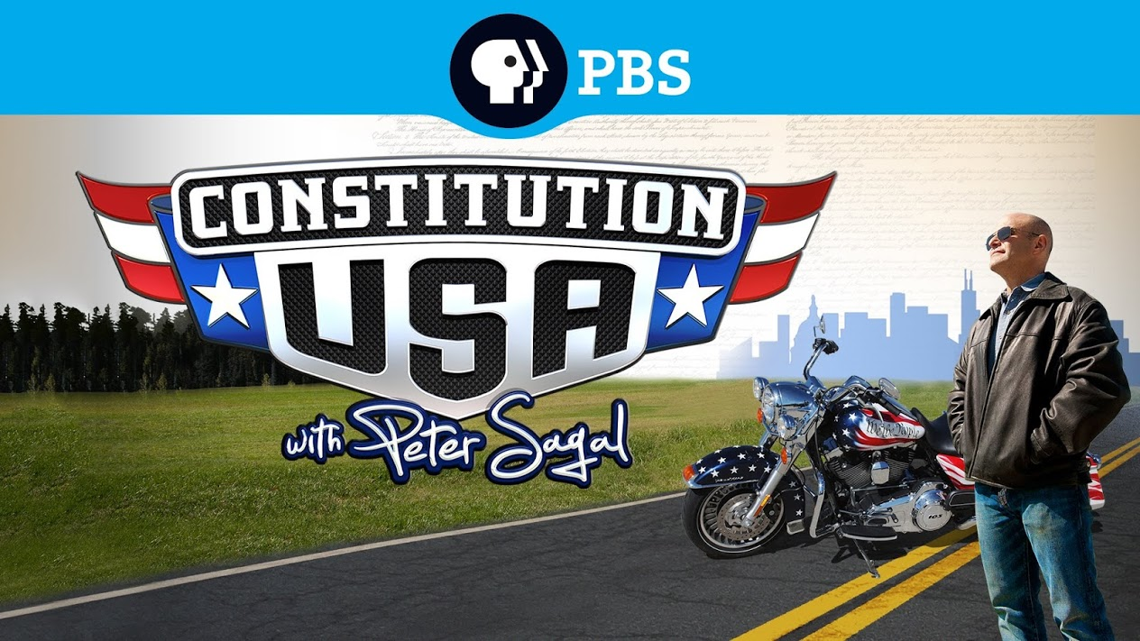
Basic US History
Unit 3 – Constituion and Voting
Constitution USA:
It’s A Free Country

Program Overview
The Constitution is all around us; it affects each of us, every day. We are told that it is the most important document in our daily lives, yet most people cannot even remember what it really says. Americans are
known for standing up for their rights and ensuring that their voices are heard, but where do these almost instinctual aspects come from? It is almost a part of our genetic make-up as Americans to dissent, but where does this expectation of rights find its genesis? It can be found in the American people and in our founding document, the Constitution. In this video series, we are going to explore the rule of law and the rights of the people. Have we struck the right balance in our country? Have we established a strong government while ensuring that our individual freedoms are safe and secure from tyranny? In this episode we explore the first ten amendments - the Bill of Rights - and examine what was written down in 1791, as well as how they have been interpreted and re-interpreted over the years.

1. What does the biker say is the reason why the Bill of Rights was added to the Constitution?

2. What does Peter Sagal identify as the purpose of the Constitution?

3. Do you believe all speech is protected or should some speech be banned?

4. Who in our national government has the task of insuring that our rights are protected?

5. What policy did Gideon’s legal fight put in place?

6. What are the arguments for and against removing the prayer banner?

7. Should the majority always rule?

8. What is the right of Eminent Domain?

9. When and where can you be searched without a warrant?

10. Give some easy examples of how people can dig into your privacy.

11. Does what you heard today make you want to re-evaluate your online activity?

12. Peter Sagan says “The Bill of Rights spells out our freedoms, but sometimes we’ve had to fight to claim them.” What right in the Bill of Rights would you be willing to fight for? Why?

