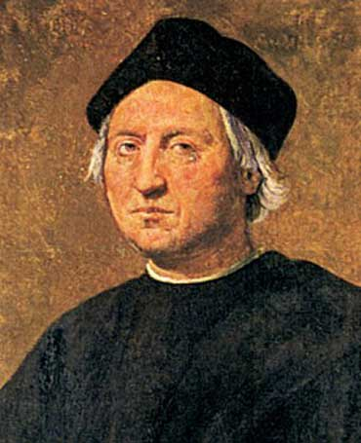
Christopher Columbus Biography

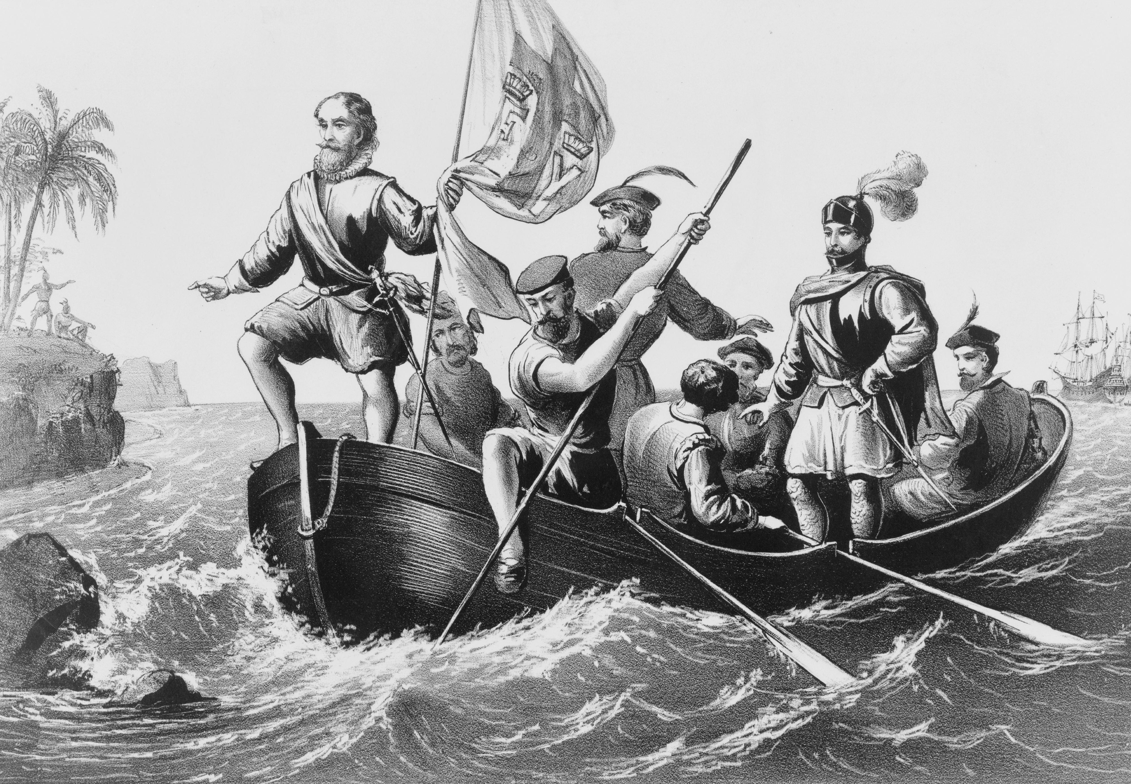
Christopher Columbus was born in Genoa, Italy in 1451. His career in exploration started when he was very young. As a teenager he traveled the seas and eventually made Portugal his base. He appealed to the kings of Portugal, France and England to finance a westward trip to the Indies, but all denied his request. After ten years of monumental efforts but fruitless results, King Ferdinand and Queen Isabella of Spain agreed to finance Columbus in the hopes of acquiring great wealth. On August 3, 1492, Columbus and three ships, the Nina, Pinta, and Santa Maria, left Palos, Spain and headed westward.
After stopping in the Canary Islands off the coast of Africa, Columbus' ships hit the open seas. Covering about 150 miles a day, the trip was long and arduous. The crew was afraid of sea monsters and grew more restless every day land was not sighted. Columbus offered a reward for the first person to sight land. On October 12, a crew member aboard the Pinta sighted one of the Bahama Islands. Columbus set foot on what he believed was one of the Spice Islands, a group of islands in Asia (now known as Indonesia), where valuable spices and riches came from. He named the land San Salvador. Columbus failed to find the riches he expected, and continued to search for China. He next visited Cuba and Hispaniola (Dominican Republic). He encountered native peoples who he named “Indians” because he believed they were inhabitants of the Indies.
Columbus returned to Spain a hero. He was named viceroy of the Indies. He soon returned to the New World but never found the riches he expected. Some began to believe that Columbus had found “a new world” rather that a shortcut to the Indies.
Christopher Columbus made one of the greatest discoveries in the history of the world - North America. Though he probably wasn't the first explorer to see the continent, and he believed until his death that the islands he encountered were in the Asian continent, his discoveries were instrumental in the establishment of Spanish colonies in North America. Today, we celebrate Columbus Day in October to commemorate his discoveries.

1. In what year was Christopher Columbus born? ____________________

2. On October 12, 1492, where did Columbus think he was? ____________________

3. About how many miles did the ships travel every day? ____________________

4. Which of the following is closest in meaning to “fruitless?”
A. Broken promise C. Without any cost
B. Without fruit D. Without success

5. What happened first?
A. King Ferdinand and Queen Isabella agreed to pay for the trip.
B. Columbus stopped in the Canary Islands
C. The Santa Maria left Spain and headed westward
D. October 12, 1492

6. What happened last?
A. Columbus was named viceroy of the Indies
B. Columbus encountered Indians
C. October 13, 1492
D. Spain set up colonies in the New World

7. What country eventually agreed to finance Christopher Columbus' trip?
A. France C. Spain
B. England D. Portugal

8. Which of the following was not a ship that went on the voyage?
A. Pinta C. Santa Maria
B. Santa Monica D. Nina

9. Christopher Columbus thought he could find a shortcut to the Indies by sailing......
A. West C. North
B. East D. South

10. Select all of the following places that Columbus visited on his voyage.
A. Florida C. Canary Islands
B. Cuba D. Dominican Republic

