Medieval and Renaissance Art on Display at the Museum of Fine Arts, Boston

The exercises that follow direct you to examine specific pieces of Medieval and Renaissance paintings on display at the Museum of Fine Arts in Boston.

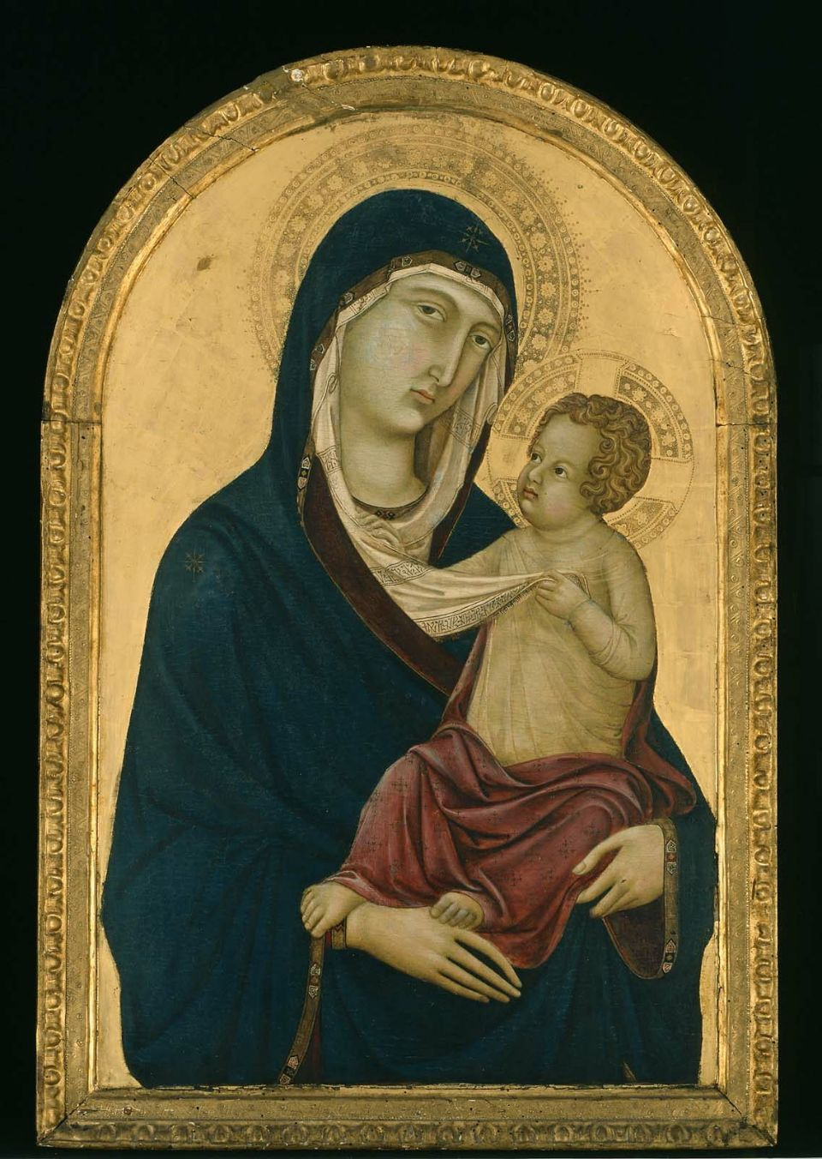
Ugolino di Nerio, Italian (Sienese), active in 1317–1339
Virgin and Child
about 1325–30
Tempera on panel
81.4 x 52.1 cm (32 1/16 x 20 1/2 in.)
16.65

What elements of this painting evidence it as being from the Medieval period?

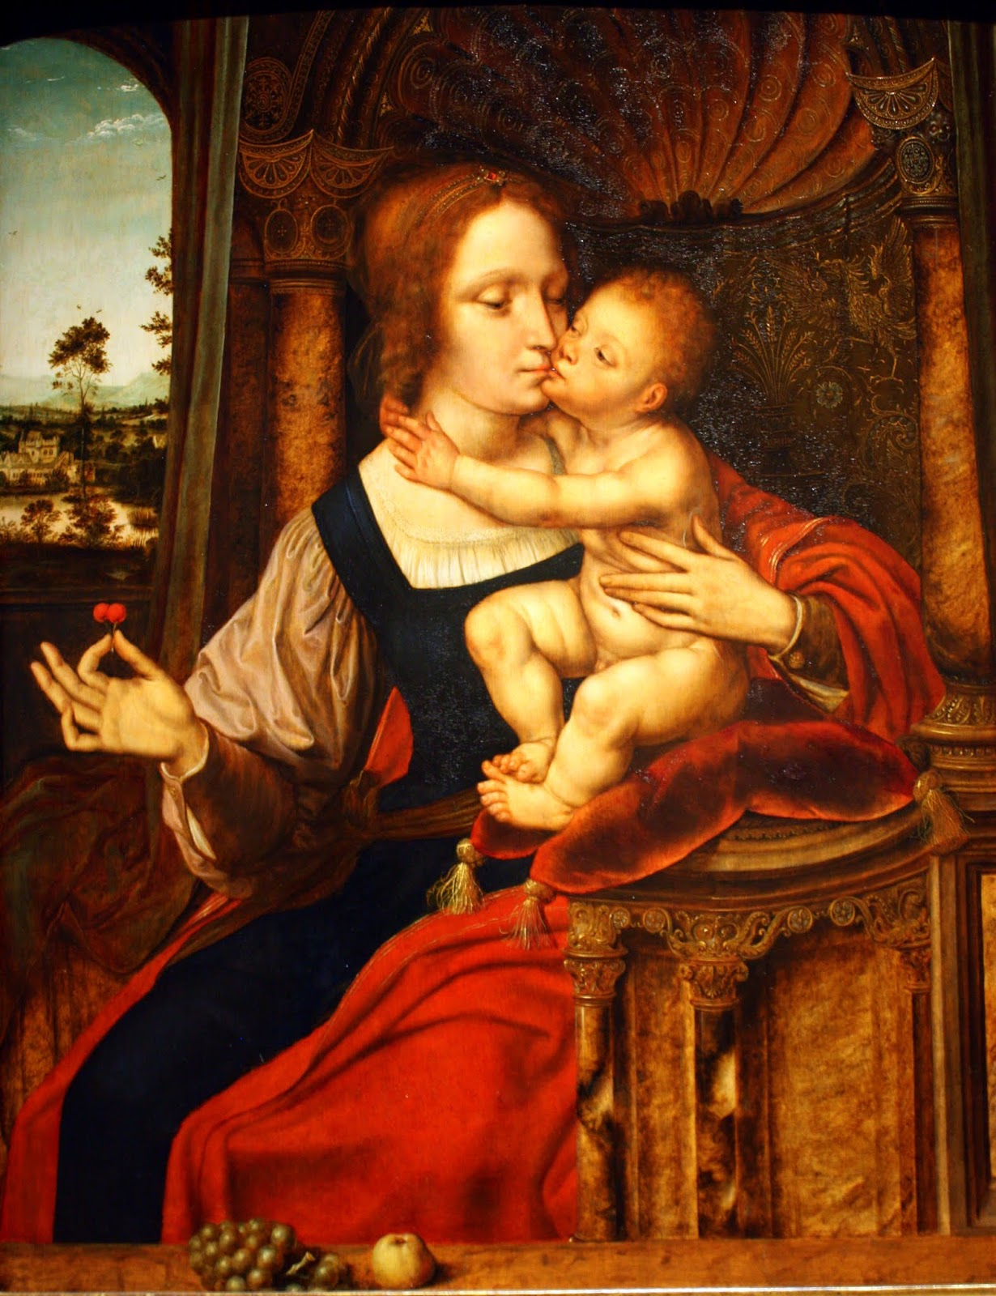

Quentin Massys (Netherlandish, 1466–1530)
Virgin and Child (Madonna of the Cherries)
Oil on panel
Overall (panel only): 75.9 x 62.9 cm
69.2009

How does the artist draw your attention to specific parts of this painting? What are the sections you are drawn to? Why is this important?

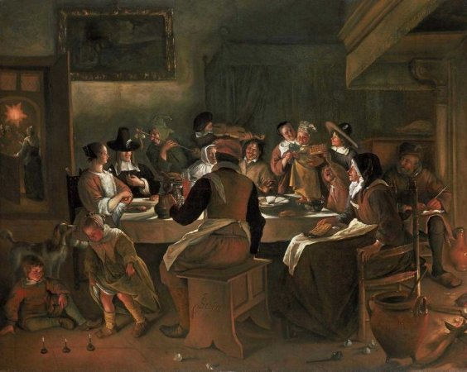
Jan Havicksz. Steen (Dutch, 1626–1679)
Twelfth-Night Feast
1662
Oil on canvas
Overall: 131.1 x 164.5cm (51 5/8 x 64 3/4in.)
54.102

What artistic styles used in this painting make it an accurate representation of Northern Renaissance Art?

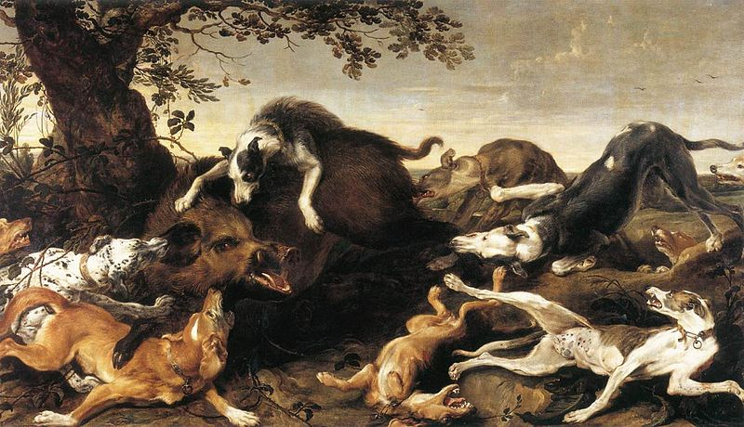
Frans Snyders (Flemish, 1579–1657)
Boar Hunt
about 1625–30
Oil on canvas
220.6 x 505.1 cm (86 7/8 x 198 7/8 in.)
17.322

This late-Renaissance era work is evidence of the shift of focus and form in painting. What are these changes, as evident in this piece?

El Greco (Domenikos Theotokopoulos) (Greek (active in Spain), 1541–1614)
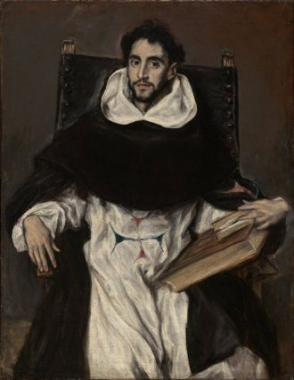
Fray Hortensio Félix Paravicino
1609
Oil on canvas
Overall: 112.1 x 86.1cm (44 1/8 x 33 7/8in.)
04.234

How does this portrait differ from those of other Renaissance-era artists? Use the artistic methods we discussed in class in your answer.

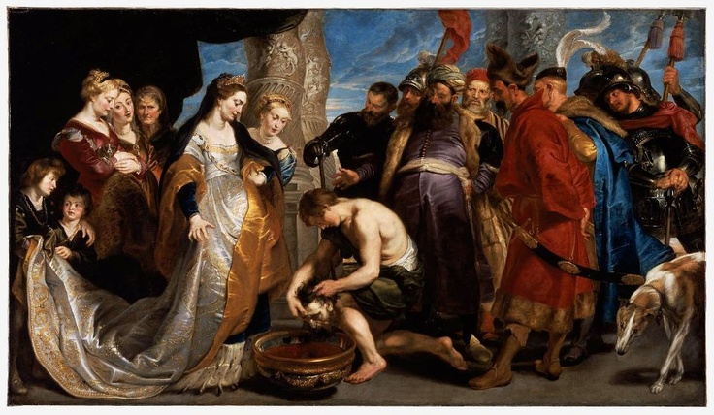
Peter Paul Rubens (Flemish, 1577–1640)
Head of Cyrus Brought to Queen Tomyris
about 1622–23
Oil on canvas
205.1 x 361 cm
41.40

What is the story behind this painting? Describe the scene both in terms of the tale it tells and the artistic methods used in its presentation.

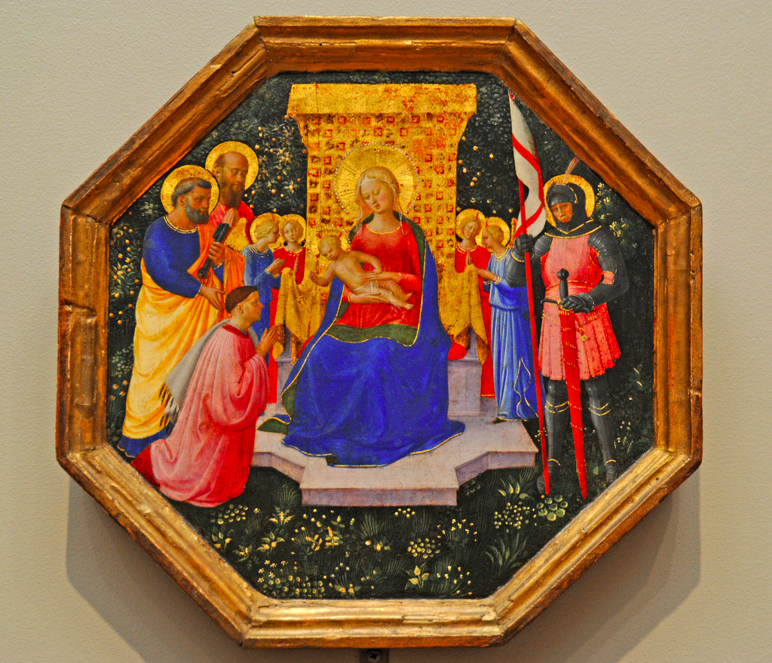
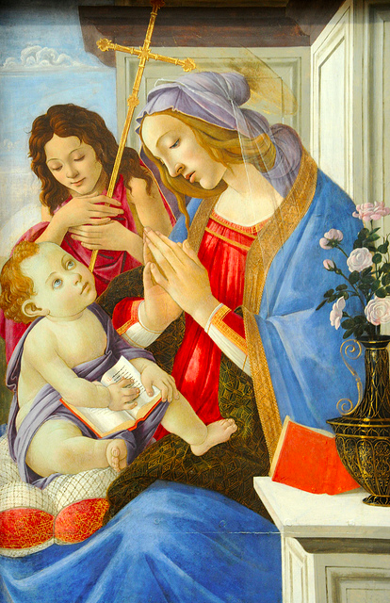
Sandro Botticelli (Italian (Florentine), 1444 or 1445–1510)
Virgin and Child with Saint John the Baptist
about 1500
Tempera on panel
123.8 x 84.4 cm (48 3/4 x 33 1/4 in.)
95.1372

Fra Angelico (Italian (Florentine), about 1395/1400–1455)
Virgin and Child Enthroned with Saints Peter, Paul and George (?), Four Angels, and a Donor about 1446–49
Tempera on panel
24.9 x 24.8 cm (9 13/16 x 9 3/4 in.)
103. 14.416

These two paintings, part of a special on-loan collection of the museum, are famous for their trademark early-Renaissance style. Identify their similarities and differences, noting why you think each exists.

