Basic US History

Unit 3 - The Constitution and Voting

Settling Western Land Claims

After completing the map, answer each of the following questions.

1. Which states did not have any western land claims?

_____________________________________________________________________________________

_____________________________________________________________________________________

2. Along what physical feature did the land claims stop? Who owned the land west of there?

_____________________________________________________________________________________

_____________________________________________________________________________________

_____________________________________________________________________________________

_____________________________________________________________________________________

Choose ONE of the following situations to write about.

> Imagine you represent a state with western land claims. What would you say to support your state’s claims?

> Imagine you represent a state without western land claims. What would say to convince the federal government that they should take over all the lands in dispute?

> Imagine you are a Native American who has been told that he and his family will have to move from their home because of a treaty signed with the US government. What would you say to your family?

_____________________________________________________________________________________

_____________________________________________________________________________________

_____________________________________________________________________________________

_____________________________________________________________________________________

_____________________________________________________________________________________

_____________________________________________________________________________________

_____________________________________________________________________________________

_____________________________________________________________________________________

_____________________________________________________________________________________

_____________________________________________________________________________________

_____________________________________________________________________________________

_____________________________________________________________________________________

_____________________________________________________________________________________

_____________________________________________________________________________________

_____________________________________________________________________________________

_____________________________________________________________________________________

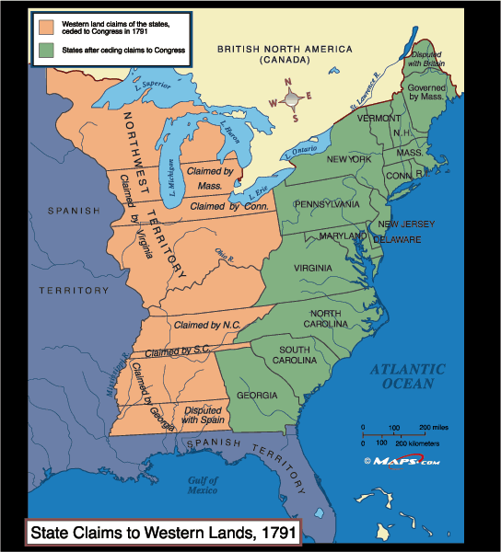

Label the original 13 states by name or postal abbreviation.

Label the five Great Lakes by name.

Label the Spanish Territory, British North America (Canada) and the Northwest Territory.

Draw the border lines for the land claims and label them by name.

Color each state and its land claims the same color, but a different color than any other state or territory that borders it.