Modern European History
Unit 9 – WWII
Schindler’s List Movie Questions

It’s September, 1939. General Sigmund List's armored divisions, driving north from the Sudetenland, have taken Cracow, Poland and now, in this club, drinking, socializing, conducting business, is a strange clientele: SS officers and Polish cops, gangsters and girls and entrepreneurs, thrown together by the circumstance of war.

1. Why does Oskar Schindler buy the NAZI soldiers dinner and drinks?

2. Why does Schindler want to buy the enamelware company that Itzhak Stern used to do the books for?

3. How does he get the money to buy it?

4. Why does Schindler prefer to hire Jews to work in his factory (rather than Poles)?

5. A Blauschein is a blue sticker that shows someone is an “essential worker.” How does the teacher get his Blauschein?

6. Describe the arrival, and swift departure, of Mrs. Schindler.

7. Why is Schindler so shaken when Mr. Lowenstein thanks him for his job?

8. Was Schindler’s concern about the workers shoveling snow financial or emotional?

9. Why is Schindler awoken early one morning and rushed to the train station?

10. What items were amassed at the train station? Why were they there?

11. Explain this quote by Amon Goeth: “For six centuries, there has been a Jewish Cracow. By this weekend, those six centuries, are a rumor. They never happened. Today is history.”

12. What was the significance of the “figure in red?”

13. How does Schindler ensure that his workers will be at work each day?

14. What happens to the man making hinges?

15. Describe the “stolen chicken” scene. What happens to the boy?

16. Why does Schindler get angry when the girl tells him that “everyone knows” that he is good?

17. What effect does Schindler’s “pardoning” discussion have on Goeth’s behavior?

18. What is the activity at the camp that causes the girls to put blood on their cheeks?

19. What happens to the children?

20. Why does Schindler bring fire hoses from the DEF (his factory)?

21. Why was Schindler arrested?

22. Where do we see “the figure in red” again?

23. Explain the significance of the following conversation between Schindler and Goeth:
Schindler: All you have to do is tell me what it's worth to you. What's a person worth to you.
Goeth: What's one worth to you? That's the question.

24. The men’s train arrives in Zwittau-Brinnlitz, Czechoslovakia, Schindler’s hometown, ahead of the women. Where does their train go? What happens to them there?

25. Explain this quote from Schindler: “Stern, if this factory ever produces a shell that can actually be fired... I'll be very unhappy.”

26. What sacrifice does Mr. Yaref make? What is made from “his sacrifice?” (hint 'Whoever saves one life, saves the world.')

27. What is the purpose of the letter the workers give to Schindler?

28. What happened to Amon Goeth?

29. What was the most moving scene of the film for you? Why?

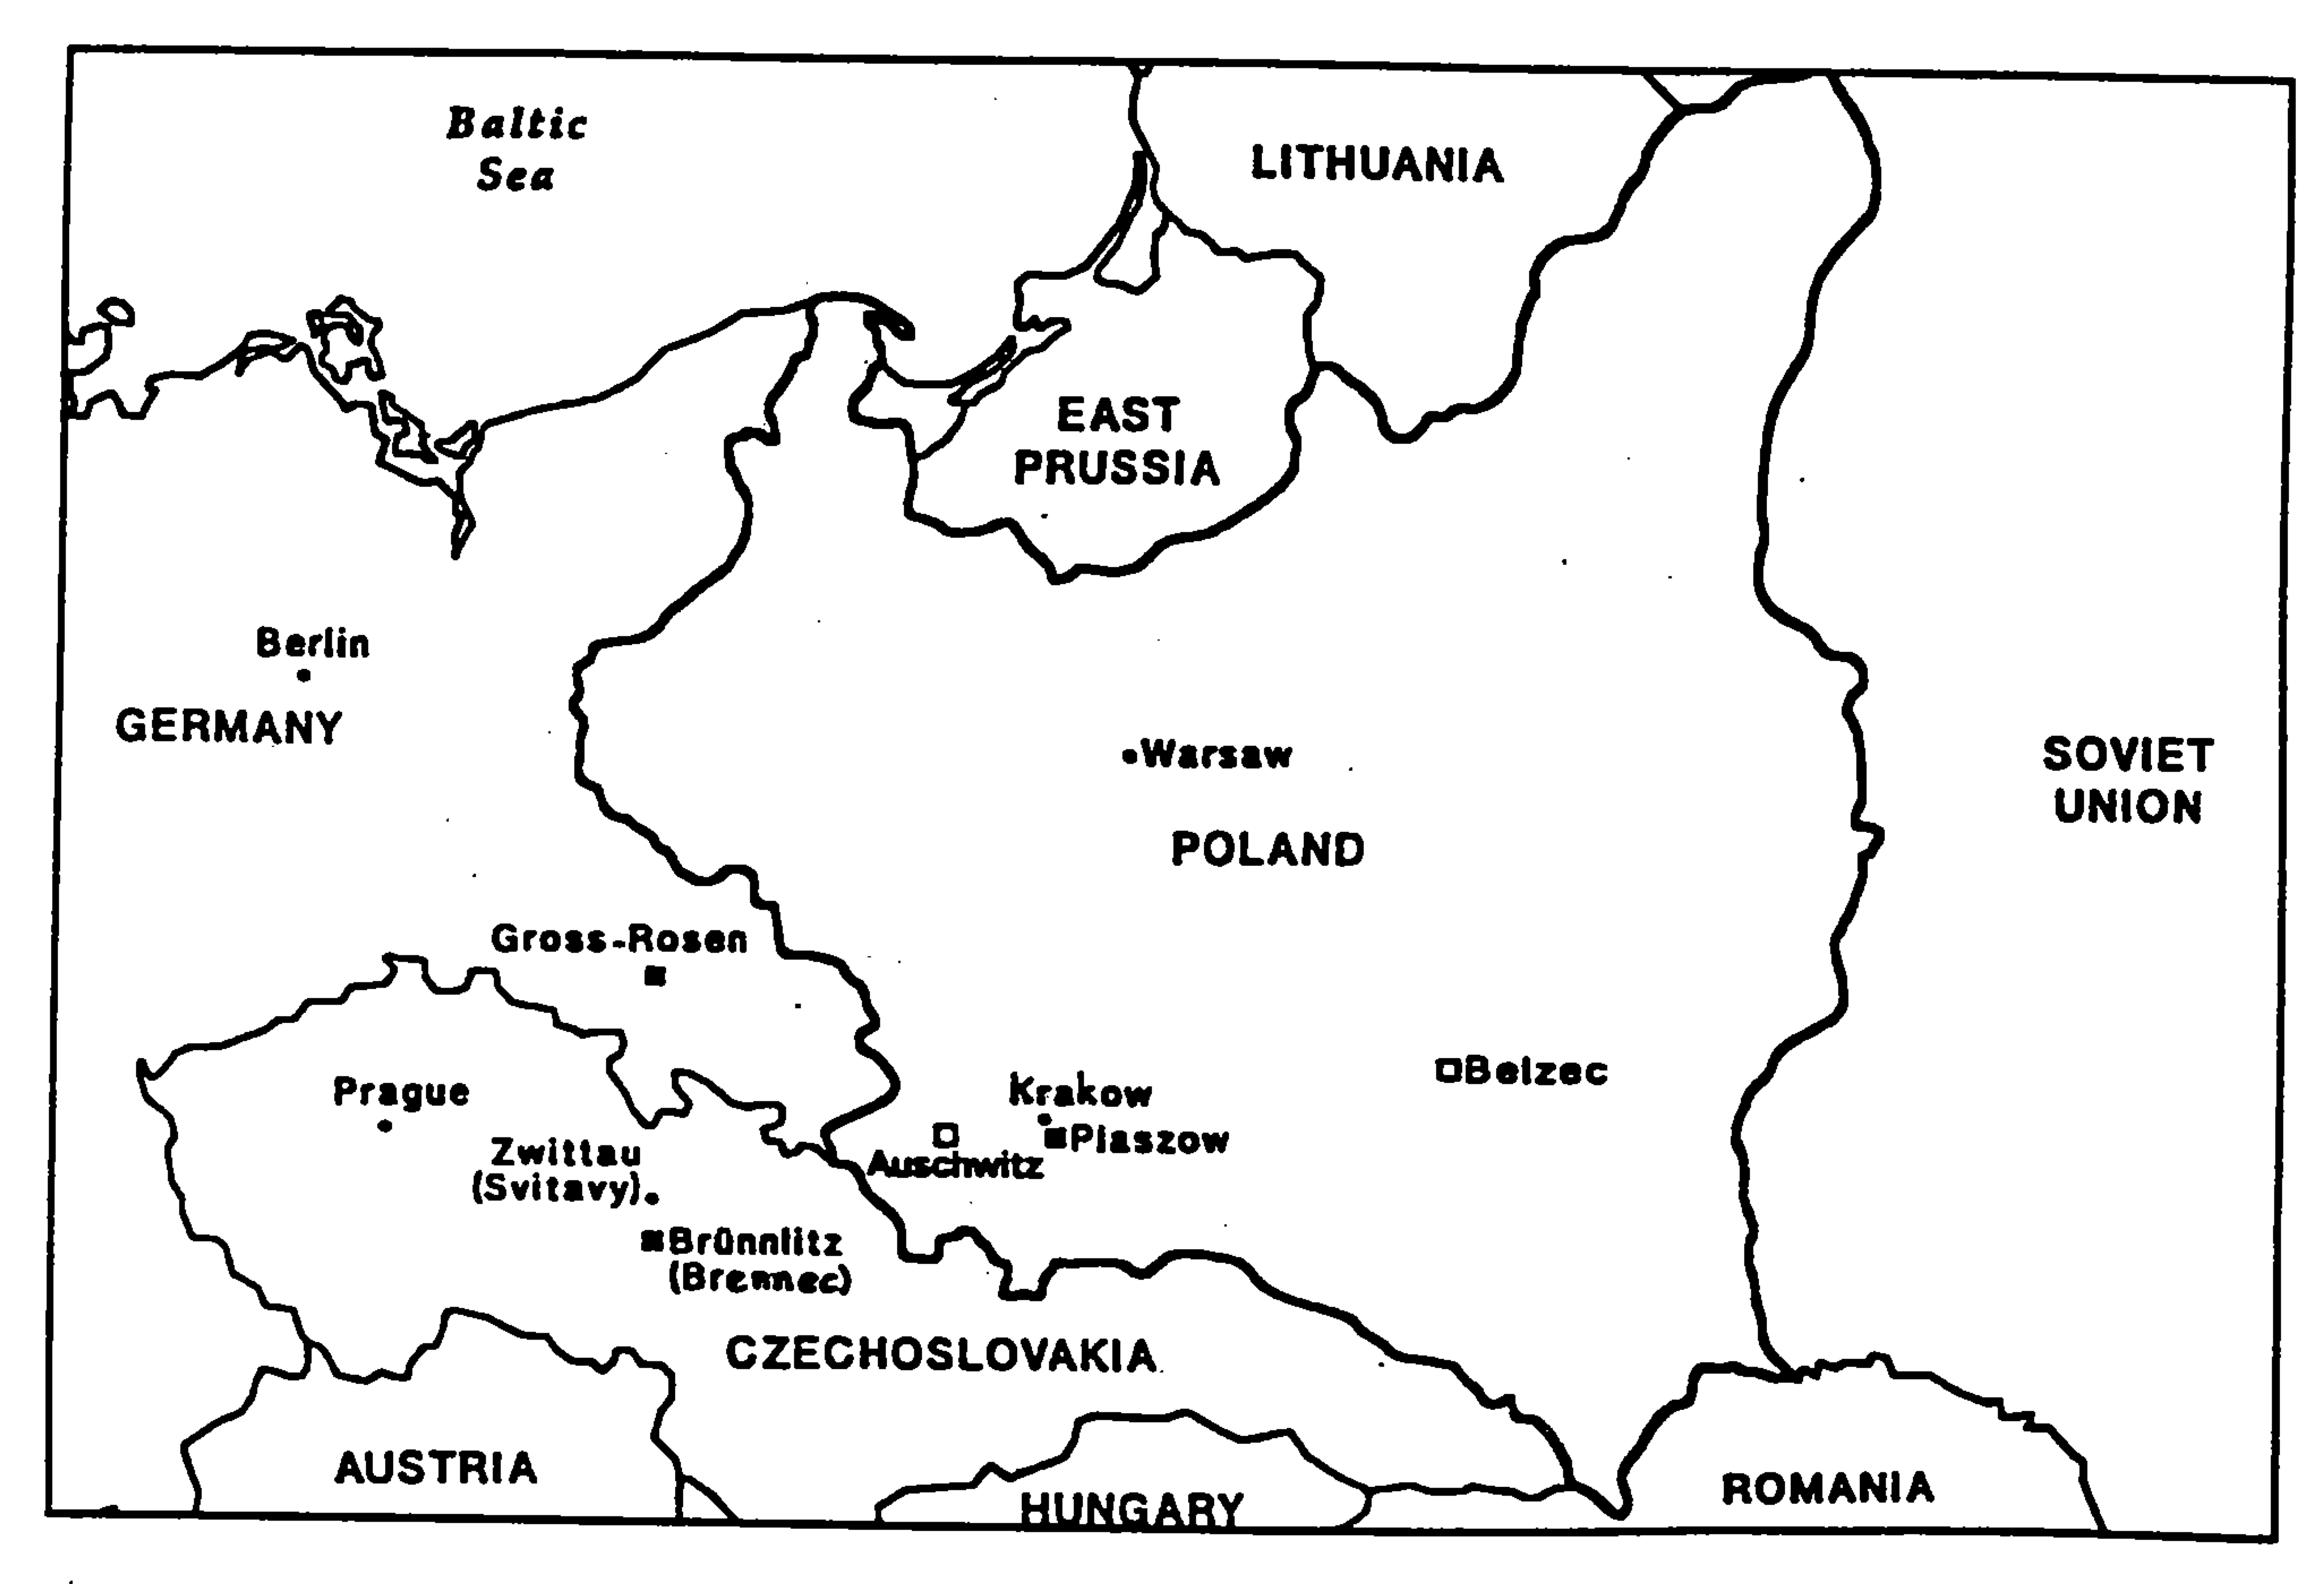
Chronology

April 28, 1908 Oskar Schindler is born in present-day Czechoslovakia

1914-1918 World War I; Czechoslovakia is established November 1918

1927 Schindler marries Emilie after a six week courtship

1935 Schindler family business goes bankrupt; father abandons mother

September 1938 Munich Conference, Sudetenland ceded to Nazi Germany

September 1, 1939 Nazi Germany invades Poland

September 17, 1939 Soviet Union invades Poland; Poland partitioned between Nazi Germany and Soviet Union

October 26, 1939 Krakow becomes capital of German-occupied Poland, the so-called General Government

November 10, 1939 Krakow Jews forced to wear blue-white armband with Star of David

December 1939 Schindler purchases enamel factory

March 20, 1941 Germans establish ghetto in suburb of Krakow

June 1942 Germans begin construction of labor camp at Plaszow

June 2, 1942 First deportations of Jews from Krakow to Belzec death camp

October 28, 1942 Second wave of deportations to Belzec

March 13, 1943 Final liquidation of ghetto

September 1944 Schindler's factory is closed; Schindlerjuden are taken to Plaszow

October 1944 Schindler prepares "list" of Jews he takes to Brunnlitz, Czechoslovakia

November 1944 Schindler rescues Jewish women from Auschwitz-Birkenau

May 8, 1945 Second World War ends; Brunnlitz camp liberated following day

April 28, 1962 Schindler named Righteous Gentile by Yad Vashem

October 9, 1974 Schindler dies in Frankfurt, West Germany; buried in Israel

