Modern European History

Unit 6 - Revolutions

Napoleon Timeline

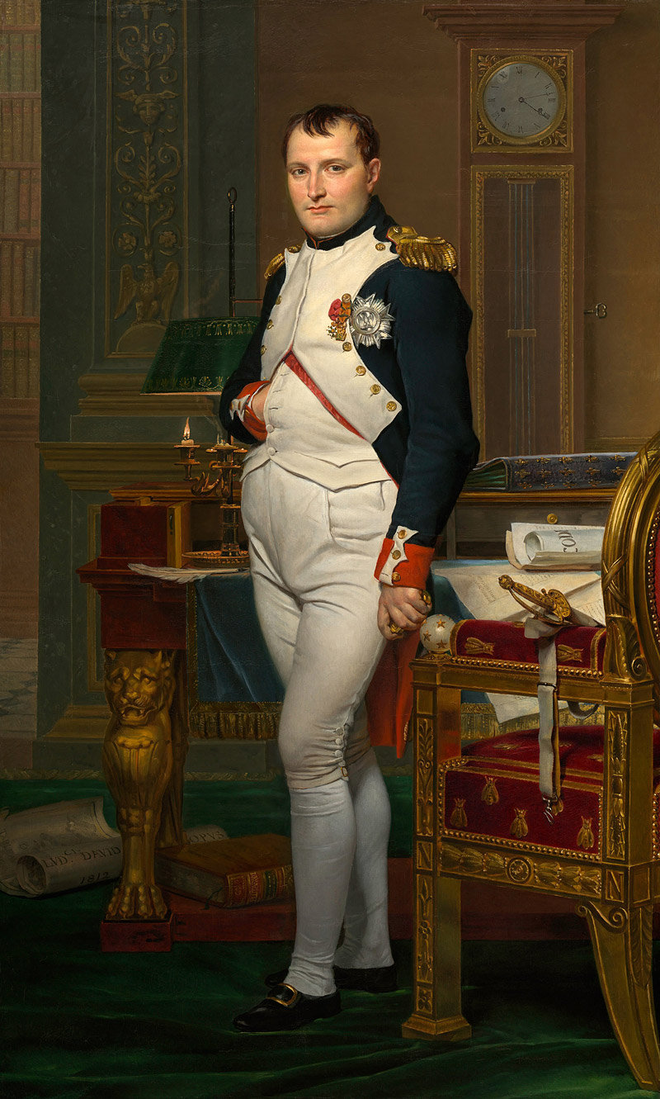

**Process**

1. Read and annotate the reading handout entitled “Who was Napoleon Bonaparte?”

2. Choose what you believe to be the ten most important events from Napoleon’s life.

> List them in order of their dates of occurrence.

> Identify the event by name and include a brief explanation of the details of the event.

3. You will now be matched with two other people.

> Each member of the group will share their ten events with the other two members.

> As a group, decide which ten events are the most important.

4. Plot this information on a visibly pleasing timeline.

*Suggestions:*

you could list the events by name and date on the timeline and then have a narrative of each event next to the name on the paper, with a numerical link to the argument for its importance that is located somewhere else on the poster

you could write the name of each event on the outside of a folded piece of paper; attach the folded paper to the appropriate date on the timeline for this event and the reader will unfold the paper to read the explanation of the event written on the inside

etc. etc. etc.

**Timeline Poster Format**

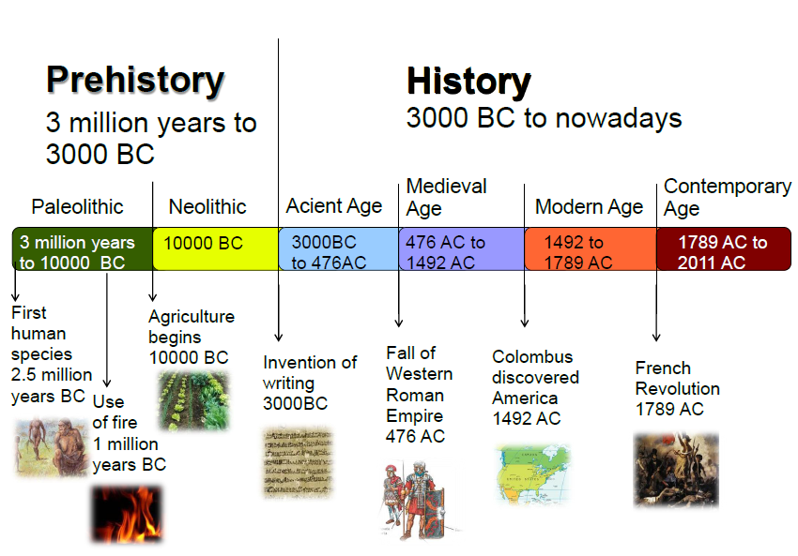

Your timeline poster must include:

all ten events, listed by name and in chronological order by date

explanations of each event

a presentation that is neat, colorful, organized, and informative

a timeline poster at least 17 x 22 in size (two 8 ½ x 11 sheets of paper taped side-by-side)