**Leonardo da Vinci**

The most famous artist in the world, Leonardo was nurtured by Lorenzo de'Medici. Botticelli, Michelangelo and da Vinci equalled unparalleled genius, now known as the “High Renaissance”. Leonardo was more than just an artist. It is argued that no man has ever studied more subjects or generated more ideas, than Leonardo da Vinci.

**Leonardo the artist**

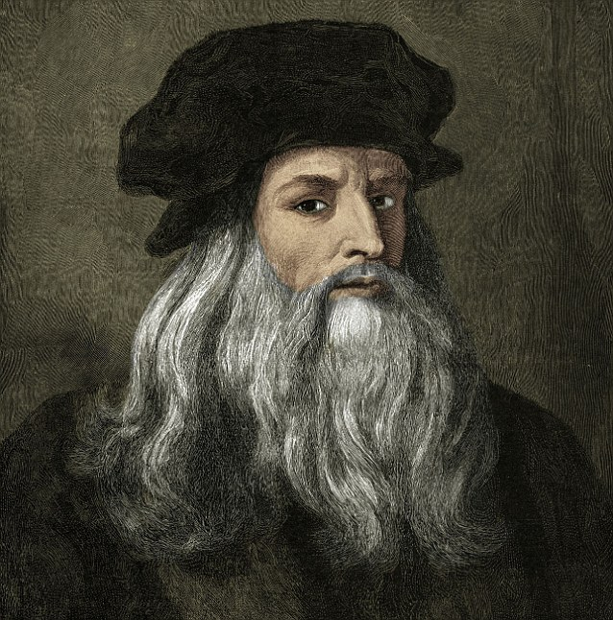Born in 1450, the son of a lawyer and his peasant lover, Leonardo, like thousands of talented boys, was drawn to Florence. He was soon employed by the painter and sculptor Verrochio, whose busy workshop served many powerful families, including the Medici. Even as an apprentice, Leonardo's talent was hard to ignore. His contribution to the “Baptism of Christ” was so vivid, it was said that Verrochio threatened to give up painting.

Leonardo was experimenting with oils, a radical technique previously known only in the Northern Europe. Traditionally, Italian artists had painted with egg tempera (pigment mixed with egg yolk or whites), a messy and smelly mixture which dried quickly and often appeared to crack. By mixing his pigment with oil, Leonardo discovered a more versatile colour, which could be built up in layers to add depth and tone, or even painted over, to cover mistakes. It was the start of an artistic revolution.

**Baptism of Christ**

Click on the image for a gallery view By 1481, Leonardo had outgrown Florence. He approached Lorenzo de'Medici for help. Lorenzo referred him to his friend, the Duke of Milan, whose needs were more practical than artistic. This suited Leonardo perfectly, as he had surpassed the need for just a studio and was desperate to build marvellous inventions. Once in Milan, he couldn't resist a commission that became the most famous fresco in history, “The Last Supper”.

Leonardo returned to Florence in 1504, and was drawn into a competition with the upstart, Michelangelo. Both artists were offered a wall of the government palace on which to paint frescoes of famous Florentine battles. Leonardo experimented unsuccessfully with his new technique, and his fresco soon fell off the wall. All that remains is a copy of his original design, or ‘cartoon’, a freeze-frame of a gruesome, action scene.

Italy soon descended into chaos, with warring armies carving their way from Milan to Rome. Leonardo fled to the French court of Francis I, where he ended his days working on the most famous portrait in the world, the “Mona Lisa”.

**Leonardo the scientist**

To be the ultimate Renaisssance man, one had to master every discipline, from natural science, engineering and architecture through to philosophy and art. Leonardo wrote detailed notes on all of these subjects, and in the margins he often left tantalizing doodles of astonishing machines, tanks, parachutes, helicopters, many of which might actually have worked.

Unlike his rival, Botticelli, who took inspiration from philosophical ideals and poetry, Leonardo was obsessed with the natural world. From a young age he was determined to reflect every detail.

“Nature is the source of all true knowledge. She has her own logic, her own laws, she has no effect without cause nor invention without necessity,” he said.

Throughout his life, Leonardo produced thousands of plant and animal studies particularly about horses. He struggled to capture the chaotic behaviour of water and also embarked on the most controversial practice of the day, the study of anatomy. Procuring corpses from the hospitals of Florence, Leonardo engaged in private dissection and research. He secretly discovered many features of human anatomy more than 200-years before they became common knowledge.

The Medieval Church condemned Leonardo's work, claiming it was anti-Christian and occult. Accused of black magic, he was forced to leave Italy and seek refuge at the more liberal court of the King of France.

Leonardo died on May 2, 1519 in Cloux, France. Legend has it that King Francis was at his side when he died, cradling Leonardo's head in his arms.

http://www.pbs.org/empires/medici/renaissance/leonardo.html