Basic US History

Unit 5 – The Civil War

Glory Movie Questions

Main Characters:

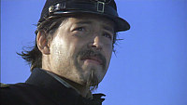 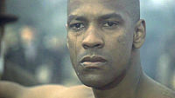

Col. Robert Gould Shaw (Matthew Broderick) Pvt. Trip (Denzel Washington)

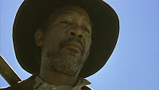 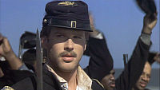

Sgt. Maj. John Rawlins (Morgan Freeman) Maj. Cabot Forbes (Cary Elwes)

Directions: You may answer the questions on another sheet of paper OR in the space provided. Be sure to answer each question thoroughly.

1. Where was Robert Shaw before and during the battle of Antietam?

2. What was Rawlins’ job?

3. Why did Col. Shaw and his majors have trouble forming companies of the men?

4. What would happen to the black soldiers who were captured with arms (guns)? What would happen if they were in uniform? What would happen to a white officer leading black soldiers?

5. How did the black soldiers act when they received their guns?

6. Why did Thomas have so much difficulty acting like a soldier?

7. Why was Trip deserting? What was his punishment and why was it really awful for him to be punished this way by his white officers?

8. How did the black soldiers react to the change made to how much they were being paid? What did the white officers do?

9. What honor was bestowed upon (given to) Rawlins?

10. What was the difference between how Montgomery’s “Contraband” regiment acted and how the 54th acted?

11. Why did Shaw agree to have his men set fire to the town?

12. What did the commanding officers say would probably happen to the men of the unit that would lead the attack on Fort Wagner?

13. Why is the fact that Shaw dismounted before the attack on Fort Wagner important?

14. Who picked up the flag when it fell and why was this person an unlikely one to do it?

15. What is important and/or symbolic about the fact that Trip and Shaw were buried next to each other?