Modern European History

*Elizabeth*

Dialogue Analysis

***Character List***

Elizabeth I (Cate Blanchett)

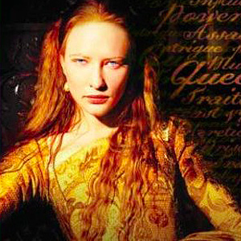

Walsingham (Geoffrey Rush)

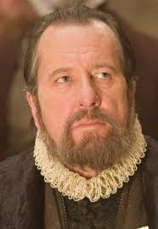

Sir Robert Dudley (Joseph Fiennes)

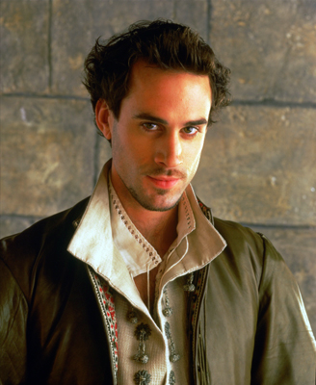

Duke of Norfolk (Christopher Eccleston)

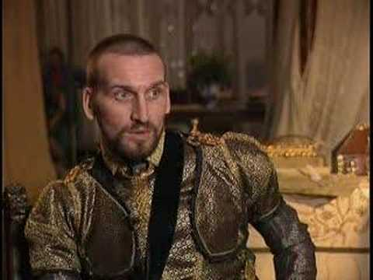

Duc d'Anjou (Vincent Cassel)

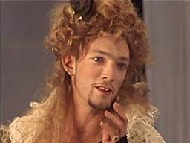

Sir William (Lord Burghley) (Richard Attenborough)

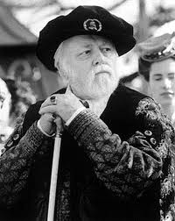

Mary of Guise (Fanny Ardant)  
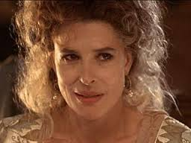

Queen Mary Tudor (Kathy Burke)

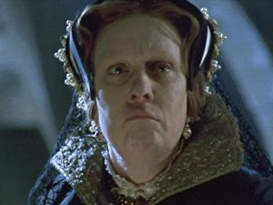

Bishop Gardiner (Terence Rigby)

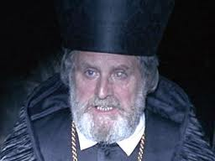

The Pope (John Gielgud)

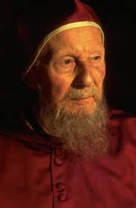

***Explain the following dialogues from Elizabeth:***

#1

Sussex: Princess Elizabeth. You are accused of conspiring with Sir Thomas White and others against her sovereign majesty. I have been commanded to take you hence from this place... to the tower. *(Elizabeth was arrested for conspiring with Sir Thomas Wyatt.)*

Sir Robert Dudley: Remember who you are. Do not be afraid of them.

#2

Queen Mary: When I look are you I see nothing of the king, only that whore, your mother. My father never did anything so good as to cut off her head.

Elizabeth: Your majesty forgets he was also my father.

#3

Queen Mary: Why will you not confess your crimes against me?

Elizabeth: Because, your majesty, I have committed none.

Elizabeth: *(Mary Moans in pain.)* Madam, you are not well.

Queen Mary: They say this cancer will make you queen, but they are wrong. Look there, that is your death warrant, all I need do is sign it.

Elizabeth: Mary, if you sign that paper you will be murdering your own sister.

#4

Elizabeth: When I am queen, I promise... to act as my conscience dictates.

Queen Mary: Then you are not to be queen at all.

#5

Elizabeth: This is the Lord's doing. And it is marvelous in our eyes.

#6

Elizabeth: Aye, but marry who, your grace? Would you give me some suggestion? For some say France and others Spain, and some cannot abide foreigners at all. So I am not sure how best to please you unless I married one of each.

#7

Elizabeth: *(On the Virgin Mary.)* She has such power over men's hearts. They would die for her.

Walsingham: They have found nothing to replace her. All men need something greater than them to look up to and worship. They must be able to touch the divine here on earth.

#8

Walsingham: All Norfolk need do is sign that paper and treason will have been committed...

Elizabeth: Then let him sign it, and let it all be done.

#9

Norfolk: I am Norfolk.

Walsingham: You were Norfolk. The dead have no titles. You were the most powerful man in England. And you could have been greater still, but you had not the courage to be loyal, only the conviction of your own vanity.

#10

Elizabeth: You will be kept alive to always remind me of how close I came to danger.

#11

Elizabeth: Observe, Lord Burghley, I am married... to England.