Modern European History

Unit 6 – Revolutions

The Restoration and Glorious Revolution Presentations

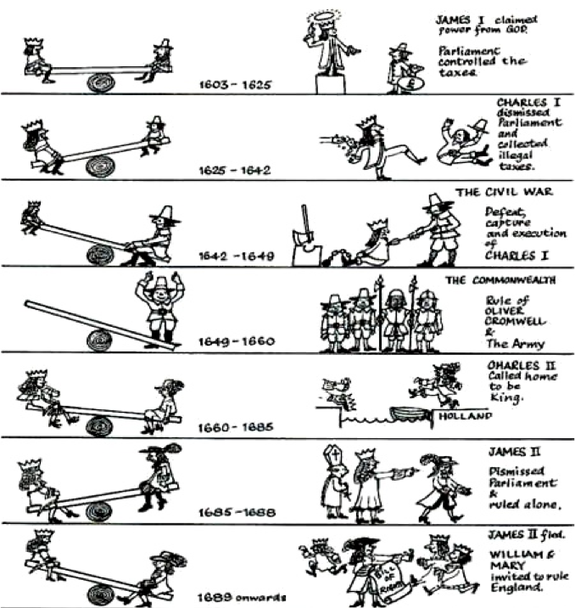

**Background**

When Queen Elizabeth I died, her cousin James, king of Scotland, became king of England. The reign of James I began a long series of struggles between king and Parliament. They fought over money. James’s religious policies also angered the Puritans in Parliament.

During the reign of his son, Charles I, there was continued conflict between king and Parliament. Parliament forced Charles to sign the Petition of Right in 1628. By signing, Charles agreed that the king had to answer to Parliament. But he then dissolved Parliament and tried to raise money without it.

When Charles tried to force Presbyterian Scots to follow the Anglican Church, Scotland threatened to invade England. Charles needed money to fight. When Charles called a new Parliament to get money, it quickly passed laws to limit his power.

Soon England was fighting a civil war. Charles and his Royalists were opposed by the supporters of Parliament. Many of Parliament’s supporters were Puritans.

The English Civil War lasted from 1642 to 1649. Under the leadership of Oliver Cromwell, the forces of the Puritans won. They tried and executed Charles for treason against Parliament. This was the first time a king had faced a public trial and execution. Cromwell became a military dictator, ruling until 1658. He crushed a rebellion in Ireland and tried to reform society at home.

**Task**

Your group will be responsible for presenting some information about what happened next in English history. Read and annotate the information below and decide as a group what the most important information is (should be included in your presentation). You will be given a computer with a Keynote slide template set up for you to adapt for your needs as well as a few other visuals/handouts to help you determine what information you should present.

*[Your presentation should be similar to what I usually give for notes during class (or BETTER!).]*

**Your group’s content:**

The Restoration

Cromwell ruled until his death in 1658. The army realized that it had lost popularity in the country, and it decided to restore the monarchy. Charles II, the son of Charles I, became king.

The restoration, or return, of the Stuart monarchy gave its name to this period in English history, which is known as the Restoration. The king was back, but this did not mean that the work of the English Revolution was undone and that things went back to the way they were before. Parliament was also back. It kept much of the power it had won during the civil war, and it continued to play an important role in government. The principle that Parliament must give its consent to taxation was accepted. King Charles continued to put forward and push his own ideas. However, many English people did not agree with a number of the king’s ideas.

Charles was sympathetic to Catholicism, and his brother James did not hide the fact that he was a Catholic. James was the heir to the throne. Parliament was concerned about the support of Catholicism by the king and his brother. Charles boldly suspended the laws that Parliament had passed against Catholics and Puritans after the restoration of the monarchy. Parliament was strongly opposed to this action, and it forced the king to end the policy. Parliament then passed a Test Act. This act rose out of strong anti-Catholic feelings. The act stated that only Anglicans, or members of the Church of England, could hold military and civil offices.

On his deathbed, Charles II decided to convert, or change his religion, to Catholicism. After Charles’s death in 1685, his brother James II became king. James was an open and devout Catholic. James began to name Catholics to high positions in the government, army, navy, and universities. Religion was once again a cause of conflict between king and Parliament.

Parliament opposed James’s policies but stopped short of rebellion. Members knew that James was an old man. They thought his Protestant daughters Mary and Anne, born to his first wife, would succeed him on the throne. However, in 1688, James and his second wife, a Catholic, had a son. Now, a Catholic monarchy was a real possibility.

**Your group’s content:**

A Glorious Revolution

*Part I*

Glorious means something that is wonderful. Supporters of the change in government from James II to William of Orange gave the events of 1689 the name the Glorious Revolution. The new rulers—William and his wife, Mary—were accepted by Parliament and by the people, and there was not much fighting in the process of the change.

The Dutch leader William of Orange was married to Mary, the daughter of King James II. A group of English nobles invited William to invade England. They told William that most of the people in the kingdom wanted a change in government. Their invitation put William in a difficult position because it would be a terrible act for Mary to fight against her father, James. However, William was already a foe of France’s Catholic king Louis XIV. For this reason, William welcomed an opportunity to become ruler of England and use England’s resources to fight his enemy, France.

William began to prepare to invade England in early 1688. He kept his plans secret. It was only in early October that James found out about William’s intentions. In November 1688, William’s forces landed at Torbay (an English town) and began their march toward London. James and his army rode out to meet them. However, many of James’ soldiers deserted, and even his daughter Anne and her husband defected. James retreated to London. He made plans for his wife and son to flee to France, and he later joined them there.

With almost no bloodshed, England had experienced what was called a “ Glorious Revolution.” From then on, the issue was not if there would be a monarchy, but who would be monarch.

**Your group’s content:**

A Glorious Revolution

*Part II*

In January 1689, Parliament offered the throne to William and Mary. William and Mary accepted the throne, but they also had to accept a Bill of Rights, which was written by Parliament. This bill contained many of the same ideas as the Petition of Right, which Parliament had presented to King Charles I in 1628. The Bill of Rights stated Parliament’s right to make laws and to levy taxes. It also made it impossible for kings to oppose Parliament or rule without it. It stated that standing, or permanent, armies could be raised only with Parliament’s consent. The rights of citizens to keep arms and to have a trial by jury were also confirmed. The Bill of Rights helped create a system of government based on the rule of law and a freely elected Parliament. This bill was the basis for a limited, or constitutional, monarchy. The monarch’s power now had clear limits.

Another important action of Parliament was the Toleration Act of 1689. This act gave Puritans the right to worship in public freely. Catholics, however, were not given the same right. The act was a turning point in English history because few English citizens were ever again persecuted for their religion.