PrepUS History
Unit 7 - Changing America
Trenches Activity

Although the specific construction of a trench was determined by the local terrain, most were built according to the same basic design. The front wall of the trench, known as the parapet, averaged ten feet high. Lined with sandbags from top to bottom, the parapet also featured two to three feet of sandbags stacked above ground level. These provided protection, but also obscured a soldier's view.
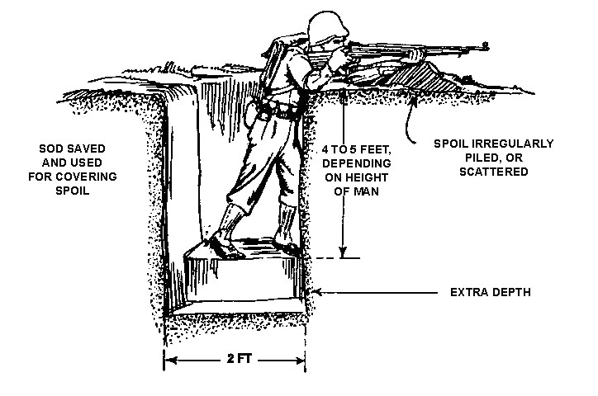
A ledge, known as the fire-step, was built into the lower part of the ditch and allowed a soldier to step up and see over the top (usually through a peep hole between sandbags) when he was ready to fire his weapon. Periscopes and mirrors were also used to see above the sandbags.

The rear wall of the trench, known as the parados, was lined with sandbags as well, protecting against a rear assault. Because constant shelling and frequent rainfall could cause the trench walls to collapse, the walls were reinforced with sandbags, logs, and branches.

Trenches were dug in a zigzag pattern so that if an enemy entered the trench, he could not fire straight down the line. Trench lines were connected by communicating trenches, allowing for the movement of messages, supplies, and soldiers and protected by fields of dense barbed wire. The area between the two opposing armies' front lines was known as "no man's land."

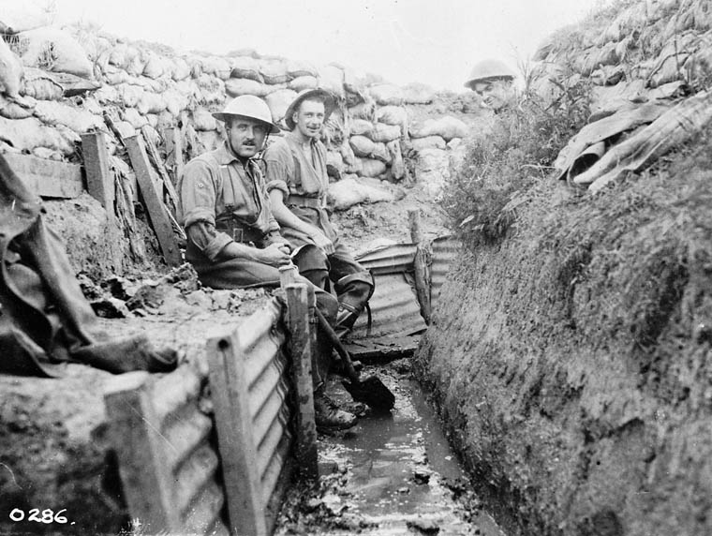
Some trenches contained dugouts below the level of the trench floor, often as deep as twenty or thirty feet. Most of these underground rooms were little more than crude cellars, but some - especially those farther back from the front - offered more conveniences, such as beds, furniture and stoves. The German dugouts were generally more sophisticated; one such dugout captured in the Somme Valley in 1916 was found to have toilets, electricity, ventilation, and even wallpaper.

Activity Guidelines
Using the information above and that you learned from your homework, draw a trench or system of trenches. Be sure to include and label each of the bold-faced words from above. Each member of your group must contribute a portion of the drawing and each individual’s contribution must be identified in a paragraph to accompany the drawing.

