PrepUS History
Unit 5 – The Civil War
“Treatment of the Slaves” ~ Alexander Falconbridge

The first African slaves were seized by the Portuguese to supply labor for their Brazilian sugar plantations. Late in the seventeenth century, after tobacco and sugar plantations were well established in North America, the Caribbean, and Brazil, the English created the Royal African company. From that time until its demise in the nineteenth century, the slave trade was dominated by the British. It was, in the word of one European trade, “a dreadful business.” Perhaps one-fourth of the slaves never survived the trip to the New World. Because perhaps 10 million slaves were taken from Africa to all the colonies in the Western Hemisphere between 1600 and 1830 it can safely be assumed that 2.5 million of them died along the way.

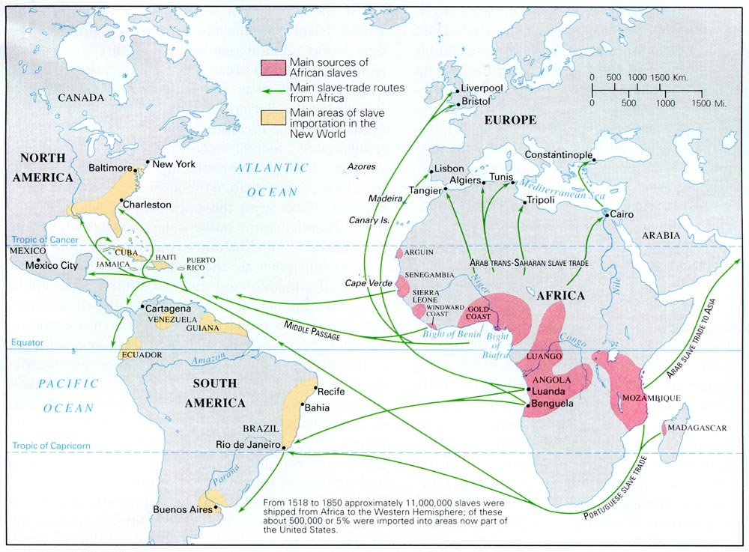

There were three stages to the enslavement of Africans. First, the slaves were captured by other Africans. Second, the African captors transported the newly acquired slaves from the interior of their countries to coastal exchange posts where European traders purchased them with rum, cotton cloth, guns, gunpowder, cowrie shells, brass rings, and pig iron. Finally, there was the third stage, the “Middle Passage” across the Atlantic to the New World. Hundreds of slaves were drowned in to the dark, damp holds of slave ships for months at a time, with little exercise, subsistence diets, and no sanitary facilities. The mortality rate from flu, dysentery, pleurisy, pneumonia, and smallpox was devastating.

"The following sheets are intended to lay before the public the present state of a branch of the British commerce, which, ever since its existence, has been held in detestation by all good men, but at this time more particularly engages the attention of the nation, and is become the object of general reprobation."

Thus begins Alexander Falconbridge's book, An Account of the Slave Trade on the Coast of Africa. Employed as a surgeon aboard various slave ships, Falconbridge had first-hand knowledge of many aspects of the slave trade, which he related in detail in his popular narrative. The book covered the trade from when the ships first acquired African captives along the African coast, through the treatment of these people during the Middle Passage, to the time they were sold into hereditary bondage in the West Indies. Popular with England's abolitionists, Falconbridge later became governor of a new colony established for freed slaves at Africa's Sierra Leone.

As soon as the wretched Africans, purchased at the fairs, fall into the hands of the black traders, they experience an earnest of those dreadful sufferings which they are doomed in future to undergo. And there is not the least room to doubt, but that even before they can reach the fairs, great numbers perish from cruel usage, want of food, travelling through inhospitable deserts, etc. They are brought from the places where they are purchased to Bonny, etc. in canoes; at the bottom of which they lie, having their hands tied with a kind of willow twigs, and a strict watch is kept over them. Their usage in other respects, during the time of passage, which generally lasts several days, is equally cruel. Their allowance of food is so scanty, that it is barely sufficient to support nature. They are, besides, much exposed to the violent rains which frequently fall here, being covered only with mats that afford but a slight defense; and as there is usually water at the bottom of the canoes, from their leaking, they are scarcely every dry.
Nor do these unhappy beings, after they become the property of the Europeans (from whom as a more civilized people, more humanity might naturally be expected), find their situation in the least amended. Their treatment is no less rigorous. The men Negroes, on being brought aboard the ship, are immediately fastened together, two and two, by handcuffs on their wrists, and irons riveted on their legs. They are then sent down between the decks, and placed in an apartment partitioned off for that purpose. The women likewise are placed in a separate room, on the same deck, but without being ironed. And an adjoining room, on the same deck is besides appointed for the boys. Thus are they placed in different apartments.

But at the same time, they are frequently stowed so close, as to admit of no other posture than lying on their sides. Neither will the height between decks, unless directly under the grating, permit them the indulgence of an erect posture; especially where there are platforms, which is generally the case. These platforms are a kind of shelf, about eight or nine feet in breadth, extending from the side of the ship towards the centre. They are placed nearly midway between the decks, at the distance of two or three feet from each deck. Upon these the Negroes are stowed in the same manner as they are on the deck underneath.

In each of the apartments are placed three or four large buckets, of a conical form, being near two feet in diameter at the bottom, and only one foot at the top, and in depth about twenty-eight inches, to which, when necessary, the negroes have recourse. It often happens, that those who are placed at a distance from the buckets, in endeavouring to get to them, tumble over their companions in consequence of their being shackled. These accidents, although unavoidable, are productive of continual quarrels, in which some of them are always bruised. In this distressed situation, unable to proceed, and prevented from getting to the tubs, they desist from the attempt; and as the necessities of nature are not to be repelled, ease themselves as they lie. This becomes a fresh source of broils and disturbances and tends to render the condition of the poor captive wretches still more uncomfortable. The nuisance arising from these circumstances is not infrequently increased by the tubs being much too small for the purpose intended, and their being usually emptied but once every day. The rule for doing this, however, varies in different ships, according to the attention paid to the health and convenience of the slaves by the captain.

About eight o’clock in the morning the negroes are generally brought upon deck. Their irons being examined, a long chain, which is locked to a ring-bolt, is run through the rings of the shackles of the men, and then locked to another ring-bolt, fixed also in the deck. By this means fifty or sixty, and sometimes more, are fastened to one chain, in order to prevent them from rising, or endeavouring to escape. If the weather proves favourable, they are permitted to remain in that situation till four or five in the afternoon, when they are disengaged from the chain, and sent down.

The diet of the Negroes while on board consists chiefly of horse beans boiled to the consistency of a pulp; of boiled yams and rice and sometimes a small quantity of beef or pork. The latter are frequently taken from the provisions laid in for the sailors. They sometimes make use of a sauce composed of palm-oil mixed with flour, water and pepper, which the sailors call slabber-sauce. Yams are the favorite food of the Eboe or Bight Negroes, and rice or corn of those from the Gold or Windward Coast; each preferring the produce of their native soil.

They are commonly fed twice a day, about eight o’clock in the morning and four in the afternoon. On most ships they are only fed with their own food once a day. Their food is served up to them in tubs, about the size of a small water bucket. They are placed round these tubs in companies of ten to each tub, out of which they feed themselves with wooden spoons. These they soon lose, and when they are not allowed others, they feed themselves with their hands. In favourable weather they are fed upon deck, but in bad weather their food is given them below. Numberless quarrels take place among them during their meals; more especially when they are put upon short allowance, which frequently happens, if the passage from the coast of Guinea to the West-India islands, proves of unusual length. In that case the weak are obliged to be content with a very scanty portion. Their allowance of water is about half a pint each at every meal. It is handed round in a bucket, and given to each negroe in a pannekin; a small utensil with a strait handle, somewhat similar to a sauce-boat. However, when the ships approach the islands with a favourable breeze, they are no longer restricted.

Upon the negroes refusing to take sustenance, I have seen coals of fire, glowing hot, put on a shovel, and placed so near their lips, as to scorch and burn them. And this has been accompanied with threats, of forcing them to swallow the coals, if they any longer persisted in refusing to eat. These means have generally had the desired effect. I have also been credibly informed, that a certain captain in the slave trade, poured melted lead on such of the negroes as obstinately refused their food.

Exercise being deemed necessary for the preservation of their health, they are sometimes obliged to dance, when the weather will permit their coming on deck. If they go about it reluctantly, or do not move with agility, they are flogged; a person standing by them all the time with a cat-o’-nine-tails in his hand for that purpose. Their musick, upon these occasions, consists of a drum, sometimes with only one head; and when that is worn out, they do not scruple to make use of the bottom of one of the tubs before described. The poor wretches are frequently compelled to sing also; but when they do so, their songs are generally, as may naturally be expected, melancholy lamentations of their exile from their native country.

On board some ships, the common sailors are allowed to have intercourse with such of the black women whose consent they can procure. And some of them have been known to take the inconstancy of their paramours so much to heart, as to leap overboard and drown themselves. The officers are permitted to indulge their passions among them at pleasure, and sometimes are guilty of such brutal excesses as disgrace human nature.

The hardships and inconveniences suffered by the Negroes during the passage are scarcely to be enumerated or conceived. They are far more violently affected by the seasickness than the Europeans. It frequently terminates in death, especially among the women. But the exclusion of the fresh air is among the most intolerable. For the purpose of admitting this needful refreshment, most of the ships in the slave trade are provided, between the decks, with five or six air-ports on each side of the ship, of about six inches in length, and four in breadth; in addition to which, some few ships, but not one in twenty, have what they denominate wind-sails. But whenever the sea is rough and the rain heavy, it becomes necessary to shut these, and every other conveyance by which the air is admitted. The fresh air being thus excluded, the Negroes' rooms very soon grow intolerably hot. The confined air, rendered noxious by the effluvia exhaled from their bodies, and by being repeatedly breathed, soon produces fevers and fluxes, which generally carries off great numbers of them.

During the voyages I made, I was frequently a witness to the fatal effects of this exclusion of the fresh air. I will give one instance, as it serves to convey some idea, though a very faint one, of the sufferings of those unhappy beings whom we wantonly drag from their native country, and doom to perpetual labour and captivity. Some wet and blowing weather having occasioned the port-holes to be shut, and the grating to be covered, fluxes and fevers among the negroes ensued. While they were in this situation, I frequently went down among them, till at length their apartments became so extremely hot, as to be only sufferable for a very short time. But the excessive heat was not the only thing that rendered their situation intolerable. The deck, that is, the floor of their rooms, was so covered with the blood and mucus which had proceeded from them in consequence of the flux, that it resembled a slaughter-house. It is not in the power of the human imagination, to picture to itself a situation more dreadful or disgusting. Numbers of the slaves having fainted, they were carried upon deck, where several of them died, and the rest were, with great difficulty, restored. It had nearly proved fatal to me also. The climate was too warm to admit the wearing of any clothing but a shirt, and that I had pulled off before I went down; notwithstanding which, by only continuing among them for about a quarter of an hour, I was so overcome with the heat, stench, and foul air, that I had nearly fainted; and it was not without assistance, that I could get upon deck. The consequence was, that I soon after fell sick of the same disorder, from which I did not recover for several months.

This ship, though a much smaller ship than that in which the event I just mentioned happened, took on board at Bonny, at least six hundred negroes; but according to the information of the black traders, from whom I received the intelligence immediately after the ship sailed, they amounted to near seven hundred. By purchasing so great a number, the slaves were so crowded, that they were even obliged to lie upon one another. This occasioned such a mortality among them, that without meeting with unusual bad weather or having a longer voyage than common, nearly half of them died before the ship arrived in the West-Indies.

The place allotted for the sick negroes is under the half deck, where they lie on the bare planks. By this means, those who are emaciated, frequently have their skin, and even their flesh, entirely rubbed off, by the motion of the ship, from the prominent parts of the shoulders, elbows, and hips, so as to render the bones in those parts quite bare. And some of them, by constantly lying in the blood and mucus, that had flowed from those afflicted with the flux, and which, as before observed, is generally so violent as to prevent their being kept clean, have their flesh much sooner rubbed off, than those who have only to contend with the mere friction of the ship. The excruciating pain which the poor sufferers feel from being obliged to continue in such a dreadful situation, frequently for several weeks, in case they happen to live so long, is not to be conceived or described. Few, indeed, are ever able to withstand the fatal effects of it. The utmost skill of the surgeon is here ineffectual. If plasters be applied, they are very soon displaced by the friction of the ship; and when bandages are used, the negroes very soon take them off, and appropriate them to other purposes.

The surgeon, upon going between decks, in the morning, to examine the situation of the slaves, frequently finds several dead; and among the men, sometimes a dead and living negroe fastened by their irons together. When this is the case, they are brought upon the deck, and being laid on the grating, the living negroe is disengaged, and the dead one thrown overboard.

It may not be improper here to remark, that the surgeons employed in the Guinea trade, are generally driven to engage in so disagreeable an employ by the confined state of their finances. An exertion of the greatest skill and attention could afford the diseased negroes little relief, so long as the causes of their diseases, namely, the breathing of a putrid atmosphere, and wallowing in their own excrements, remain. When once the fever and dysentery get to any height at sea, a cure is scarcely ever effected.

Almost the only means by which the surgeon can render himself useful to the Haves, is, by seeing that their food is properly cooked, and distributed among them. It is true, when they arrive near the markets for which they are destined, care is taken to polish them for sale, by an application of the lunar caustic to such as are afflicted with the yaws. This, however, affords but a temporary relief, as the disease most assuredly breaks our, whenever the patient is put upon a vegetable diet.

It has been asserted, in favour of the captains in this trade, that the sick staves are usually fed from their tables. The great number generally ill at a time, proves the falsity of such an assertion. Were even a captain disposed to do this, how could he feed half the staves in the ship from his own table I for it is well known, that more than half are often sick at a time. Two or three perhaps may be fed.

The loss of slaves, through mortality, arising from the causes just mentioned, are frequently very considerable. In the voyage lately referred to (not the Leverpool ship before-mentioned) one hundred and five, out of three hundred and eighty, died in the passage. A proportion seemingly very great, but by no means uncommon. One half, sometimes two thirds, and even beyond that, have been known to perish. Before we left Bonny River, no less than fifteen died of fevers and dysenteries, occasioned by their confinement. On the Windward Coast, where staves are procured more slowly, very few die, in proportion to the numbers which die at Bonny, and at Old and New Calabar, where they are obtained much faster; the latter being of a more delicate make and habit.

The havock made among the seamen engaged in this destructive commerce, will be noticed in another part; and will be found to make no inconsiderable addition to the unnecessary waste of life just represented.

As very sew of the negroes can so far brook the loss of their liberty, and the hardships they endure, as to bear them with any degree of patience, they are ever upon the watch to take advantage of the least negligence in their oppressors. Insurrections are frequently the consequence; which are seldom suppressed without much bloodshed. Sometimes these are successful, and the whole ship's company is cut off. They are likewise always ready to seize every opportunity for committing some act of desperation to free themselves from their miserable state j and notwithstanding the restraints under which they are laid, they often succeed.

While a ship, to which I belonged, lay in Bonny River, one evening, a short time before departure, a lot of negroes, consisting of about ten, was brought on board; when one of them, in a favourable moment, forced his way through the net-work on the larboard side of the vessel, jumped overboard, and was supposed to have been devoured by the sharks.

During the time we were there, fifteen negroes belonging to a vessel from Leverpool, found means to throw themselves into the river; very few were saved; and the residue fell a sacrifice to the sharks. A similar instance took place in a French ship while we lay there.

Circumstances of this kind are very frequent.

On the coast of Angola, at the River Ambris, the following incident happened: During the time of our residing on shore, we erected a tent to shelter ourselves from the weather. After having been there several weeks, and being unable to purchase the number of slaves we wanted, through the opposition of another English slave vessel, we determined to leave the place. The night before our departure, the tent was struck; which was no sooner perceived by some of the negroe women on board, than it was considered as a prelude to our sailing; and about eighteen of them, when they were sent between decks, threw themselves into the sea through one of the gun ports; the ship carrying guns between decks. They were all of them, however, excepting one, soon picked up; and that which was missing, was, not long after, taken about a mile from the shore.

I once knew a negroe woman, too sensible of her woes, who pined for a considerable time, and was taken ill of a fever and dysentery; when declaring it to be her determination to die, she refused all food and medical aid, and, in about a fortnight after, expired. On being thrown overboard, her body was instantly torn to pieces by the sharks.

The following circumstance also came within my knowledge. A young female negroe, falling into a desponding way, it was judged necessary, in order to attempt her recovery, to fend her on shore, to the hut of one of the black traders. Elevated with the prospect of regaining her liberty by this unexpected step, she soon recovered her usual cheerfulness; but hearing, by accident, that it was intended to take her on board the ship again, the poor young creature hung herself.

It frequently happens that the negroes on being purchased by the Europeans, become raving mad, and many of them die in that state; particularly the women. While I was one day ashore at Bonny, I saw a middle aged stout woman, who had been brought down from a fair the preceding day, chained to the post of a black S trader's door, in a state of furious insanity. On board a ship in Bonny River, I saw a young negroe woman chained to the deck, who had lost her senses, soon after he was purchased and taken on board. In a former voyage, on board a ship to which I belonged, we were obliged to confine a female negroe, of about twenty-three years of age, on her becoming a lunatic. She was afterwards fold during one of her lucid intervals.

One morning, upon examining the place allotted for the sick negroes, I perceived that one of them, who was so emaciated as scarcely to be able to walk, was miffing, and was convinced that he must have gone overboard in the night, probably to put a more expeditious period to his sufferings. And, to conclude on this subject, I could not help being sensibly affected, on a former voyage, at observing with what apparent eagerness a black woman seized some dirt from off an African yam, and put it into her mouth; seeming to rejoice at the opportunity of possessing some of her native earth.

From these instances I think it may be clearly deduced, that the unhappy Africans are not bereft of the finer feelings, but have a strong attachment to their native country, together with a just sense of the value of liberty. And the situation of the miserable beings above described, more forcibly urge the necessity of abolishing a trade which is the source of such evils, than the most eloquent harangue, or persuasive arguments could do.

Directions: Highlight or underline the portion of the text that answers each question, noting the question number next to the text portion.

1. Why were the first Africans seized?
2. What country dominated the slave trade until the nineteenth century?
3. How many slaves are estimated to have died along the way during the years of the slave trade?
4. What were the 3 stages of enslavement?
5. What were the slaves transported in from the middle of Africa to the coast?
6. How were the males and females processed differently when they entered the boat?
7. How much movement could they make?
8. What toilet facilities were available?
9. What were they allowed to do from 8 to 5 on days when there was good weather?
10. What did they eat on the ship?
11. How were they fed?
12. What was done to them if they refused to eat?
13. What did they do for exercise? What happened if they refused?
14. What types of interactions were allowed between the women and the sailors? The women and the officers?
15. What hardship does Falconbridge say was “the most intolerable?”
16. What covered the floor below deck?
17. How many slaves were on this voyage?
18. What happened to the skin of the sick sometimes?
19. What was done with the slaves that die?
20. What did the captain say he did for the ill slaves?
21. About what proportion of slaves perished?
22. What did slaves sometimes do to end their existence?

After reading the article, what evidence is there to suggest that even though the author feels this treatment is wrong, he still feels he (and his race) is superior? What are your feelings about that?

___________________________________________________________________

___________________________________________________________________

___________________________________________________________________

___________________________________________________________________

___________________________________________________________________

___________________________________________________________________

___________________________________________________________________

___________________________________________________________________

___________________________________________________________________

___________________________________________________________________

___________________________________________________________________

___________________________________________________________________

___________________________________________________________________

