PrepUS History

Unit 8 - WWII and Beyond

The War Ends

**The Third Reich Collapses**

Although D-Day had been a success, it was only the beginning. Surrounding many fields in Normandy were hedgerows—dirt walls, several feet thick, covered in shrubbery—built to fence in cattle and crops. They also enabled the Germans to fiercely defend their positions. The battle of the hedgerows ended on July 25, 1944, when 2,500 U.S. bombers blew a hole in the German lines, enabling U.S. tanks to race through the gap.

As the Allies broke out of Normandy, the French Resistance— French civilians who had secretly organized to resist the German occupation—staged a rebellion in Paris. When the Allies liberated Paris on August 25, the streets were filled with French citizens celebrating their victory.

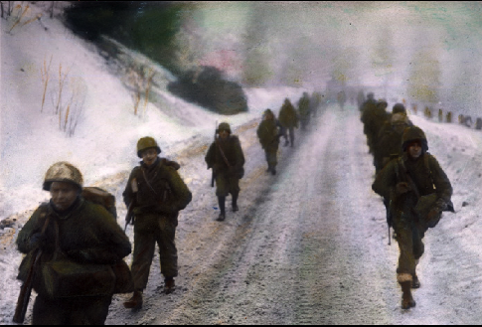**The Battle of the Bulge**

As the Allies advanced toward the German border, Hitler decided to stage one last desperate offensive. His goal was to cut off Allied supplies coming through the port of Antwerp, Belgium. The attack began just before dawn on December 16, 1944. Six inches (15 cm) of snow covered the ground, and the weather was bitterly cold. Moving rapidly, the Germans caught the American defenders by surprise. As the German troops raced west, their lines bulged outward, and the attack became known as the Battle of the Bulge.

Eisenhower ordered General Patton to the rescue. Three days later, faster than anyone expected in the midst of a snowstorm, Patton’s troops slammed into the German lines. As the weather cleared, Allied aircraft began hitting German fuel depots.

On Christmas Eve, out of fuel and weakened by heavy losses, the German troops driving toward Antwerp were forced to halt. Two days later, Patton’s troops broke through to the German line. Fighting continued for three weeks, but the United States had won the Battle of the Bulge. On January 8, the Germans began to withdraw, having suffered more than 100,000 casualties. They had very few resources left to prevent the Allies from entering Germany.

**The War Ends in Europe**

While American and British forces fought to liberate France, the Soviets attacked German troops in Russia. By the end of the Battle of the Bulge, the Soviets had driven Hitler’s forces out of Russia and across Poland. By February 1945, the Soviets were only 35 miles (56 km) from Germany’s capital, Berlin.

Soviet troops crossed Germany’s eastern border, while American forces attacked its western border. By the end of February 1945, American troops had reached the Rhine River, Germany’s last major line of defense in the west. On March 7, American tanks crossed the Rhine. As German defenses crumbled, American troops raced east to within 70 miles (113 km) of Berlin. On April 16, Soviet troops finally smashed through the German defenses and reached the outskirts of Berlin five days later.

Deep in his Berlin bunker, Adolf Hitler knew the end was near. On April 30, 1945, he committed suicide. On May 7, 1945, Germany accepted the terms for an unconditional surrender. The next day—May 8, 1945— was proclaimed V-E Day, for “Victory in Europe.”

**Japan Is Defeated**

Unfortunately, President Roosevelt did not live to see the defeat of Germany. On April 12, 1945, while vacationing in Warm Springs, Georgia, he died of a stroke. His vice president, Harry S. Truman, became president during this difficult time.

The next day, Truman told reporters: “Boys, if you ever pray, pray for me now. . . . When they told me yesterday what had happened, I felt like the moon, the stars, and all the planets had fallen on me.” Despite his feelings, Truman began at once to make decisions about the war. Although Germany surrendered a few weeks later, the war with Japan continued, and Truman was forced to make some of the most difficult decisions of the war during his first six months in office.

**The Battle of Iwo Jima**

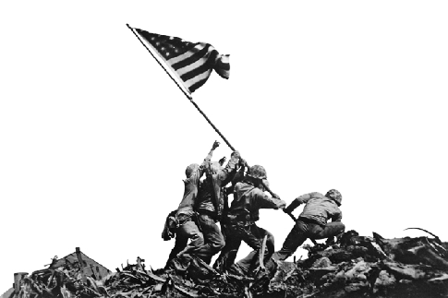On November 24, 1944, bombs fell on Tokyo. Above the city flew 80 B-29 Superfortress bombers that had traveled more than 1,500 miles (2,414 km) from new American bases in the Mariana Islands. Many of their bombs missed the targets. By the time the B-29s reached Japan, they did not have enough fuel left to fix their navigational errors or to adjust for high winds. The pilots needed an island closer to Japan so the B-29s could refuel. American military planners chose Iwo Jima.

Iwo Jima was perfectly located, roughly halfway between the Marianas and Japan, but its geography was formidable. It had a dormant volcano at its southern tip and rugged terrain with rocky cliffs, jagged ravines, and dozens of caves. Volcanic ash covered the ground. Even worse, the Japanese had built a vast network of concrete bunkers connected by miles of tunnels.

On February 19, 1945, some 60,000 marines landed on Iwo Jima. As the troops leaped from the amphtracs, they sank up to their ankles in the soft ash and were pounded by Japanese artillery. The marines crawled inland, attacking the Japanese bunkers with flamethrowers and explosives. More than 6,800 marines were killed capturing the island. Admiral Nimitz later wrote that, on Iwo Jima, “uncommon valor was a common virtue.”

**Firebombing Japan**

While American engineers prepared airfields on Iwo Jima, General Curtis LeMay, commander of the B-29s based in the Marianas, changed strategy. To help the B-29s hit their targets, he ordered them to drop bombs filled with napalm—a type of jellied gasoline. The bombs would not only explode but would also start fires. Even if the B-29s missed their targets, the fires they started would spread to the intended targets.

The use of firebombs was very controversial because the fires would also kill civilians; however, LeMay could think of no other way to destroy Japan’s war production quickly. Loaded with firebombs, B-29s attacked Tokyo on March 9, 1945. As strong winds fanned the flames, the firestorm grew so intense that it sucked the oxygen out of the air, asphyxiating thousands. As one survivor later recalled:

*"The fires were incredible . . . with flames leaping hundreds of feet into the air. . . . With every passing moment the air became more foul . . . the noise was a continuing crashing roar. . . . Fire-winds filled with burning particles rushed up and down the streets. I watched people . . . running for their lives. . . . The flames raced after them like living things, striking them down. . . . Wherever I turned my eyes, I saw people . . . seeking air to breathe."*

*~ quoted in* American Heritage New History of World War II

The firebombing of Tokyo killed more than 80,000 people and destroyed more than 250,000 buildings. By the end of June 1945, Japan’s six key industrial cities had been firebombed. By the end of the war, the B-29s had firebombed 67 Japanese cities.

**The Invasion of Okinawa**

Despite the massive damage that firebombing caused, there were few signs in the spring of 1945 that Japan was ready to quit. Many American officials believed the Japanese would not surrender until Japan had been invaded. To prepare for the invasion, the United States needed a base near Japan to stockpile supplies and build up troops. Iwo Jima was small and still too far away. Military planners chose Okinawa—only 350 miles (563 km) from mainland Japan.

American troops landed on Okinawa on April 1, 1945. Instead of defending the beaches, the Japanese troops took up positions in the island’s rugged mountains. To dig the Japanese out of their caves and bunkers, the American troops had to fight their way up steep slopes against constant machine gun and artillery fire. More than 12,000 American soldiers, sailors, and marines died during the fighting, but by June 22, 1945, Okinawa had finally been captured.

**The Terms for Surrender**

Shortly after the United States captured Okinawa, the Japanese emperor, Hirohito, urged his government to find a way to end the war. The biggest problem was the American demand for unconditional surrender. Many Japanese leaders were willing to surrender, but on one condition: Hirohito had to stay in power.

American officials knew that the fate of Hirohito was the most important issue for the Japanese. Most Americans, however, blamed the emperor for the war and wanted him removed from power. President Truman was reluctant to go against public opinion. Furthermore, he knew the United States was almost ready to test a new weapon that might force Japan to surrender without any conditions. The new weapon was the atomic bomb.

**The Manhattan Project**

In 1939 Leo Szilard, a Jewish physicist who had fled Nazi persecution, learned that German scientists had split the uranium atom. Szilard had been the first scientist to suggest that splitting the atom might release enormous energy. Worried that the Nazis were working on an atomic bomb, Szilard convinced the world’s best-known physicist, Albert Einstein, to sign a letter Szilard had drafted and send it to President Roosevelt. In the letter, Einstein warned that by using uranium, “extremely powerful bombs of a new type may . . . be constructed.”

Roosevelt responded by setting up a scientific committee to study the issue. In 1941 the committee met with British scientists who were already working on an atomic bomb. The Americans then convinced Roosevelt to begin a program to build an atomic bomb.

The secret American program to build an atomic bomb was code-named the Manhattan Project and was headed by General Leslie R. Groves. The first breakthrough came in 1942, when Szilard and Enrico Fermi, another physicist, built the world’s first nuclear reactor at the University of Chicago. Groves then organized a team of engineers and scientists to build an atomic bomb at a secret laboratory in Los Alamos, New Mexico. Physicist J. Robert Oppenheimer led the team. On July 16, 1945, they detonated the world’s first atomic bomb in New Mexico.

**Hiroshima and Nagasaki**

Even before the bomb was tested, American officials began debating how to use it. Admiral William Leahy, chairman of the Joint Chiefs of Staff, opposed using the bomb because it would kill civilians. He believed an economic blockade and conventional bombing would convince Japan to surrender. Secretary of War Henry Stimson wanted to warn the Japanese about the bomb and tell them their emperor could stay in power if they surrendered. Secretary of State James Byrnes, however, wanted to drop the bomb on Japan without any warning.

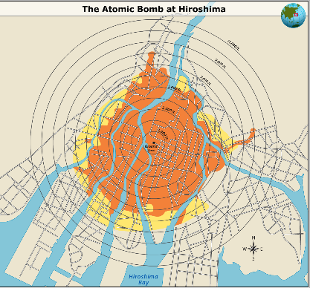President Truman later wrote that he “regarded the bomb as a military weapon and never had any doubts that it should be used.” His advisers had warned him to expect massive casualties if the United States invaded Japan. Truman believed it was his duty as president to use every weapon available to save American lives.

The Allies threatened Japan with “prompt and utter destruction” if the nation did not surrender, but the Japanese did not reply. Truman then ordered the military to drop the bomb. On August 6, 1945, a B-29 bomber named Enola Gay dropped an atomic bomb, code-named “Little Boy,” on Hiroshima, an important industrial city.

The bomb destroyed about 63 percent of the city. Between 80,000 and 120,000 people died instantly, and thousands more died later from burns and radiation sickness. Three days later, on August 9, the Soviet Union declared war on Japan. Later that day, the United States dropped another atomic bomb, code-named “Fat Man,” on the city of Nagasaki, killing between 35,000 and 74,000 people. Faced with such massive destruction and the shock of the Soviets joining the war, Hirohito ordered his government to surrender. On August 15, 1945—V-J Day—Japan surrendered. The long war was over.

**Putting the Enemy on Trial**

In August 1945, the United States, Britain, France, and the Soviet Union created the International Military Tribunal (IMT) to punish German and Japanese leaders for war crimes. The tribunal held trials in Nuremberg, Germany, where Hitler had staged Nazi Party rallies.

Twenty-two German leaders were prosecuted at the Nuremberg Trials. Three were acquitted, 7 were given prison sentences, and 12 were sentenced to death. Trials of lower-ranking leaders continued until April 1949, leading to 24 more executions and 107 prison sentences.

Similar trials were held in Tokyo. The IMT for the Far East charged 25 Japanese leaders with war crimes. The Allies did not indict Hirohito, fearing that any attempt to put the emperor on trial would lead to an uprising. Eighteen Japanese defendants were sentenced to prison. The rest were sentenced to death by hanging.

The trials punished many of the people responsible for World War II and the Holocaust, but they were also part of the American plan for building a better world. As Robert Jackson, chief counsel for the United States at Nuremberg, said in his opening statement to the court: “The wrongs we seek to condemn and punish have been so calculated, so malignant and so devastating, that civilization cannot tolerate their being ignored because it cannot survive their being repeated.”

**Short Answer**

1. Who were the French Resistance?

______________________________________________________________________________

______________________________________________________________________________

2. How did the U.S. army break out of Normandy?

______________________________________________________________________________

______________________________________________________________________________

3. What was Hitler's last offensive called?

______________________________________________________________________________

______________________________________________________________________________

4. What was the result of the Battle of the Bulge?

______________________________________________________________________________

______________________________________________________________________________

5. How did the Soviet Union contribute to Germany's surrender?

______________________________________________________________________________

______________________________________________________________________________

6. By what other name did May 8, 1945 become known?

______________________________________________________________________________

______________________________________________________________________________

7. Why was Iwo Jima crucial to America in its war with Japan?

______________________________________________________________________________

______________________________________________________________________________

8. What was General LeMay's strategy to ensure that bombs dropped on Tokyo would accomplish maximum damage?

______________________________________________________________________________

______________________________________________________________________________

9. What was the Manhattan Project?

______________________________________________________________________________

______________________________________________________________________________

10. What two factors convinced Emperor Hirohito to surrender to the U.S. unconditionally?

______________________________________________________________________________

______________________________________________________________________________

**Constructed Response**

1. Why was the Battle of the Bulge so important to the Allied forces?

______________________________________________________________________________

______________________________________________________________________________

______________________________________________________________________________

______________________________________________________________________________

______________________________________________________________________________

2. Do you agree or disagree with President Truman’s decision to drop the atomic bomb? Explain your reasons.

______________________________________________________________________________

______________________________________________________________________________

______________________________________________________________________________

______________________________________________________________________________

______________________________________________________________________________

3. Why were napalm bombs so highly destructive?

______________________________________________________________________________

______________________________________________________________________________

______________________________________________________________________________

______________________________________________________________________________

______________________________________________________________________________