PrepUS History
Unit 8 - WWII and Beyond
The Origins of World War II

The Rise of Dictators
The Treaty of Versailles, along with the economic depression that followed, contributed to the rise of antidemocratic governments in both Europe and Asia. These antidemocratic states would eventually break the peace agreement that ended World War I.

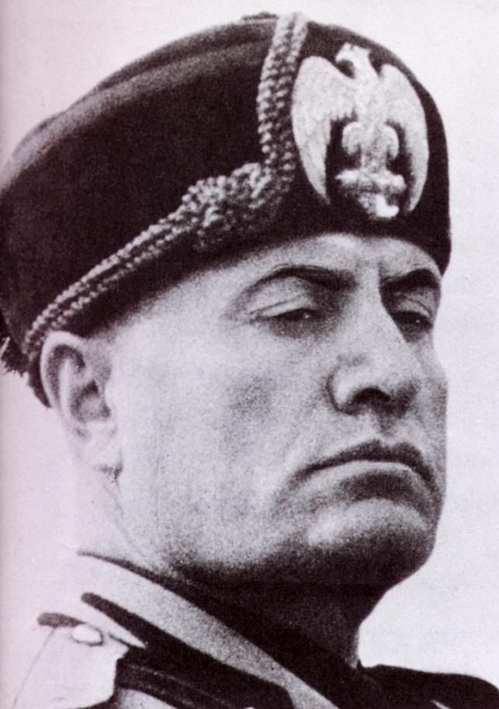
Mussolini and Fascism in Italy
One of Europe’s first dictatorships arose in Italy. In 1919 Benito Mussolini founded Italy’s Fascist movement. Fascism was an aggressive nationalistic movement that considered the nation more important than the individual. Fascists believed that order in society and national greatness came through a dictator who led a strong government and built an empire.

Fascism was also strongly anticommunist. After the Russian Revolution, many Europeans feared that Communists, allied with labor unions, were trying to bring down their governments. Mussolini exploited these fears by portraying fascism as a bulwark against communism, protecting private property and the middle class. He pledged to return Italy to the glories of the Roman Empire.

Backed by the Blackshirts, a Fascist militia, Mussolini threatened to march on Rome in 1922, claiming he was defending Italy against a communist revolution. Liberal members of the Italian parliament insisted that the king declare martial law. When he refused, the cabinet resigned. Conservative advisers then persuaded the king to appoint Mussolini as the premier. Once in office, Mussolini - who took the title of Il Duce, or “The Leader” - embarked on an ambitious program of bringing order to Italy.

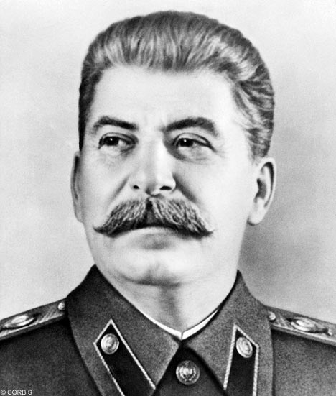
Stalin Takes Over the Soviet Union
After the Russian Revolution, the Communist Party, led by Vladimir Lenin, created the Union of Soviet Socialist Republics (USSR) in 1922. The Communists instituted one-party rule, suppressed individual liberties, and punished opponents.

After Lenin died in 1924, Joseph Stalin came to power. By 1926, Stalin was the new Soviet dictator. He began a massive effort to industrialize his country using Five-Year Plans. Steel production increased, but industrial wages declined by 43 percent from 1928 to 1940. Family farms were combined and turned into collectives, or government-owned farms. Peasants who resisted by killing livestock or hoarding crops faced show trials or death from starvation. As many as 10 million peasants died in famines during 1932 and 1933. Stalin also sought to expand Soviet influence beyond its borders, proclaiming, “[W]orld dictatorship can be established only when the victory of socialism has been achieved in certain countries or groups of countries . . . [growing into] a World Union of Soviet Socialist Republics uniting the whole of mankind. . . .”

Stalin tolerated no opposition, targeting political enemies along with artists and intellectuals. He used concentration camps, which held nearly 2 million people by 1935. Prisoners were used as slave labor. Between 15 and 20 million people died under Stalin’s rule, which lasted until his death in 1953.

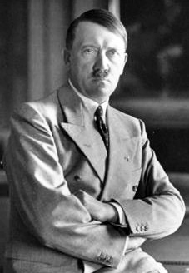
Hitler and Nazi Germany
Adolf Hitler was a fervent nationalist who hated both the victorious Allies and the German government that had accepted their peace terms ending World War I. He became the leader of the National Socialist German Workers’ Party, or Nazi Party. The Nazis were one of many political parties that arose out of postwar Germany’s political and economic chaos. The party called for Germany to expand its territory and to reject the terms of the Treaty of Versailles. It also was anti-Semitic. In November 1923, the Nazis tried to seize power by marching on city hall in Munich, Germany. The plan failed, the Nazi Party was banned for a time, and Hitler was arrested.

While in prison, Hitler wrote Mein Kampf (“My Struggle”), in which he claimed that Germans, particularly blond, blue-eyed Germans, belonged to a “master race” called Aryans. He argued that the Slavic peoples of Eastern Europe belonged to an inferior race, which Germans should enslave. Hitler’s racism was strongest, however, toward Jews. Hitler blamed the Jews for many of the world’s problems, especially for Germany’s defeat in World War I.

After his release, Hitler changed his tactics. He focused on getting Nazis elected to the Reichstag, the lower house of the German parliament. When the Depression struck Germany, many desperate Germans began to vote for radical parties, including the Nazis and Communists. By 1932, the Nazis were the largest party in the Reichstag. The following year, the German president appointed Hitler as chancellor.

After taking office, Hitler called for new elections. Storm troopers, as the Nazi paramilitary units were called, began intimidating voters. After the election, the Reichstag, dominated by the Nazis and other right-wing parties, voted to give Hitler dictatorial powers. In 1934 Hitler became president, which gave him control of the army. He then gave himself the new title of Der Führer, or “The Leader.”

Militarists Control Japan
In Japan, as in Germany, difficult economic times helped undermine the political system. Japanese industries had to import nearly all of the resources they needed to produce goods. When the Depression struck, other countries raised their tariffs, making things worse. Many Japanese military officers blamed the country’s problems on corrupt politicians. They believed that Japan was destined to dominate East Asia and that straying from traditional beliefs corrupted the country.

The military leaders argued that seizing territory was the only way Japan could get the resources it needed. In September 1931, the Japanese army invaded Manchuria, a resource-rich region of northern China. In October, hoping to avoid conflict with the United States, Emperor Hirohito’s prime minister asked Minister of War Hideki Tōjō to withdraw some troops from China. Tōjō refused, threatening to bring down the government. The military was in command of the country. The Japanese army swept through China, and in 1937 invaded Nanking (now Nanjing), destroying the city and killing as many as 300,000 of its residents. The incident became known as the “Rape of Nanking.” In October 1941, Tōjō took over as prime minister.

World War II Begins
In 1935 Hitler began to defy the Treaty of Versailles that had ended World War I. He announced that Germany would build a new air force and begin a military draft that would greatly expand its army - actions in direct violation of the treaty. Rather than enforce the treaty by going to war, European leaders tried to negotiate with Hitler.

Europe’s leaders had several reasons for believing - or wanting to believe - that a deal could be reached with Hitler to avoid war. First, they wanted to avoid a repeat of World War I. Second, some thought most of Hitler’s demands were reasonable, including his demand that all German-speaking regions be united. Third, many people assumed that the Nazis would want peace once they gained more territory.

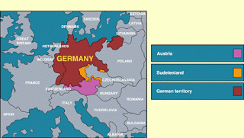
The Austrian Anschluss
In late 1937, Hitler again called for the unification of all German-speaking people, including those in Austria and Czechoslovakia. He believed that Germany could expand its territory only by force.

In February 1938, Hitler threatened to invade German-speaking Austria unless Austrian Nazis were given important government posts. Austria’s chancellor gave in to this demand, but then tried to put the matter of unification with Germany to a democratic vote. Fearing the outcome, Hitler sent troops into Austria in March and announced the Anschluss, or unification, of Austria and Germany.

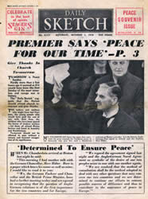
The Munich Crisis
Hitler next announced German claims to the Sudetenland, an area of Czechoslovakia with a large German-speaking population. The Czechs strongly resisted Germany’s demands. France threatened to fight if Germany attacked Czechoslovakia, and the Soviet Union also promised aid. Prime Minister Neville Chamberlain pledged Britain’s support to France, its ally.

Representatives of Britain, France, Italy, and Germany met in Munich, Germany, to decide Czechoslovakia’s fate. At the Munich Conference, on September 29, 1938, Britain and France agreed to Hitler’s demands, a policy that came to be known as appeasement. In other words, they made concessions and believed that if they gave Hitler what he wanted, they could avoid war. Czechoslovakia had to give up the Sudetenland or fight Germany on its own. When Chamberlain returned home, he stated, “My good friends, for the second time in our history, a British Prime Minister has returned from Germany bringing peace with honor. I believe it is ‘peace for our time.’ Go home and get a nice quiet sleep.”

Appeasement, however, failed to preserve the fragile peace. In March 1939, Germany sent troops into Czechoslovakia and divided the country. Slovakia became independent in name, but it was actually under German control. The Czech lands became a German protectorate.

Hitler Demands Danzig
A month after the Munich Conference, Hitler demanded that the city of Danzig be returned to German control. Danzig was more than 90 percent German, and it had been part of Poland since World War I. Hitler also requested a highway and railroad across the Polish Corridor.

Hitler’s new demands convinced Britain and France that war was inevitable. On March 31, 1939, Britain announced that if Poland went to war to defend its territory, Britain and France would come to its aid. This declaration encouraged Poland to refuse Hitler’s demands. In May 1939, Hitler ordered the German army to prepare to invade Poland. He also ordered his foreign minister to begin negotiations with the Soviet Union. If Germany was going to fight Britain and France, Hitler did not want to have to fight the Soviets too.

The Nazi-Soviet Pact
When German officials proposed a non-aggression treaty to the Soviets, Stalin agreed. He believed the best way to protect the Soviet Union was to turn the capitalist nations against each other. If the treaty worked, Germany would go to war against Britain and France.

The non-aggression pact, signed by Germany and the Soviet Union on August 23, 1939, shocked the world. Communism and Nazism were supposed to be opposed to each other. Leaders in Britain and France understood, however, that Hitler had made the deal to free himself for war against their countries and Poland. They did not know that the treaty called for the division of Poland between Germany and the Soviet Union.

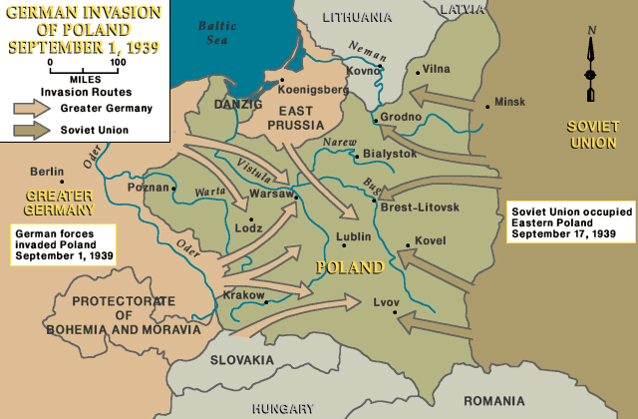
The Invasion of Poland and the Fall of France
On September 1, 1939, Germany invaded Poland. Two days later, Britain and France declared war on Germany. World War II had begun. The Germans used a new type of warfare called blitzkrieg, or “lightning war.” Blitzkrieg used massive numbers of tanks, combined with waves of aircraft and paratroopers, to break through and encircle enemy positions. By October 5, 1939, the Germans had defeated the Polish military.

Meanwhile, Western Europe remained quiet. British and French troops in France waited for a German attack. On May 10, 1940, Hitler launched a new blitzkrieg. While German troops parachuted into the Netherlands, tanks rolled into Belgium and Luxembourg. British and French forces raced north into Belgium. The Germans crossed the Ardennes Mountains of Luxembourg and eastern Belgium. German tanks smashed through the French lines and moved west across northern France. The British and French were trapped in Belgium.

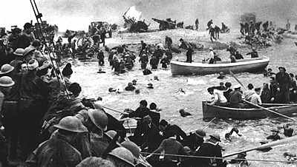
The Miracle at Dunkirk
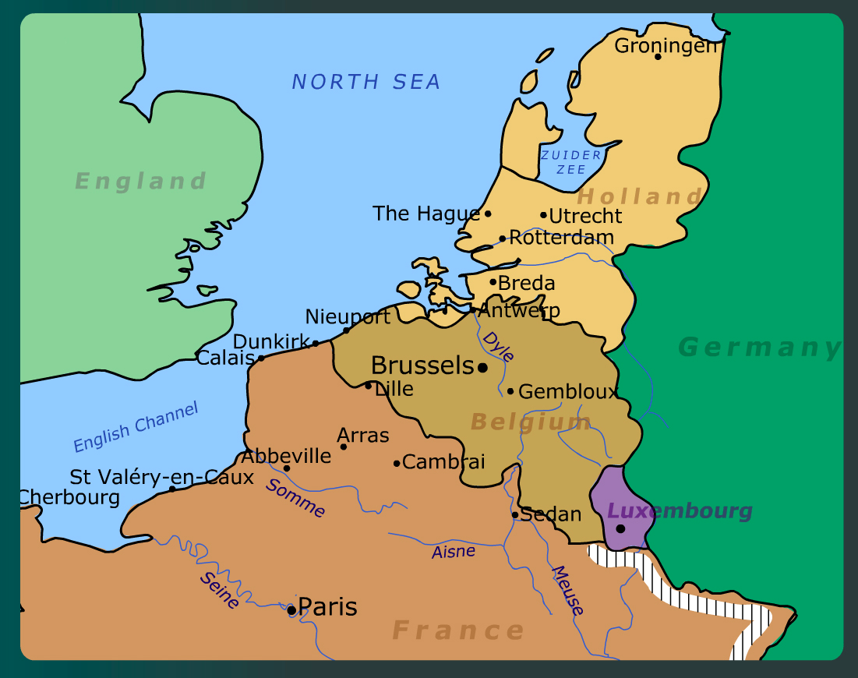
German troops drove Allied forces toward the English Channel. The port of Dunkirk became the Allies’ only way out. As German forces moved in on Dunkirk, Hitler ordered them to stop. Historians think that Hitler was nervous about risking his tank forces. Whatever his reasons, Hitler’s orders provided a three-day delay that allowed Allied forces to evacuate.

When the evacuation ended on June 4, an estimated 338,000 British and French troops had been saved during the “Miracle at Dunkirk.”

Less than three weeks later, on June 22, 1940, France surrendered. To govern the rest of France, Germany set up a puppet government at the town of Vichy and made Marshal Philippe Pétain the leader but gave him no power. French general Charles de Gaulle led the Free French resistance forces from the French colony of Algiers. He worked with Allied leaders and refused to recognize the defeat of France.

Britain Remains Defiant
Hitler expected Britain to negotiate peace after France surrendered. He was mistaken. On June 4, 1940, British prime minister Winston Churchill delivered a defiant speech, vowing that Britain would never surrender:
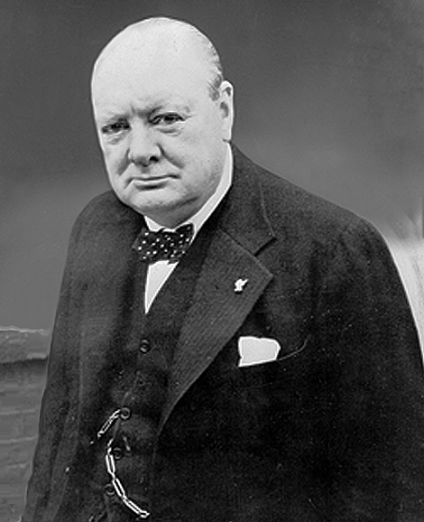

"Even though large tracts of Europe and many old and famous States have fallen or may fall into the grip of the Gestapo and all the odious apparatus of Nazi rule, we shall not flag or fail, we shall go on to the end. . . . [W]e shall defend our island, whatever the cost may be . . . we shall never surrender. . . ." ~ Winston Churchill, from his speech to Parliament, June 4, 1940 ~

That same month, Hitler ordered the German air force, the Luftwaffe, to begin attacking British ships in the English Channel. Then, in August and September, the Luftwaffe battled the British Royal Air Force in what became known as the Battle of Britain. After London was bombed accidentally, Britain retaliated by bombing Berlin. The Luftwaffe then began targeting its attacks on London and other cities. Britain’s use of radar gave it the advantage. After major losses on both sides, Hitler canceled the planned invasion of Britain. Churchill praised the sacrifices of the pilots who saved Britain, saying, “Never in the field of human conflict was so much owed by so many to so few.”

- Adolf Hitler
- Anschluss
- anti-Semitism
- appeasement
- Battle of Britain
- Benito Mussolini
- blitzkrieg
- Charles de Gaulle
- Der Führer
- Emperor Hirohito
- Fascism
- Five-Year Plans
- Hideki Tōjō
- Joseph Stalin
- Luftwaffe
- master race
- Mein Kampf
- Miracle at Dunkirk
- Munich Conference
- Nazi Party
- Rape of Nanking
- Storm troopers
- Sudetenland
- Vichy
- Winston Churchill

_____ 1. “lightning war”; a new type of German warfare; used massive numbers of tanks, combined with
waves of aircraft and paratroopers, to break through and encircle enemy positions

_____ 2. “My Struggle”; book Hitler wrote while in prison in which he claimed that blond, blue-eyed
Germans should enslave the inferior Slavic peoples of Eastern Europe

_____ 3. “The Leader”; Hitler’s self-proclaimed title after he became President of Germany in 1934

_____ 4. “unification”; refers to Hitler’s unification of Austria and Germany

_____ 5. 1940 air battle between the German Luftwaffe and the British Royal Air Force

_____ 6. an area of Czechoslovakia with a large German-speaking population that Hitler took over

_____ 7. British prime minister during most of WWII

_____ 8. Communist dictator of Soviet Union; tolerated no opposition, targeting political enemies

_____ 9. fascist dictator of Italy; the first dictator in Europe after WWI; nicknamed Il Duce: "the leader."

_____ 10. fervent German nationalist; became the leader of the Nazi Party and later chancellor and president
of Germany; blamed the Jews for Germany’s defeat in World War I

_____ 11. French general; worked with Allied leaders and refused to recognize the defeat of France

_____ 12. French town in which Germany set up a puppet government from which to rule occupied France

_____ 13. German air force

_____ 14. hatred toward Jews, individually and as a group

_____ 15. how Hitler referred to the blond, blue-eyed Germans called Aryans

_____ 16. Joseph Stalin’s massive effort to industrialize the Soviet Union; millions died

_____ 17. leader of Japan in 1931 when they invaded Manchuria

_____ 18. Minister of War in Japan in 1931; took over as Prime Minister of Japan in 1941

_____ 19. name given to the total destruction of the Chinese city of Nanking (now Nanjing) during the 1937
Japanese invasion of China; as many as 300,000 of its residents were killed

_____ 20. named given to the incredible evacuation of 338,000 British and French troops from France

_____ 21. National Socialist German Workers’ Party; anti-Semitic political group that called for Germany to
expand its territory and to reject the terms of the Treaty of Versailles

_____ 22. Nazi paramilitary units that intimidated voters

_____ 23. non-democratic form of government that stresses the greatness of a race or nation; Italy and
Germany both had this type of government in the 1930s

_____ 24. September 29, 1938 meeting in which French and British leaders agreed to Hitler’s demand to
take over Czechoslovakia

_____ 25. the policy put forth by France and Britain during the Munich Conference that allowed Hitler to
take Czechoslovakia; they believed that if they gave Hitler what he wanted, they could avoid war

1. What did Hitler, Mussolini, and Stalin have in common?

______________________________________________________________________________

______________________________________________________________________________

______________________________________________________________________________

______________________________________________________________________________

______________________________________________________________________________

______________________________________________________________________________

______________________________________________________________________________

______________________________________________________________________________

2. What reason did Hitler give for invading Austria?

______________________________________________________________________________

______________________________________________________________________________

______________________________________________________________________________

______________________________________________________________________________

______________________________________________________________________________

______________________________________________________________________________

______________________________________________________________________________

______________________________________________________________________________

3. List the areas Hitler and Germany took over prior to the outbreak of WWII. What actions could other countries have taken to avoid WWII?

______________________________________________________________________________

______________________________________________________________________________

______________________________________________________________________________

______________________________________________________________________________

______________________________________________________________________________

______________________________________________________________________________

______________________________________________________________________________

______________________________________________________________________________

______________________________________________________________________________

