PrepUS History
Unit 8 - WWII and Beyond
Saving Private Ryan Movie Questions

Main Characters in the Film
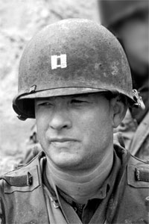
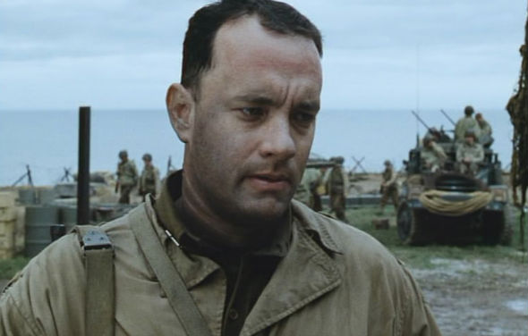
Captain Tom Miller (TOM HANKS)
On D-Day, June 6, 1944, Miller led Company C of the 2nd Ranger Battalion onto Omaha Beach. Miller's men suffered high casualties during the attack. On June 9th, Miller picked out a squad of men to complete a special mission to retrieve Private James Ryan, whose three brothers had been recently killed in combat.
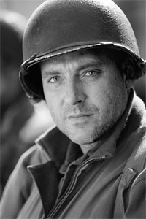
Sergeant Horvarth (TOM SIZEMORE)
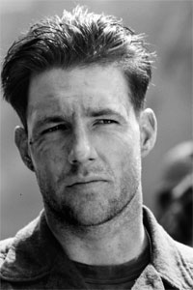
Given the nickname “Sarge” by the squad, Technical Sergeant Horvath was a tough, experienced soldier who had served previously alongside Captain Miller in North Africa and Italy. Miller relied heavily on Horvath to help lead the company.

Private Reiben (EDWARD BURNS)
Reiben was hand-picked by Captain Miller for the mission to retrieve Private Ryan. This 24 yr-old smart New Yorker was the first member of the squad to question the logic of their orders, and the most vocal in expressing his displeasure at the risky mission.
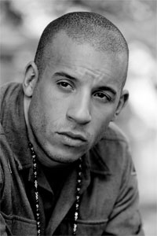
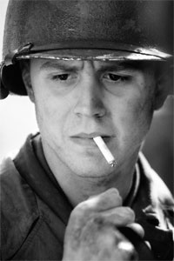
Private Caparzo (VIN DIESEL)
22 yr-old tough Chicago Italian with a gentle side.

Corporal Edward Wade (GIOVANNI RIBISI)
Twenty-eight-year-old, from California: the unit’s sensitive and dedicated medic. He takes great risks in order to save wounded soldiers, often with little success.

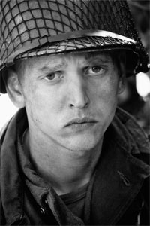
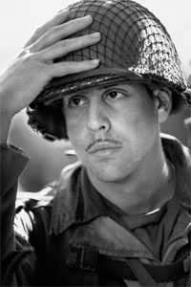
Private Daniel Jackson (BARRY PEPPER)
The unit’s 23 yr-old, deeply religious, Tennessee sharpshooter. His shooting skills turn out to be invaluable to the unit.

Private Stanley Mellish (ADAM GOLDBERG)
21 yr-old Private Mellish was a Jewish soldier nicknamed "fish." Handed a Hitler Youth knife by Caparzo shortly after making their way off of the beach, Mellish joked that it was now a Shabbat challah cutter, a Jewish bread knife.
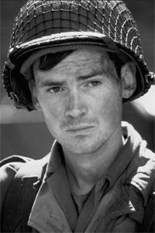
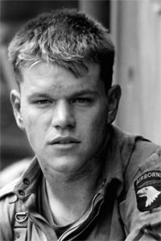
Corporal Upham (JEREMY DAVIES)
Twenty-four-year-old mapmaker and translator who joins Miller’s group when their interpreter is killed. More accustomed to office work than to fighting, he initially asks Miller if he may take his typewriter with him, since he is writing a book based on his war experiences.

Private Ryan (MATT DAMON)
The youngest of four brothers, brought up on a farm in Iowa. A simple soldier but with solid values of comradeship. He becomes a symbol for Miller and his men: if he goes home the whole group can go home.

Movie Questions

1. Why did so many Allied soldiers die in the D-Day beach landings?

2. How were family members notified of a soldier’s death during World War II?

3. Why was a rescue mission ordered for Private James Francis Ryan?

4. What lesson does the squad learn at the French family’s war-damaged home?

5. What is the confusion about the “first” Private Ryan the squad finds?

6. What is wrong with the method the squad uses to determine if Ryan has already died?

7. Why doesn’t the squad bypass the German radar station?

8. Why does Captain Miller reveal what he did for a living back in the states?

9. Why won’t Ryan leave with the squad?

10. What roles do Upham and the released German soldier play in the final defense of the bridge?

11. Who was your favorite character in the film? Why?

12. Do you think the mission to save Private Ryan was justified? Why or why not?

