PrepUS History
Unit 5 – A Nation Divided
The Mexican-American War
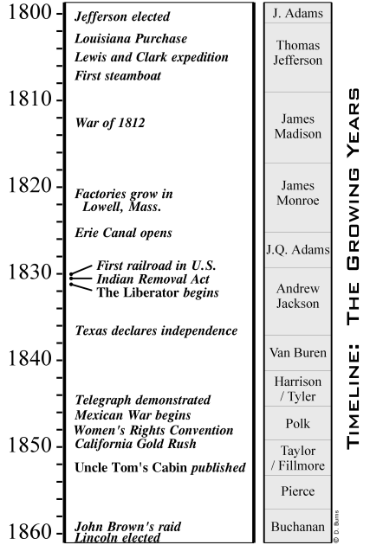
The Mexican-American War started in 1846, but its story really begins a quarter of a century earlier. In 1821, Mexico won its independence from Spain. The country was in debt to both its own citizens and Britain. Mexico enticed American citizens into immigrating to the northeastern part of the country, known today as Texas. Mexico had a series of internal battles, and the residents of Texas, most of whom were English-speaking, seceded. In 1836, Texas defeated Mexican General Santa Anna and declared its independence. Mexico never recognized Texas' independence and disputed its borders even after its annexation into the U.S. Mexico insisted the border was at the Nueces River, while Texas insisted it was the Rio Grande.

Polk's War
As soon as the United States annexed Texas, President James K. Polk sent a diplomat, John Slidell, to Mexico to negotiate three things:
> the location of the border.
> what to do about the debts owed by the Mexican
government to U.S. citizens.
> the purchase of California and New Mexico for as
much as $50 million before they sold it to Britain.
Of course, he hoped to weave some of these issues together (such as forgiving the debts if the border were settled at the Rio Grande). But Mexico's own government was in turmoil, and unless Polk had sent someone to undo what Tyler had done, there was probably no way any negotiations would have even occurred. Slidell was sent back to Washington.

But Polk couldn't live with 'no' for an answer. This time, he sent a different kind of negotiator: General Zachary Taylor. The army occupied the disputed land southwest of the Nueces, angering not only the Mexican government but many American citizens as well. When a few soldiers were killed in a skirmish, Polk told Congress that Mexico had shed American blood on American soil. On May 13, 1846, Congress approved the Mexican-American War, but America was deeply divided over the issue. Opponents called it “Polk's War.”

The Political War
Whigs, like then-Captain Ulysses S. Grant, accused the President of provoking an unjust war against a weaker neighbor. Abraham Lincoln doubted the provocation and demanded to know the exact spot where American soldiers had been killed. Abolitionists opposed going to war with Mexico because they feared the expansion of slavery. But even some Southern slave owners opposed the war because they didn't want non-whites admitted to the Union. Senator John C. Calhoun of South Carolina said 'We have never dreamt of incorporating into our Union any but the Caucasian race - the free white race…' Then, there was Congressman David Wilmot. He proposed banning all African-Americans - slave or free - from any territory that might be gained at the end of the war.

This so-called Wilmot Proviso was primarily an abolitionist piece of legislation, but Wilmot hoped that it would resonate with the Southern Democrats by reserving all of that land for white yeoman farmers. Calhoun saw through this, of course, and defeated the Wilmot Proviso in the Senate on the grounds that Congress could not legally ban slavery anywhere since the Constitution allowed it. Finally, a Michigan senator devised the brilliantly simple solution of popular sovereignty - letting the residents of new territories decide for themselves whether they wanted slavery. Of course, all this negotiation meant nothing at the time, since war had just started. But popular sovereignty persisted as an uneasy solution into the next decade.

The War On The Battlefields
Mexico had overestimated its manpower and weaponry, steadily losing ground to General Taylor and American officers like Ulysses S. Grant, Robert E. Lee, William T. Sherman and others who would later direct the Civil War on both sides. In early 1847, the navy pounded Vera Cruz and marines captured the city. From there, they could move towards Mexico City. The President's political opponents continued to question why America was pushing deeper into Mexico if our goal had been to defend our border. So when marines captured the 'Halls of Montezuma' (Mexico City) in September of 1847, Polk knew it was time to quit.

Meanwhile, back in 1846, Captain John Frémont led American settlers in a rebellion against Mexican authorities in California. They declared the independent 'Bear Flag Republic' and with the navy's help soon asserted that California belonged to the United States. When they met resistance, an army colonel marching through New Mexico came to their rescue and defeated the remaining Mexican forces in California in 1847. Once Mexico City was captured, the peace negotiations included all of California.

The Treaty Of Guadalupe Hidalgo
Although President Polk had officially recalled his diplomat from Mexico City, Nicholas Trist proceeded with negotiations. And since the terms were favorable, Polk sent the Treaty of Guadalupe Hidalgo to the Senate for ratification. The main provision of the treaty was America's right to buy about half of Mexico's land (the territories of California and New Mexico) for $15 million. This land has come to be known as the Mexican cession. Additionally, the U.S. would assume $3.25 million in debts owed to U.S. citizens in exchange for settling the Texas border at the Rio Grande.

The Senate approved the Treaty of Guadalupe Hidalgo on March 10, 1848. Though the Wilmot Proviso never passed both houses, the controversy over slavery in the Mexican cession persisted, dominating congressional attention until after the Civil War.

Characters
Write a short description of the following people that identifies the role they played in the Mexican-American War and why they are historically important.

General Santa Ana

James K. Polk

Zachary Taylor

David Wilmot

John Fremont

What event made Polk declare war on Mexico? Why did he send American troops to Mexico in the first place (before the war started)?

Why were abolitionists against war with Mexico?

What does “popular sovereignty” mean?

How many years did the war last? Give the dates that it started and ended.

What did the United States gain in the Treaty of Guadalupe Hidalgo? How much did it cost them?

