PrepUS History
Unit 8 - WWII and Beyond
From Neutrality to War

The rise of dictatorships and militarism in Europe discouraged many Americans. The sacrifices they had made during World War I seemed pointless. In addition, during the Depression, most European nations announced they would no longer repay their war debts to the United States. In response, many Americans once again began supporting isolationism and trying to avoid involvement in international conflicts.

The Nye Committee
Meanwhile, accusations emerged that arms manufacturers had tricked the United States into entering World War I. In 1934 Senator Gerald P. Nye held hearings to investigate these allegations. The Nye Committee report documented the huge profits that arms factories had made during the war and created the impression that these businesses influenced the decision to go to war. Even more Americans turned toward isolationism.

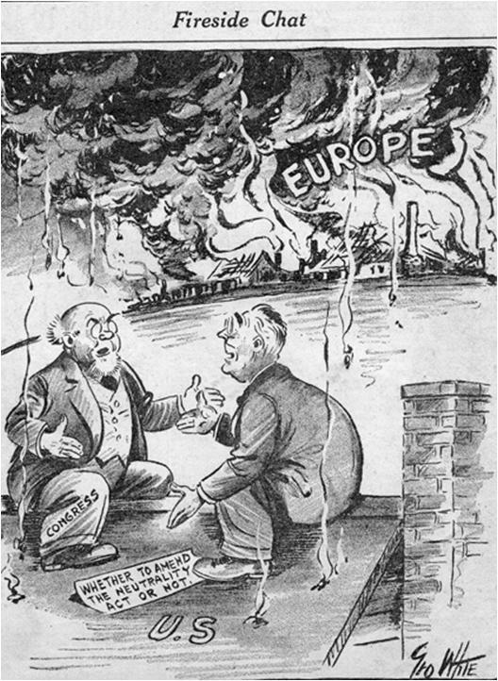
Legislating Neutrality
In response to growing Italian and German aggression in Europe, Congress passed the Neutrality Act of 1935. This legislation - reflecting a response to the Nye report - made it illegal for Americans to sell arms to any country at war. Then, in 1936, a rebellion erupted in Spain that soon became a civil war. Congress responded by passing a second neutrality act, banning the sale of arms to either side in a civil war.

Soon after the Spanish Civil War began, Hitler and Mussolini pledged to cooperate on several international issues, and Japan aligned itself with Germany and Italy. Together, the three nations became known as the Axis Powers. As European tensions worsened, Congress passed the Neutrality Act of 1937, continuing the ban on selling arms to warring nations and also requiring them to buy all nonmilitary supplies from the United States on a “cash-and-carry” basis. Countries had to send their own ships to pick up goods and had to pay in cash. Loans were not allowed. Isolationists knew that attacks on American ships had helped bring the country into World War I. They wanted to prevent such attacks that could bring the nation into another European war.

Roosevelt’s Internationalism
Despite the government’s stand on neutrality, President Roosevelt supported internationalism, the idea that trade between nations creates prosperity and helps prevent war. He warned that the neutrality acts “might drag us into war instead of keeping us out,” but he did not veto the bills. When Japan invaded China in July 1937 without declaring war, Roosevelt claimed the Neutrality Act of 1937 did not apply. He authorized the sale of weapons to China, warning that the nation should not let an “epidemic of lawlessness” infect the world:

“There is no escape through mere isolation or neutrality. . . . When an epidemic of physical disease starts to spread, the community . . . joins in a quarantine of the patients in order to protect the health of the community against the spread of the disease. . . . War is a contagion, whether it be declared or undeclared.”
~ from The Public Papers and Addresses of Franklin D. Roosevelt

Neutrality Tested
Roosevelt wanted to help Britain and France in their struggle and asked Congress to revise the neutrality laws to allow the sale of weapons to warring nations. Congress passed the Neutrality Act of 1939 permitting the sale of weapons, but only on a “cash-and-carry” basis.

In the spring of 1940, the United States faced the first test of its neutrality. Britain asked Roosevelt for old American destroyers to replenish its fleet, and the president used a loophole in the cash-only requirement for purchases. He sent 50 ships to Britain in exchange for America’s use of British bases in the Atlantic. Because the deal did not involve an actual sale, the Neutrality Act did not apply.

Widespread acceptance of the Destroyers-for-Bases deal indicated a change in public opinion. By July 1940, most Americans favored offering limited aid to the Allies, but debate continued over the scope of that aid. The Fight for Freedom Committee wanted the repeal of neutrality laws and stronger actions against Germany. On the other side, the America First Committee opposed any intervention to help the Allies.

After winning reelection in 1940, Roosevelt expanded the nation’s role in the war. Speaking to Congress, he listed the Four Freedoms for which both the United States and Britain stood: freedom of speech, freedom of worship, freedom from want, and freedom from fear.

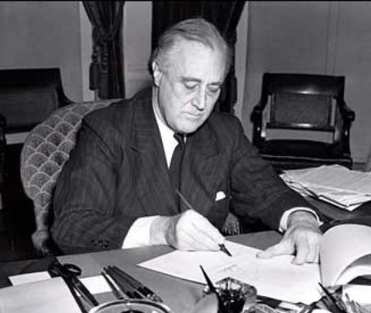
The Lend-Lease Act
By December 1940, Great Britain had run out of funds to fight the war. Roosevelt proposed the Lend-Lease Act, which allowed the United States to lend or lease arms to any country considered “vital to the defense of the United States.” Britain could receive weapons, then return them or pay rent for them after the war. Congress passed the Lend-Lease Act by a wide margin. Lend-lease aid eventually went to the Soviet Union as well, when in June 1941, Hitler invaded the Soviet Union. Roosevelt followed Britain’s lead in supporting any state fighting the Nazis.

A Hemispheric Defense Zone
The problem of getting American arms and supplies to Britain remained. German submarines in the Atlantic sank hundreds of thousands of tons of cargo each month. The British Navy lacked the ships to stop them.

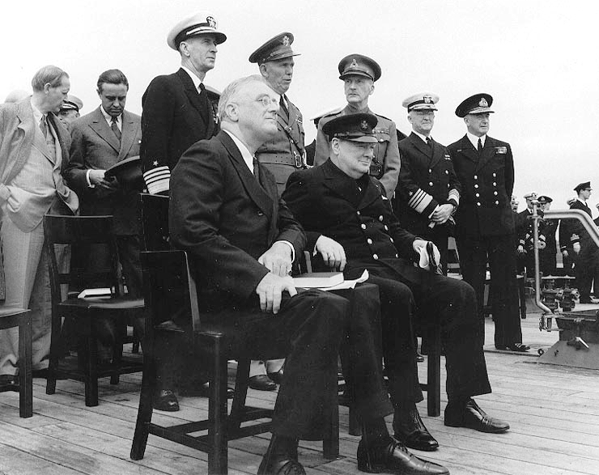
Because the United States was still officially neutral, Roosevelt could not order the navy to protect British cargo ships. Instead, he developed the idea of a hemispheric defense zone, declaring that the entire western half of the Atlantic was part of the Western Hemisphere and therefore neutral. He then ordered the U.S. Navy to patrol the western Atlantic and reveal the location of German submarines to the British.

The Atlantic Charter
In August 1941, Roosevelt and Churchill met and developed the Atlantic Charter, which committed both nations to a postwar world of democracy, nonaggression, free trade, economic advancement, and freedom of the seas. Churchill later said that FDR “made it clear that he would look for an ‘incident’ which would justify him in opening hostilities” with Germany.

In early September, a German submarine, or U-boat, fired on an American destroyer that had been radioing the U-boat’s position to the British. Roosevelt promptly responded by ordering American ships to follow a “shoot-on-sight” policy toward German submarines. The Germans escalated hostilities the following month, targeting two American destroyers. One of them, the Reuben James, sank after being torpedoed, killing over 100 sailors. As the end of 1941 drew near, Germany and the United States continued a tense standoff.

Japan Attacks Pearl Harbor
Despite the growing tensions in Europe, it was the Japanese attack on Pearl Harbor that finally brought the United States into World War II. Ironically, Roosevelt’s efforts to help Britain fight Germany resulted in Japan’s decision to attack the United States.

America Embargoes Japan
As German submarines sank British ships in the Atlantic, the British began moving warships from Southeast Asia, leaving India and other colonial possessions vulnerable to Japanese attack. To hinder Japanese aggression, Roosevelt began applying economic pressure. Japan depended on the United States for many key materials, including scrap iron, steel, and especially oil. In July 1940, Congress gave the president the power to restrict the sale of strategic materials—items important for fighting a war. Roosevelt then blocked the sale of airplane fuel and scrap iron to Japan. Furious, the Japanese signed an alliance with Germany and Italy, becoming a member of the Axis.

In 1941 Roosevelt began sending lend-lease aid to China, hoping to enable the Chinese to tie down the Japanese and prevent them from attacking elsewhere. The strategy failed. By July 1941, Japan had sent military forces into southern Indochina, directly threatening the British Empire. In response, Roosevelt froze all Japanese assets in the United States, reduced the oil shipments to Japan, and sent General Douglas MacArthur to the Philippines to build up American defenses there.

With its war against China in jeopardy because of a lack of resources, the Japanese military planned to attack the resource-rich British and Dutch colonies in Southeast Asia. They also decided to seize the Philippines and to attack the American fleet at Pearl Harbor. Negotiations with the Americans continued, but neither side would back down. In late November 1941, six Japanese aircraft carriers, two battleships, and several other warships set out for Hawaii.

Surprise Attack
The Japanese government appeared to be continuing negotiations with the United States in good faith. American intelligence, however, had decoded Japanese messages that made it clear that Japan was preparing to go to war against the United States. On November 27, American commanders at the Pearl Harbor naval base received a war warning from Washington, D.C., but it did not mention Hawaii as a possible target. Because of its great distance from Japan, officials doubted that Japan would attack Hawaii.

The U.S. military’s inability to interpret the information that they were receiving correctly left Pearl Harbor an open target. Japan’s surprise attack on December 7, 1941, was devastating. Eight battleships, three cruisers, three destroyers, and four other vessels were sunk or damaged. The attack destroyed over 180 aircraft and killed 2,403 Americans. Another 1,178 were injured.

That night, a gray-faced Roosevelt met with his cabinet, telling them the country faced the most serious crisis since the Civil War. The next day, he asked Congress to declare war:

“As Commander in Chief of the Army and Navy I have directed that all measures be taken for our defense, that always will our whole nation remember the character of the onslaught against us. . . With confidence in our armed forces, with the unbounding determination of our people, we will gain the inevitable triumph.” ~ from his speech to Congress, December 8, 1941

The Senate voted 82 to 0 and the House 388 to 1 to declare war on Japan.
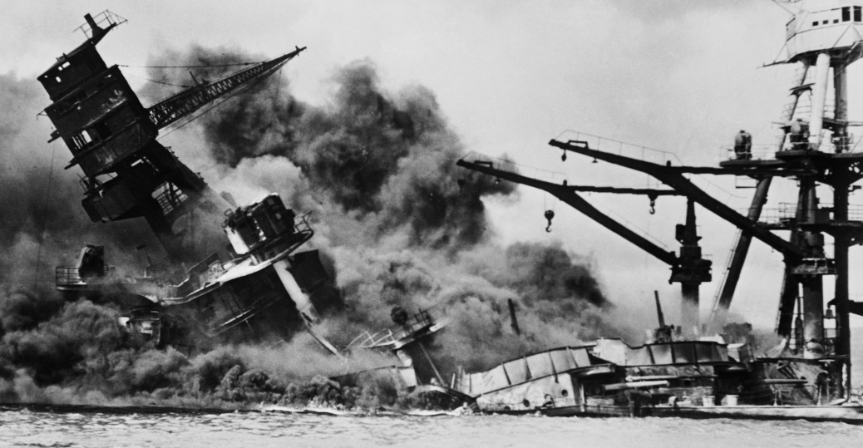
The Arizona was the US battleship that sustained the most damage and had the most casualties during the attack on Pearl Harbor.

Germany Declares War
Hitler had hoped that Japan would attack the United States so that the majority of U.S. forces would be sent to the Pacific front. He expected the United States to enter the European war as incidents between German submarines and the United States mounted in the Atlantic.

Hitler underestimated the strategy of the United States, which was to view Germany as the larger threat but fight the Japanese with the U.S. Navy. By helping Japan, he hoped for Japanese support against the Soviet Union after they had defeated the Americans. On December 11, Germany and Italy both declared war on the United States.

Answer the following questions in complete sentences.

1. What steps did the supporters of United States isolationism take to ensure that the country remained neutral in an international conflict?

______________________________________________________________________________

______________________________________________________________________________

______________________________________________________________________________

______________________________________________________________________________

______________________________________________________________________________

______________________________________________________________________________

______________________________________________________________________________

______________________________________________________________________________

______________________________________________________________________________

2. How did President Roosevelt assist Britain while maintaining U.S. neutrality?

______________________________________________________________________________

______________________________________________________________________________

______________________________________________________________________________

______________________________________________________________________________

______________________________________________________________________________

______________________________________________________________________________

______________________________________________________________________________

______________________________________________________________________________

______________________________________________________________________________

3. How did restricting the sale of strategic materials hinder Japan's aggression in the Pacific?

______________________________________________________________________________

______________________________________________________________________________

______________________________________________________________________________

______________________________________________________________________________

______________________________________________________________________________

______________________________________________________________________________

______________________________________________________________________________

______________________________________________________________________________

______________________________________________________________________________

4. What sequence of events led the United States to a declaration of war?

______________________________________________________________________________

______________________________________________________________________________

______________________________________________________________________________

______________________________________________________________________________

______________________________________________________________________________

______________________________________________________________________________

______________________________________________________________________________

______________________________________________________________________________

______________________________________________________________________________

