PrepUS History
Unit 6 – America Expands
America The Story of Us
Questions for Episode 7: Cities

Vocabulary to know before watching the film:
audacious: bold, daring or fearless

filament: a slender fiber or thread

irrevocable: something that cannot be undone or changed

rogue: something that is out of ordinary, or against the rules

unscrupulous: someone or something that is dishonest or immoral

veritable: real or genuine

Background information to know before watching the film:
Between 1880 and 1930, nearly 24 million new immigrants arrive in the United States. Many go to work building a new frontier: the modern city. The high cost of land in cities like New York and Chicago means the only way to build is up. A new kind of building, the skyscraper, is made possible by steel. Produced on a massive scale, steel production underpins the infrastructure of the modern city.

This new urban frontier depends on the labor of rural migrants and newly arrived immigrant workers to grow. For many, the Statue of Liberty is their first sight of the New World and Ellis Island is the gateway to the American Dream. The lawless city offers opportunities for many and astronomical wealth for a few. Police chief Thomas Byrnes uses his harsh new innovation “the third degree,” to keep a lid on crime.

The millions flocking to urban areas of the US often experience terrible conditions in disease-ridden tenements. Jacob Riis, photographer and reformer, brings their plight to the world with his groundbreaking photographs in the book “How the Other Half Lives.” Workers in new high-rise factories become urban martyrs in New York City’s Triangle Shirtwaist factory fire in March of 1911, as the city struggles to make these new buildings safe. Powered by steel and electricity, the city begins to be tamed and defined by mass transportation, stunning skylines, electric light...and the industrious American spirit.

Questions to answer while watching the film:
1. Why was the Statue of Liberty given to the US as a gift from France?

2. How did Pulitzer raise money to construct the Statue of Liberty?

3. What is the Statue of Liberty’s official name?

4. How many immigrants came to the US through way of New York/Ellis Island?
5. What is “Walking the steel”? How many ‘rough necks’ die on the job?

6. Which invention, besides producible steel, helped cities to grow?

7. What did Detective Thomas Brynes’ “Rogues Gallery” of mug shots help to establish?

8. How did Jacob Riis contribute to changing America?

9. Why is Colonel George Waring known as “America’s First Eco-Warrior?”

10. After testing over 6,000 elements what did Edison use to create the first light bulb?

11. What good (laws) came out of the deadly Triangle Shirt Waste Fire?

Questions to answer after watching the film:
1. What was the Bessemer steel converter? How did this invention shape US history?

2. Why do you think so many everyday Americans contributed money to help build the Statue of Liberty?

3. What was the “rogues’ gallery” and what was its importance? What were some of the other methods used to curb crime?

4. What was the key factor in Thomas Edison’s success in designing the light bulb? What were some of the new things that were possible because of this invention?

5. Why do you think the Triangle Shirtwaist fire happened? What were some of the results of this tragedy?
The Statue of Liberty

Emma Lazarus wrote the following poem in 1883; today it is engraved on a plaque in the statue of Liberty museum. Lazarus was an immigrant to the US who became an advocate for other immigrants arriving on new shores for the first time.
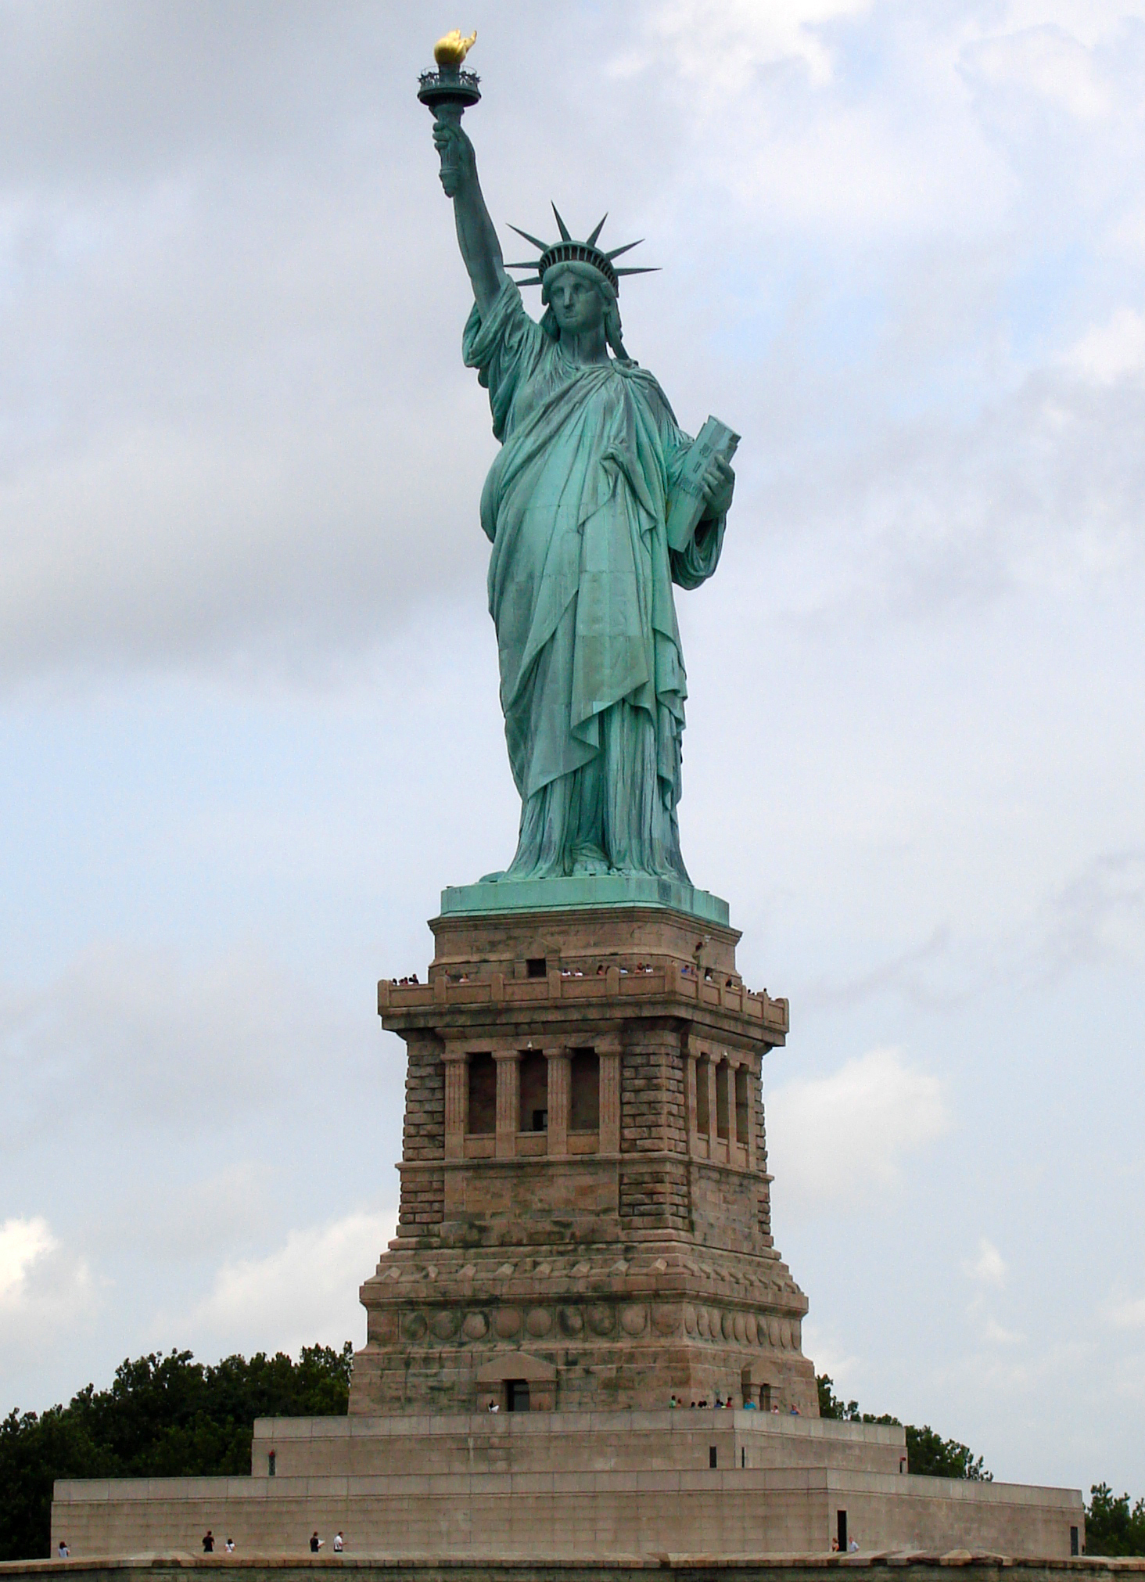
The New Colossus

Not like the brazen giant of Greek fame,
with conquering limbs astride from land to land;
here at our sea-washed, sunset gates shall stand
A mighty woman with a torch, whose flame
Is the imprisoned lightning, and her name
Mother of exiles. From her beacon-hand
Glows world-wide welcome; her mild eyes command
The air-bridged harbor that twin cities frame.

“Keep ancient lands, your storied pomp!” cries she
with silent lips. “Give me your tired, your poor,
Your huddled masses yearning to breathe free,
The wretched refuse of your teeming shore.
send these, the homeless, tempest-tost to me,
I lift my lamp beside the golden door!”

1. What do you think the phrase “world-wide welcome” means in relation to immigration in the US? What are some other phrases from this poem that are meaningful?

2. Why do you think this poem is considered an American classic today?

