Chapter 8: Estimating with Confidence

Key Vocabulary:

* point estimator
* point estimate
* confidence interval
* margin of error
* interval
* confidence level
* random
* normal
* independent
* four step process
* level C confidence interval
* degrees of freedom
* standard error
* one -sample z interval
* t distribution
* t-procedures
* one-sample t interval
* robust

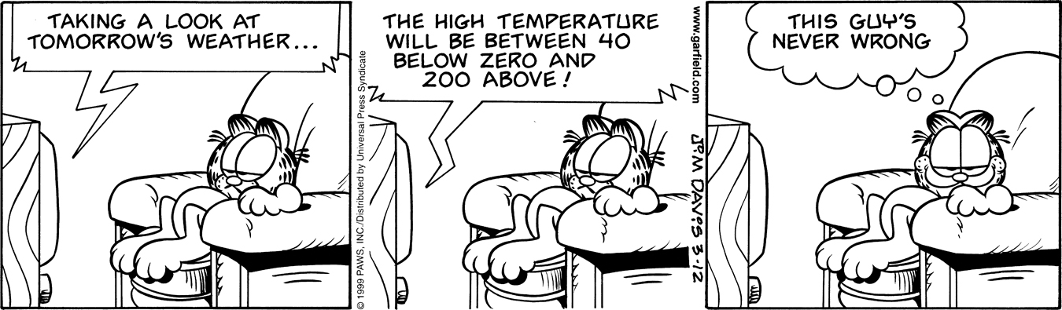

8.1 Confidence Intervals: The Basics (pp.615-643)

1. A *point estimator* is a statistic that…
2. The value of the point estimator statistic is called a ____________________ and it is our

"best guess" at the value of the _____________________.

1. **Example** “From Batteries to Smoking” Answer parts “a” and “b.”
2. Point Estimator is______________________ (notation is ______) for the population mean (μ).
   * The Point Estimate is_____________________________
3. Point Estimator is______________________ (notation is ______) for the population proportion (p).
   * The Point Estimate is_____________________________
4. **Example** “The Mystery Mean” we will do as an activity next class.
5. Summarize the facts about *sampling distributions* learned in chapter 7:

|  |  |
| --- | --- |
| *sampling distributions* ***for means***   * **Shape** * **Center** * **Spread** | *sampling distributions* ***for proportions***   * **Shape** * **Center** * **Spread** |

1. “**The Big Idea…** is that the __________________________________of $\overline{x}$ tells us how close to _____ the _________________________ ($\overline{x}$**)** is likely to be.

* Or, said a different way…“How close ___ is likely to be to the __________ population ___________ (___).

1. A **Confidence Interval** for a parameter has 2 parts : **“estimate margin of error”**



1. $\overline{x}$ and $\hat{p}$ are examples of the ____________________.
2. Define margin of error:
3. The confidence level C is a _____________. That is, in **C%** of all possible ____________, the method would yield an ___________________ that captures the ______________ population __________________________________.
4. What is the difference in interpretation between **Confidence Interval** and **Confidence Level**?
5. ***Interpret a Confidence Level (CL)*** : "To say that we are 95% confident is shorthand for …..
6. Explain how to interpret a ***Confidence Interval (CI).***
7. The ***confidence level(CL)*** does **NOT** tell us the chance that a particular confidence interval captures the population parameter because the ______________________ is not a probability. **What does CL tell us**? And explain “***plausible values****?*”
8. Sketch and label a *95% confidence interval* for the standard normal curve N(0,1). Label the mean, ±3 standard deviations, shade the *95%* confidence area, and confidence interval.
   * + In a sampling distribution of , why is the interval of numbers between called a *95% confidence interval*? HINT: Think Empirical Rule.



1. General form to calculate a confidence interval is on the **Green Sheet:**

**statistic  (critical value) ● (standard deviation of the statistic)**

**statistic  _____________________________________________**

1. From this formula, what is the **“margin of error?**”
2. What does the **“critical value”** depend on?
3. What does the **“standard deviation”** depend on?
4. What happens when the **sample size (n)** increases?
5. When the **confidence level** increases, what happens to the **confidence interval**?

**[_____% CI]**

**[_____% CI]**

1. Explain the two conditions when the margin of error gets smaller.

#1 ___________________________________________________________________

#2 ___________________________________________________________________

1. State the 3 **conditions for constructing a confidence interval** for population parameters *p* or .



* Random
* Normal
* Independent

19. What are the two important reminders for constructing and interpreting confidence intervals?

#1 ___________________________________________________________________

#2 ___________________________________________________________________