12.1 Regression Inference KEY POINTS
Regression Model Example – Refer to the graph
- How much would an adult female weigh if she were 5 feet?
  - What would you expect the distribution of weights to be?

- What would you expect the distribution of weights to be for other heights?
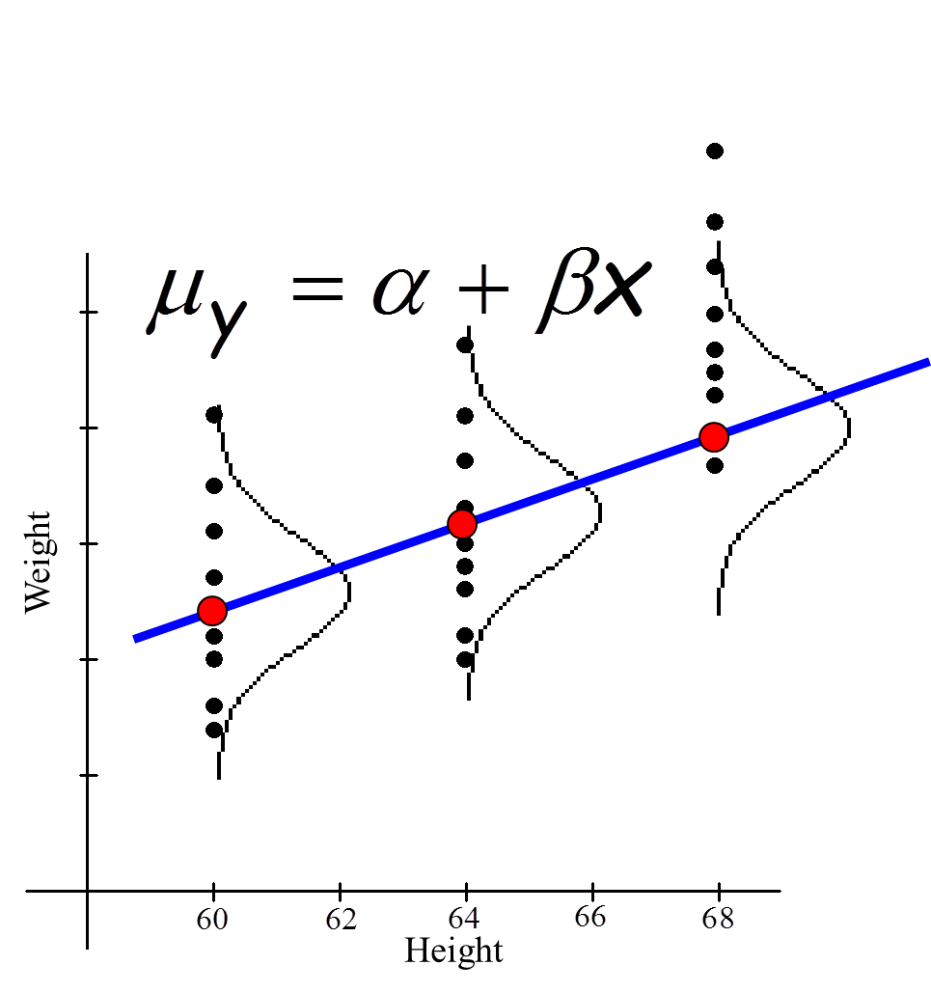
- Where would you expect the TRUE LSRL to be?

- What is the population regression model equation?

- What about the standard deviations of all these normal distributions?

Now the Regression Model:

- The mean response $(μ_{y}$ ) has a ____________________________________________ relationship with $x$.

The model is:
$μ_{y}=α+βx$;
Where, the unknown population parameters are:
$β$ is the __________________________and
$α$ is the _____________________________.

- For any fixed value of the x (the explanatory variable), the ______ _______ variable ( $y$ ) varies according to a _______ ________ distribution.

The repeated responses of $y$ are _________________________________ of each other.

- The standard deviation of $y$ $\left(σ_{y}\right)$ is the __________ for all values of ( $x$).

$σ_{y}$ is also an unknown _______________________
_____________________________.

Regression Inference
Unbiased Estimators

Population Parameters

- We use the model ________________________ to estimate the population least square regression line (LSRL) $μ_{y}=α+βx.$
- The slope $b$ of the LSRL is an ________ ____ estimator of the true _________ ____ $β$.
- The intercept $a$of the LSRL is an _ __ _________ estimator of the true _________ ____ $α$.
- The standard error $s$ is an _________ ___ estimator of the true standard deviation of y $\left(σ_{y}\right)$.
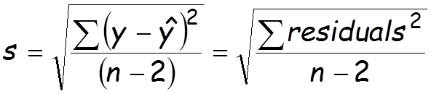
Notice degrees of freedom (df) is __________!
We lose _____ degrees of freedom for estimating _____ parameters $\left(α and β\right)$.

Regression Inference
Sampling Distribution for $β$

  - Suppose you took many samples of the same size from this population & calculated the LSRL for each, what shape will this sampling distribution have?

  - The mean of the sampling distribution:
$$μ_{b}=β$$

  - The standard deviation of the sampling distribution:
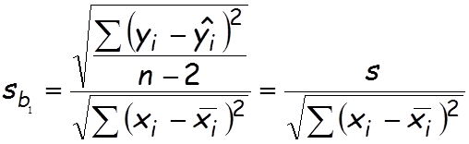

Notes:
- b₁ = ________ _ ___ .
- s_{b1} = SE(b) (the S.D. of the slope)
  - Rarely do we need to calculate.
  - Typically it will be given in computer output.
- s = the S.D. of our LSRL model
Regression Inference
Conditions for Regression Inference on Slope

- Random and Independent Observations
The observations are Random.
*Check that you have an _____________ of data.

The observations are Independent
*Check the 10% condition when sampling without replacement.

- Linear Relationship
The true relationship is __________________.
Check the ______________________________ for __________________ scattering of residual points.

- Constant Standard Deviation
The standard deviation of the
__________________ variable (y) is constant.
Check __________________ , with the LSRL included in the plot, to see if the points are ______________ spaced across LSRL (points above and below the LSRL).

- Responses Vary Normally
Since samples will typically have fewer than 30 observations (aka CLT cannot be applied), the responses (response variable, y) must vary normally about the ________ regression line.
Check the __________________________ of ____________ for symmetry and no outliers.

Regression Inference
Confidence Interval Formula – (for the slope of the LSRL)

Identify the…
- point estimate
- critical value
- degrees of freedom
- standard deviation of what? _______________________
- margin of error

$$b±t^{*}*s_{b_{1}}$$

Regression Inference
Hypothesis Test Formula

Here is the test statistic value we calculate for the slope of the least squares regression line:

Identify the…
- test statistic,
- sample statistic
- population parameter
- standard deviation of the statistic

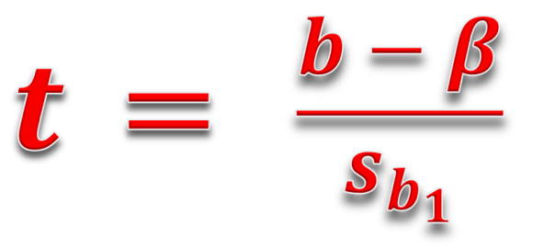

Notice, $df = n-2$
We lose 2 degrees of freedom for ______________
two parameters!

Hypothesis Statements for Regression Inference
(the slope of the LSRL)

$H_{0}: β=0$
- This implies that there is no __________________________________ between x and y; or

- that x should not be used to __________________________________ y.

$H_{a}: β>0$ means a ________________relationship.
$H_{a}: β<0$ means a _________________relationship.
$H_{a}: β≠0$ means __________________relationship.

You must always define the population parameter!!!!

Where, is the true ________________________ of the LSRL ... (in context)

Regression Inference
EXAMPLE 1“Weight vs. Body Fat”
It is difficult to accurately determine a person’s body fat percentage without immersing him or her in water. Researchers hoping to find ways to make a good estimate immersed 20 randomly selected male subjects, and then measured their weights.
Find the LSRL, correlation coefficient, and coefficient of determination.

Weight (lb) | Body Fat (%)
175 | 6
181 | 21
200 | 15
159 | 6
196 | 22
192 | 31
205 | 32
173 | 21
187 | 25
188 | 30
188 | 10
240 | 20
175 | 22
168 | 9
246 | 38
160 | 10
215 | 27
159 | 12
146 | 10
219 | 28

$LSRL:$
$\hat{y}=$

- Must define x and y !!!!
- where
x= ________ ____
y= ________ ____

Recommend write LSRL in context

$$Corrleation Coefficent:$$
$$r =$$

$$Coefficient of Determination:$$
$$r^{2}=$$

$Rewrite LSRL:$
$\hat{body fat}=____________+___________(weight)$

- Example 2:
Explain the meaning of the slope in context of the problem.

Does the y-intercept of the LSRL have meaning in context of the problem?

Explain the meaning of the correlation coefficient in context of the problem.

Explain the meaning of the coefficient of determination in context of the problem.

- Example 3:
Estimate 𝛼, 𝛽 𝑎𝑛𝑑 𝜎 for the problem.

Create a scatterplot for the data.

Create a residual plot for the data.

Example 4: (Significance Test) Is there sufficient evidence that weight can be used to predict body fat?
Conditions – You must sketch the graphs to support conditions

- Example 5: (Confidence Interval) Find a 95% confidence interval for the true slope of the LSRL.

- Example 6: (Computer generated data) Here is the computer generated result from the data:
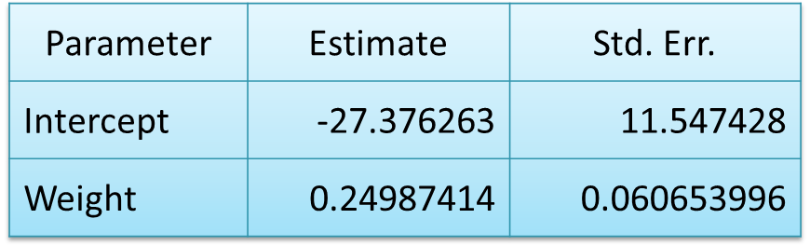
$$Sample size: n = 20 \\ R-square = 43.83\% \\ s = 7.0491323$$

What are the degrees of freedom? __________________
What is the correlation coefficient?

- How do you determine the sign?

What does the value of s represent?

What is the equation of the LSRL?

What does the value 0.060653996 represent? IMPORTANT!!!

It is difficult to accurately determine a person’s body fat percentage without immersing him or her in water. Researchers hoping to find ways to make a good estimate immersed 20 randomly selected male subjects, and then measured their weights.

