Chapter 9: Testing a Claim

Key Vocabulary:

* Significance test
* Null Hypothesis
* Alternative Hypotheses
* One sided alternative
* Two sided alternative
* p-value
* level



* significance level
* one-sample z test
* test statistic
* one sample t test
* paired data
* four-step process
* statistically significant
* Type I Error
* Type II Error
* Power
* Degrees of freedom
* t-distribution
* paired t procedures

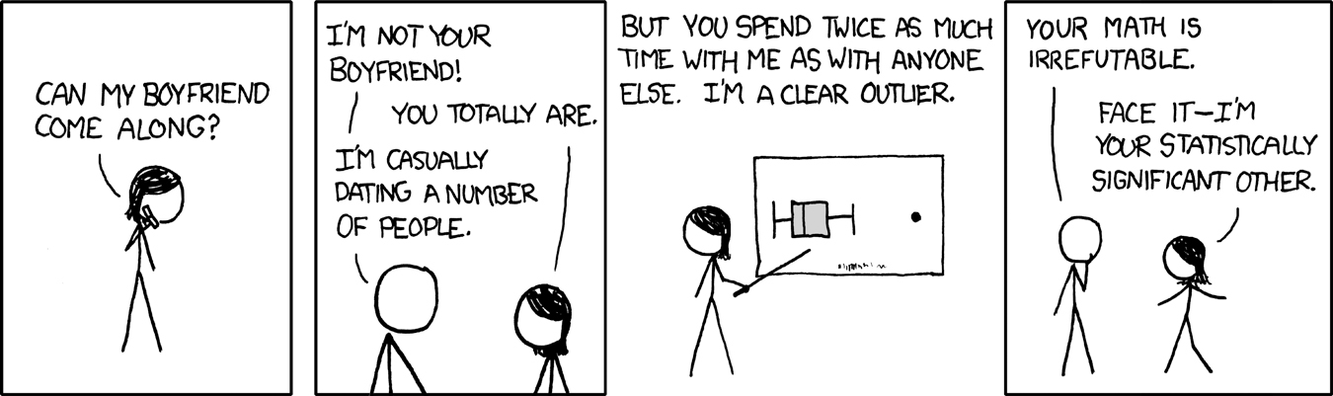

9.1 Significance Tests: The Basics (pp.528-543)

1. What is a *significance test*?
2. What is the difference between a *null and an alternative hypothesis*? What *notation* is used for each?
3. Explain the differences between one-sided and two-sided hypotheses. How can you decide which one to use?
4. What form does the null and alternative hypothesis take in significance testing?
5. Hypotheses always refer to a ___________, not to a ______________.
6. In statistics, what is meant by the *P-value*? What does a P-value measure?
7. If a *P-value* is small, what do we conclude about the *null hypothesis*?
8. If a *P-value* is large, what do we conclude about the *null hypothesis*?
9. What are *common errors* students make in their conclusions of P-values?
10. On what evidence would we *reject the null hypothesis*?
11. On what evidence would we *accept the null hypothesis* (ie. fail to reject the null hypothesis)?
12. What is meant by a *significance level*?
13. Explain what it means to say that data are *statistically significant*.
14. How small should the *P-value* be in order to claim that a result is *statistically significant*?
15. When using a *fixed significance level* to draw a conclusion in a statistical test what can be concluded when the P value is < α and ≥α?
16. What two circumstances guide us in choosing a level of significance?






1. 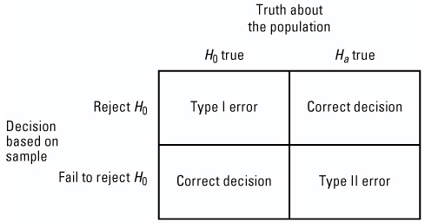What is a *Type I Error*?
2. What is a *Type II Error* ?
3. Which error is worse, Type I or Type II?
4. Complete the *Check Your Understanding on page 539*.
5. What is the relationship between the *significance level * and the probability of *Type I Error*?
6. How can we reduce the *probability* of a Type I error?
7. What is meant by the *power* of a significance test?
8. What is the relationship between *Power and Type II Error*? Will you be expected to calculate the power on the AP exam?
9. What *four factors* affect the power of a test? Why does this matter?
10. Describe the three influences that must be verified before deciding on how many observations are needed in a study.

* Significance Level
* Practical Importance
* Power

9.2 Tests about a Population Proportion (pp.549-561)

1. Summarize the three conditions that must be checked before carrying out significance tests:











1. State the general form of the “*test statistic*”.
2. What does the *test statistic* measure? Is this formula on the AP exam formula sheet?
3. Describe the four step process for signifigance tests. Explain what is required at each step.

* State
* Plan
* Do
* Conclude

1. What test statistic is used when testing for a *population proportion*? Is this on the formula sheet?
2. Summarize the one-sample z test for a proportion and sketch the three possible ’s.



* Choose…
* To test…
* Find…
* Use this test…
* If Normaility is not met

1. What happens when the data does not support ?
2. If asked to carry out a signifigance test and there is no α provided, what is recommended?
3. Can you use confidence intervals to decide between two hypotheses? What is the advantage to using confidence intervals for this purpose?
4. Why don't we always use confidence intervals?

9.3 Tests about a Population Mean (pp.565-585)

1. What are the three conditions for conducting a *significance test for a population mean*?
2. What *test statistic* do we use when testing a *population mean*? Is this formula on the AP exam formula sheet?
3. How do you calculate *p-values using the t-distributions*?
4. What do you do if the *degrees of freedom* you need is not in table b?
5. How do you find *p-values* when carrying out a signifigance test about a population mean on the *calculator*?
6. For a **one-sample** t- test for a **population mean**, state:

* 
* the three possible ’s (with small sketches to illustrate)



* What is the t test statistic and how is it interpreted?
* Under what conditions can this test be used…

1. In terms of rejecting the hypothesis , how is a significance test related to a confidence interval on the same population?
2. Use your calculator to find the p value (tcdf command) for the example Healthy Streams. What is that p-value?
3. When using technology for the *"DO"* part of the four step process, what is recommended on page 573?
4. Work through the *Juicy Pineapple example* on page 574. Use a calculator to find the exact P-value. Why is *tcdf* mulitplied by 2?
5. Why is the difference between using the calculator versus Table b when finding the p-value in this example?
6. Do we have encough evidence to reject  in the Juicy Pineapple example? Explain.
7. Read the Check Your Understanding on page 577 and answer questions 1 and 2.
8. What is *paired data*?
9. What information would lead us to apply a *paired t-test* to a study, and what would be the statistic of interest?
10. In the example, *Is Caffeine Dependence Real*, explain the difference in the "Do" procedures for this example versus the *Juicy Pineapple* example.
11. Describe the four points to be aware of when *interpreting* signifigance tests.