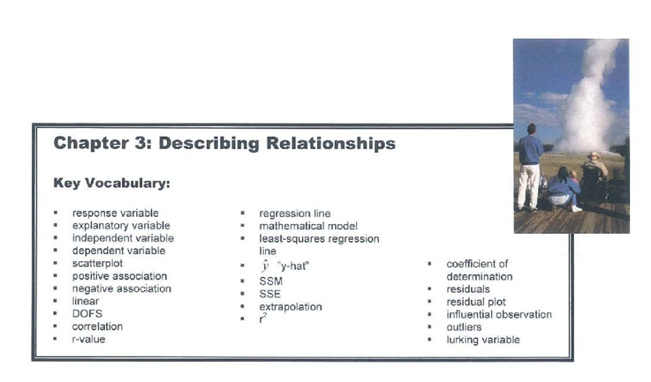
3.1 Scatterplots and Correlation (pp.142-156)

1. Why do we study the relationship between two quantitative variables?

- What is the difference between a response variable and the explanatory variable?

- How are response and explanatory variables related to dependent and independent variables?

- When is it appropriate to use a scatterplot to display data?

- A scatterplot shows the relationship between…

- Which variable always appears on the horizontal axis of a scatterplot?

- When examining a scatterplot, you can describe the overall pattern by its:
D_____ O_____ F_____ S_____

- Explain the difference between a positive association and a negative association.

- What is correlation r?

- Answer the five questions for the Check Your Understanding on page 149.

- What does correlation measure?

- Explain why two variables must both be quantitative in order to find the correlation between them.

- What is true about the relationship between two variables if the r-value is:
- Near 0?

- Near 1?

- Near -1?

- Exactly 1?

- Exactly -1?

- Is correlation resistant to extreme observations? Explain.

- What do you need to know in order to interpret correlation?

3.2 Least-Squares Regression (pp.164-188)
- What is a regression line?

- In what way is a regression line a mathematical model?

- What is the general form of a regression equation? Define each variable in the equation.

- What is the difference between y and ?

- What is extrapolation and why is this dangerous?

- Answer the four questions for the Check Your Understanding on page 167.

- What is a residual? How do you interpret a residual?

- What is a least-squares regression line?

- What is the formula for the equation of the least-squares regression line?

- The least-squares regression line always passes through the point ...

- What is a residual plot? Sketch a graph of a residual plot.

- If a least-squares regression line fits the data well, what two characteristics should the residual plot exhibit?

- What is the standard deviation of the residuals? How is it interpreted?

- How is the coefficient of determination defined?

- What is the formula for calculating the coefficient of determination?

- If r² = 0.95, what can be concluded about the relationship between x and y?
______% of the variation in (response variable) is accounted for by the regression line.

- When reporting a regression, should r or r² be used describe the success of the regression? Explain.

- Identify the slope, the y intercept, s and r² on the computer output.
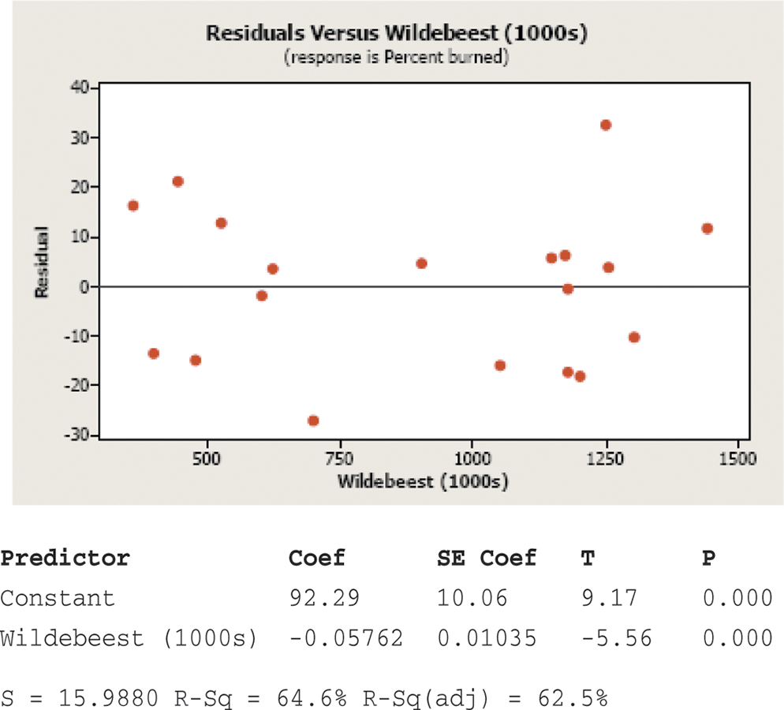

- What are three limitations of correlation and regression?

- What is an outlier?

- What is an influential point?

- Under what conditions does an outlier become an influential observation?

- Why does association not imply causation?
