Goal Self Assessment
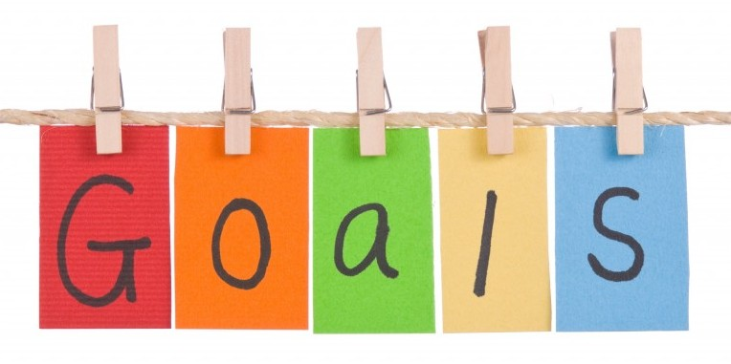

Reading Goal: _____________________________________________________
_________________________________________________________________

Did you reach your goal, if so how (what were some strategies you used)? Do you want to continue working on your goal this year, if so why?

______________________________________________________________________________________________________________________________________________________________________________________________________

Writing Goal: ______________________________________________________
__________________________________________________________________

Did you reach your goal, if so how (what were some strategies you used)? Do you want to continue working on your goal this year, if so why?

_________________________________________________________________________________________________________________________________________________________________________________________________________

