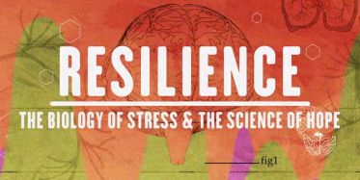
Resilience: The Biology of Stress and the Science of Hope chronicles the promising beginnings of a national movement to prevent childhood trauma, treat toxic stress and greatly improve the health of future generations.
Official Trailer: https://kpjrfilms.co/resilience/
Parent Night
Please Join the BJHS Counseling Department, Geno Ring and Clinical Staff from Mid Coast Hospital in viewing “Resilience” with discussion to follow.
Thursday, March 14th, 2019
6:00pm – 7:30pm
BJHS Library

Please RSVP by March 12th to:
Caitlin D'Amour @ cdamour@brunswick.k12.me.us or
Alanna Roy @ aroy@brunswick.k12.me.us

