Jewell Island Supply List

- 2” binder with 6 dividers for language arts (3 dividers), math, science, and social studies
- 4 - one subject spiral notebooks
  - language arts
  - science
  - social studies
  - math
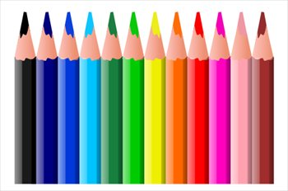
- 5 two-pocket folders
  - health (Mrs. Bingham’s students)
  - math
  - science
  - social studies
- Composition notebook
  - health (Mrs. Costa’s students)
  - math
OTHER SUPPLIES:

- Scientific (fraction) calculator
- Metric ruler (optional), preferably Wescott
- Flash drive
- LOTS of pencils!!!
- Cap erasers
- 3-hole punched, lined notebook paper
- 2 Fine tip black sharpies
- Colored pencils
- 2 different colored highlighters
- Sticky notes
- Hand held pencil sharpener
- Earbuds/headphones (inexpensive)
- Box of tissues would be greatly appreciated

Jewell Island teachers:
Mrs. Acheson pacheson@brunswick.k12.me.us
Ms. Anderson handerson@brunswick.k12.me.us
Mrs. Arzate warzate@brunswick.k12.me.us
Mrs. Iuzzolino jiuzzolino@brunswick.k12.me.us
Mrs. Lamdin slamdin@brunswick.k12.me.us
Mr. McNamara cmcnamara@brunswick.k12.me.us
Mrs. Reynolds creynolds@brunswick.k12.me.us
Mrs. Shaw cshaw@brunswick.k12.me.us

