EAGLE ISLAND SUPPLY LIST

Set of colored pencils
#2 Pencils for homework (lots!)
Pens (blue and black ink)
Highlighters (yellow and one other color)
4 1½ inch binders with dividers
1 package of lined paper

Scientific Calculator TI-30X IIS
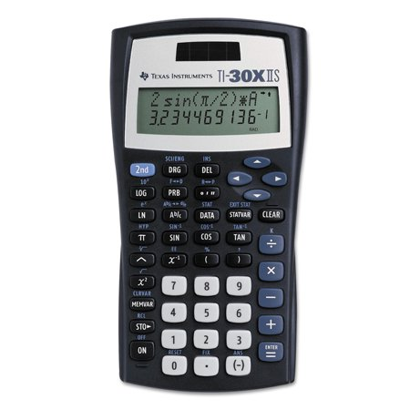

Personal reading book
1 pair ear buds (inexpensive)
Sticky notes
String bag
Box of tissues

