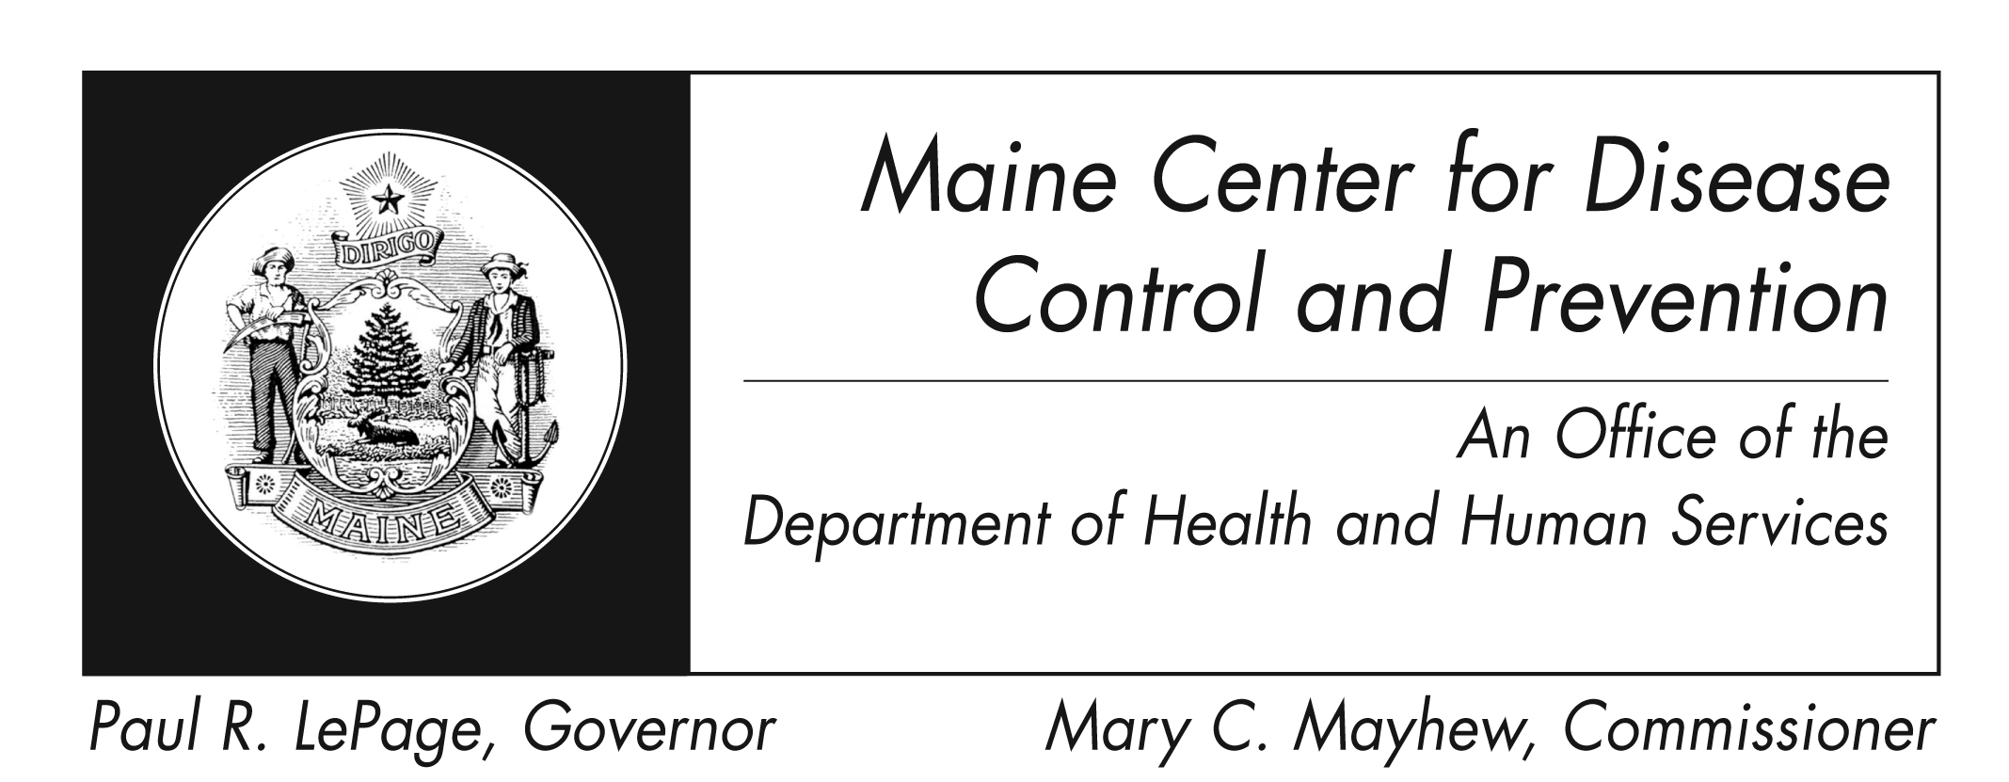
Varicella (Chickenpox)
Fact Sheet

What is Varicella?

It is an infection caused by the varicella zoster virus.

Who can get it?

Anyone who is un- or under vaccinated or not immune from previous infection.

What are the symptoms?

The most common symptoms are a skin rash on the face, scalp, and trunk. Most people have a fever, which develops just before rash appears.

Are there complications?
Yes, skin infections, swelling of the brain, and pneumonia can occur. Adolescents and adults are more at risk for severe disease.

How soon do symptoms appear?

Symptoms typically appear 14-16 days after infection, but can range from 10-21 days.

How is chickenpox spread?

It can be spread by coughing and sneezing, direct contact, and contact with tiny liquid droplets from skin lesions. Surfaces of items like toys can also spread the virus if someone who is sick touches them without washing their hands, and someone else then touches the same surface and then rubs their eyes, mouth, or nose.

How long is an infected person able to spread the disease?

An infected person can spread the disease up to 5 days before starting symptoms, but more commonly 1-2 days prior to onset of rash. The infected person remains contagious until all lesions are crusted (usually 5 days after start of symptoms).

What is the treatment for chickenpox?
Infected persons who were otherwise healthy will not need specific treatment.

Do not use aspirin or products containing aspirin to relieve your child’s fever, as this has been known to cause Reye’s syndrome, a potentially fatal disease affecting all organs, but most seriously affecting the liver and brain. Use only non-aspirin medicines.

Persons with poor immune systems from disease or drugs should contact their doctor immediately if they are exposed to or develop chickenpox. If you are pregnant and are either exposed to or develop chickenpox, you should immediately discuss your options with your doctor.

How do I protect myself and my family?

Vaccine is the best prevention. Washing hands well and often with soap and teaching children to do the same is also important. Eating utensils should not be shared and surfaces that are frequently touched (toys, doorknobs, tables, counters, etc.) should also be regularly cleaned with soap and water or with cleaning wipes.

Where can I get more information?
Your healthcare provider or local health center will have additional information. You can also contact Maine Center for Disease Control and Prevention by calling 1-800-821-5821 or visiting the website http://www.maine.gov/dhhs/mecdc/infectious-disease/epi/vaccine/varicella.shtml. The federal Centers for Disease Control and Prevention website http://www.cdc.gov/varicella is another excellent source of health information.

