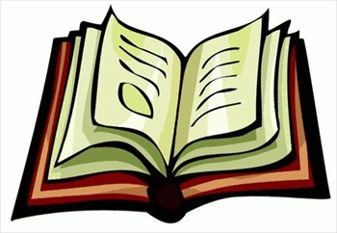

1. Look at the pictures. What do you think this text might be about?
2. Read the captions. What did you learn?
3. Look at the maps, charts, and graphs. What information did they show you?

4. Look at the titles, headings, and bold-faced words. What will this section be about?

5. What key ideas do you get from previewing?

6. Ask questions. Give yourself a reason to read.

Purpose of the Lesson:

1. Look at the pictures. What do you think this text might be about? | 2. Read the captions. What did you learn?
3. Look at the maps, charts, and graphs. What information did they show you? | 4. Look at the titles, headings, and bold-faced words. What will this section be about?
5. What are the key ideas you get from previewing? | 6. Ask questions. Give yourself a reason to read.

