Purpose of the Lesson:

Page ____ Paragraph_____

______________________________________________________
Page ____ Paragraph_____

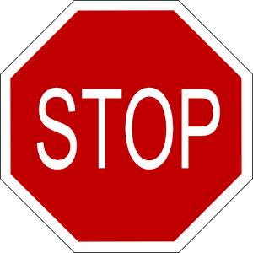
______________________________________________________
Page ____ Paragraph_____

______________________________________________________
Page ____ Paragraph_____

______________________________________________________
Page ____ Paragraph_____

______________________________________________________
Page ____ Paragraph_____

______________________________________________________

