

**BRUNSWICK HIGH SCHOOL PLAYERS**

*Place an advertisement or celebrate your B.H.S. player in our show program! Check off the size and attach any business cards, logos, or pictures to be used for your ad design. Complete the instructions and return to Carla Selberg at Brunswick High School, 116 Maquoit Rd, Brunswick, Maine 04011 or e-mail to Carla Selberg at* [*cselberg@brunswick.k12.me.us*](mailto:cselberg@brunswick.k12.me.us)*. Thank you for supporting our BHS Players!*

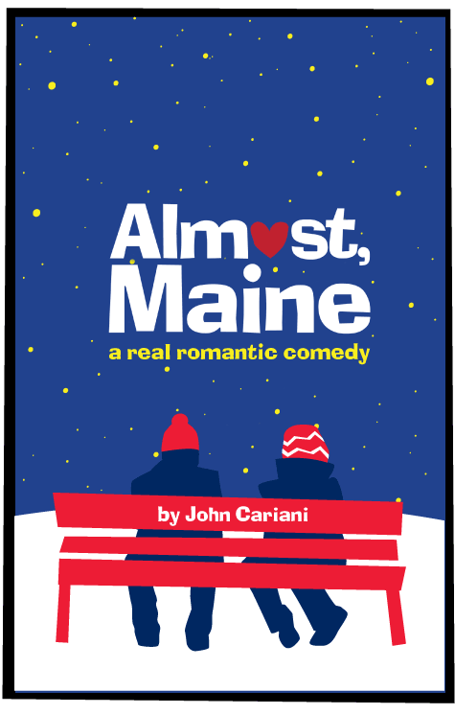

**Fall Production 2017:**

**Almost, Maine**

**November 16, 17, & 18 - 7:00 p.m.**

**Saturday, Nov. 18 - 2:00 p.m. Matinee**

**Production Sponsor – 4 Shows Annual Sponsor – 8 Shows**

_____Full Page (5” x 8”) $100.00 _____ Full Page $200.00

_____1/2 Page (4” x 5”) $50.00 _____ 1/2 Page $100.00

­­ _____1/4 Page (2 x 4) $25.00 _____ 1/4 Page $50.00

***\* Make checks payable to B.H.S. Players***

**Information:**

Name of Contact Person:___________________________________________________

Address:________________________________________________________________

Phone:____________________E-mail:________________________________________

Instructions:_____________________________________________________________

_______________________________________________________________________

_______________________________________________________________________