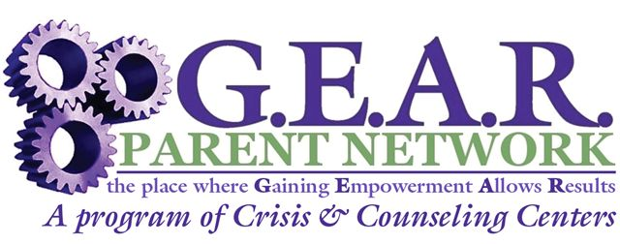

Support Group for Dads Raising Kids with
Behavioral, Emotional & Developmental Needs

Facilitated by: Norm LeBlanc, Regional Parent Support Coordinator

Have you wondered what goes on at a Parent Support Group for Dads? Are you are a Dad of a child with Behavioral, Emotional, & Developmental Health needs? Please come & join in the discussion with other Dad’s, who are on a similar journey as yours. The next 3 meeting dates are scheduled, as follows:

All Dads are welcome → New Dads, Old Dads, First-Time Dads, Step-Dads, Divorced Dads, Married Dads, Single Dads, Granddads, & Great-Granddads

Tuesday, April 18th, 2014
Tuesday May 20th, 2014
Tuesday, June 17th, 2014
6-8 pm at Providence’s Merrymeeting Center (Back Entrance),
62 Pegasus Street, Brunswick Landing (Old Naval Base) in Brunswick
(This back entrance is shared with the Mid-Coast Veterans Resource Center.)

Free to parents/guardians of children with behavioral/developmental/emotional health needs.

You may express your interest by email at nleblanc@crisisandcounseling.org; by telephone at 721-0161 or 1-800-264-9224, or fax this completed registration form to 207-621-6228 Attn: Carol Tiernan.
________________________________________________________________________

I am a Parent or Professional (please check one)

Name: ____________________________________ Telephone #: ___________________

Full Mailing Address: _______________________________________________________

Email Address: ___________________________________________________________
Check here if you wish to be included on our email/mailing list

Are you worried about your child’s emotional well-being? Through parent-to-parent sharing of experiences and knowledge, G.E.A.R. empowers parents of children with behavioral health needs to build on their family’s strengths and to advocate for their family’s needs. Free services available to parents & caregivers include: information and support by phone, monthly support groups, education, health & legal trainings and social opportunities. We are parents helping each other; we offer unconditional support – no blame, no shame and no judgment. We want you to know that you are not ALONE!


G.E.A.R. Parent Network, a Parent-to-Parent Network of Information & Support for Parents of Children with Emotional and Behavioral Health
Concerns, is a program of Crisis & Counseling Centers, Inc. and funded by the Department of Health & Human Services, United Way & private donations.

